Social Media Toolkit for Adding It Up: Investing in Contraception and Maternal and Newborn Health, 2017

This toolkit provides sample messages and infographics highlighting key findings from our new fact sheet. Feel free to use any of the content below or in our in our Dropbox folder, which also contains the fact sheet and news release in English, Spanish and French.
PLEASE NOTE: All of these materials are embargoed until 7:01pm EDT on Wednesday, June 28, 2017, and should not be shared until then. Links to the fact sheet and news release will not work before this time.
For additional content and infographics, join Guttmacher Institute on Twitter and Facebook or visit our website.
If you have any questions about these materials, please contact Gustavo Suárez at gsuarez@guttmacher.org or Colette Rose at crose@guttmacher.org. Contact Noli Vega with any social media questions: nvega@guttmacher.org.
We hope you will join us in spreading the word about Adding It Up!

ENGLISH SOCIAL MEDIA CONTENT
(scroll down for Spanish and French content)

Link to Fact Sheet: gu.tt/AddingItUp2017
Link to News Release: gu.tt/SeJpe7

Tweets
All tweets can accommodate links and images unless otherwise noted

Find Twitter graphics here
214M women in developing regions have an unmet need for modern #contraception, down from 225M in 2014 gu.tt/SeJpe7 #AddingItUp
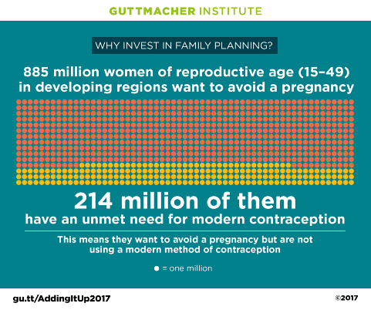

Find Twitter graphics here
Investing in both #contraceptive care & #maternal & #newbornhealth would have striking & wide-ranging results gu.tt/AddingItUp2017
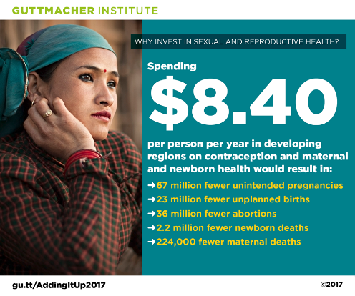

Find Twitter graphics here
Modern #contraception can help prevent #unintendedpregnancies in the developing world gu.tt/AddingItUp2017
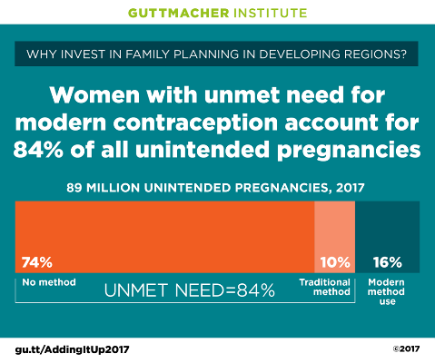

No accompanying graphic
Meeting the sexual & #reprohealth needs of women in developing regions should be an urgent #globalhealth priority gu.tt/AddingItUp2017

Facebook Posts

Find Facebook graphics here
NEW: In developing regions, the number of women with an unmet need for modern contraception has declined to 214 million in 2017 from 225 million in 2014. However, continued investments in family planning remain essential to maintain progress. gu.tt/SeJpe7
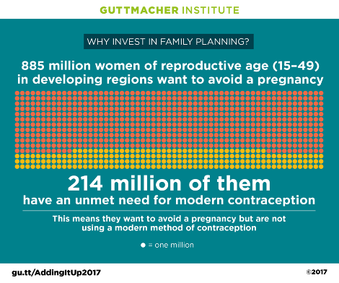

Find Facebook graphics here
What are the costs and benefits of investing in both contraceptive care and maternal and newborn health in developing regions? gu.tt/AddingItUp2017 #AddingItUp
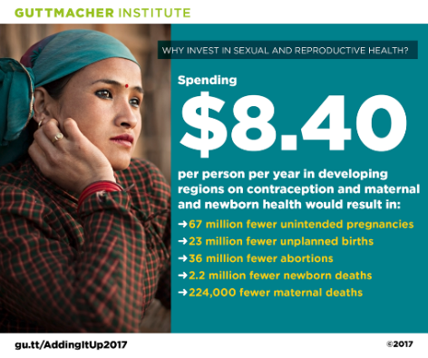

Find Facebook graphics here
The 214 million women in developing regions with an unmet need for modern contraception account for a vast majority of all unintended pregnancies. Ensuring that they can overcome barriers to effective contraceptive use is crucial to reducing unintended pregnancies. gu.tt/AddingItUp2017
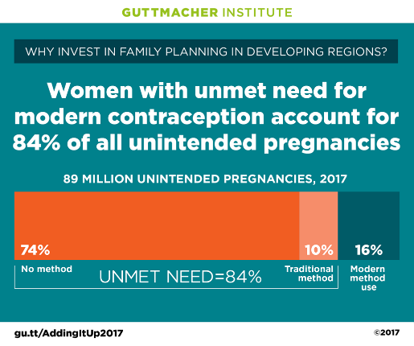

No accompanying graphic
In developing regions, investing in contraceptive services and maternal and newborn health (MNH) together—rather than in MNH alone—saves money and has a larger impact in improving the health and well-being of women and their families. gu.tt/AddingItUp2017 #AddingItUp

SPANISH SOCIAL MEDIA CONTENT

Link to Fact Sheet: gu.tt/HaciendoCuentas2017
Link to News Release: gu.tt/r1v9m5

Tweets
All tweets can accommodate links and images

Find Twitter graphics here
El uso de #anticoncepción moderna en regiones en desarrollo ha crecido pero falta invertir en #planificaciónfamiliar gu.tt/r1v9m5

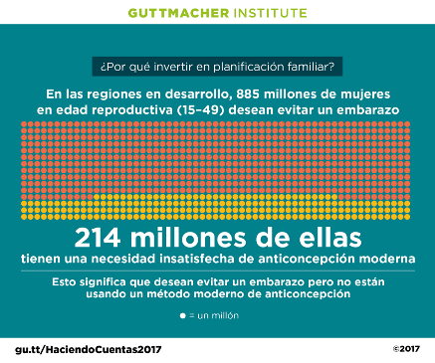

Find Twitter graphics here
Invertir tanto en #anticoncepción como en salud #materna y #neonatal tendría resultados de amplio impacto y alcance gu.tt/HaciendoCuentas2017

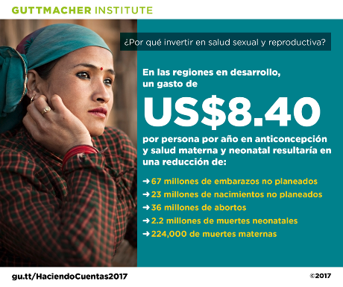

Find Twitter graphics here
La #anticoncepción moderna puede ayudar a prevenir embarazos no planeados en el mundo en desarrollo gu.tt/HaciendoCuentas2017

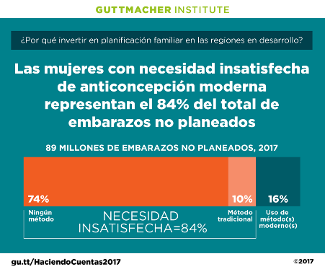

Facebook Posts

Find Facebook graphics here
NUEVO: En las regiones en desarrollo, el número de mujeres con necesidad insatisfecha de anticoncepción moderna disminuyó a 214 millones en 2017 de 225 millones en 2014. Sin embargo, inversiones constantes en planificación familiar siguen siendo esenciales para seguir avanzando. gu.tt/r1v9m5

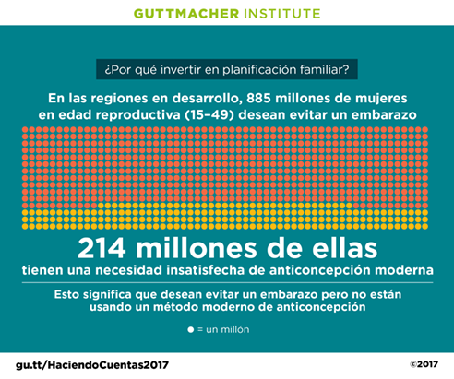

Find Facebook graphics here
Satisfacer la necesidad de anticoncepción moderna en las regiones en desarrollo y asegurar que las mujeres embarazadas y sus recién nacidos reciban servicios esenciales de salud tendría un impacto significativo y de amplio alcance. gu.tt/HaciendoCuentas2017

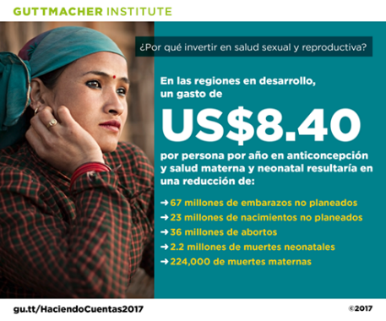

Find Facebook graphics here
Los 214 millones de mujeres en regiones en desarrollo con necesidad insatisfecha de anticoncepción moderna representan la gran mayoría de embarazos no planeados. Asegurar que puedan superar barreras para la anticoncepción efectiva es crucial para reducir los embarazos no planeados. gu.tt/HaciendoCuentas2017

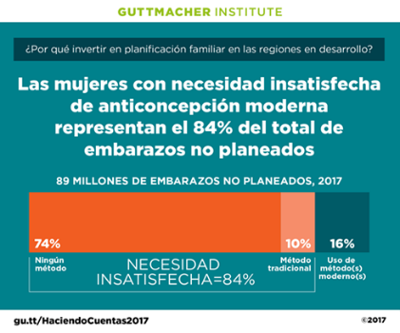

FRENCH SOCIAL MEDIA CONTENT

Link to Fact Sheet: gu.tt/UneVueDensemble2017
Link to News Release: gu.tt/MrgxmG
Tweets
All tweets can accommodate links and images
Find Twitter graphics here
Hausse #contraception moderne dans régions en dév. mais besoin investissements continus en #planificationfamiliale gu.tt/MrgxmG

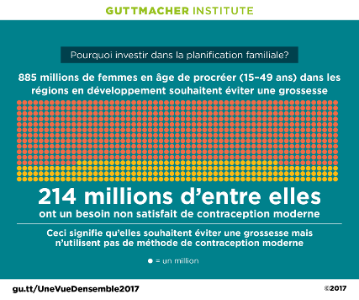

Find Twitter graphics here
Investir en soins de #contraception et de #santématernelle et #néonatale aurait des résultats percutants et élargis gu.tt/UneVueDensemble2017

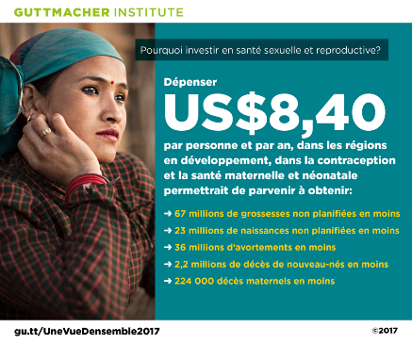

Find Twitter graphics here
La #contraception moderne peut aider à éviter des grossesses non planifiées dans le monde en développement gu.tt/UneVueDensemble2017

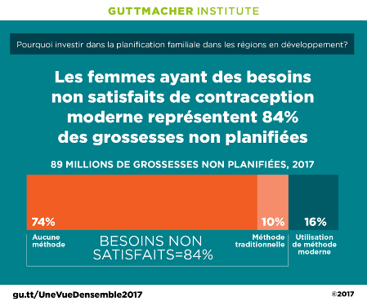

Facebook Posts

Find Facebook graphics here
NOUVEAU : Baisse du nombre de femmes des régions en développement ayant des besoins non satisfaits de contraception moderne de 225 millions (2014) à 214 millions (2017). Les investissements continus en planification familiale demeurent néanmoins essentiels pour soutenir les progrès. gu.tt/MrgxmG

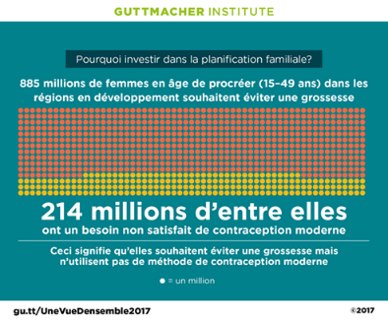

Find Facebook graphics here
Satisfaire aux besoins de contraception moderne dans les régions en développement et veiller à ce que les femmes enceintes et leurs nouveau-nés bénéficient des soins essentiels auraient un impact majeur et élargi. gu.tt/UneVueDensemble2017

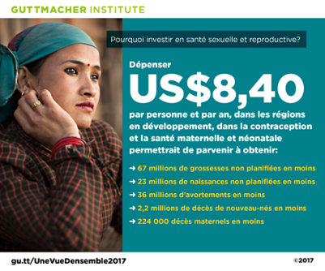

Find Facebook graphics here
Les 214 millions de femmes des régions en développement aux besoins de contraception moderne non satisfaits représentent l’immense majorité des grossesses non planifiées. Pour réduire ce nombre, il faut qu’elles puissent dépasser les obstacles à une pratique contraceptive efficace. gu.tt/UneVueDensemble2017

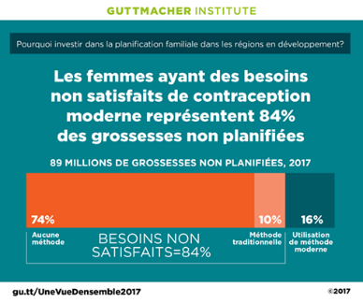

For additional content and infographics in English, Spanish and French, join Guttmacher on Twitter and Facebook or visit our website.

Many thanks for helping to amplify these new findings on June 28 and beyond!

