Meeting the Commodity Challenge:
The Ghana National Contraceptive Security
Strategy
2004 – 2010

The Ministry of Health
Agencies and Partners

Table of Contents

FOREWORD………………………………………………………………………………. 3

ACKNOWLEDGEMENT…………………………………………………………………. 4

LIST OF ABBREVIATIONS……………………………………………………………… 5
I. EXECUTIVE SUMMARY…………………………………………………………….. 6
A. Key Outputs……………………………………………………………….. 7
B. Estimated Budget………………………………………………………….. 8
II. GHANA CONTRACEPTIVE SECURITY STRATEGY…………………………….. 9
A. Background………………………………………………………………… 9
III. CONTRACEPTIVE SECURITY STRATEGY COMPONENTS…………………… 13
A. Vision, Objectives, Framework……………………………………………. 13
- Quality………………………………………………………………………15
- Efficiency……………………………………………………………………17
- Financing…………………………………………………………………… 19
- Partnerships………………………………………………………………… 24
- Monitoring & Evaluation………………………………………………….. 26
IV. WORKPLAN AND BUDGET……………………………………………………….. 28
A. Quality……………………………………………………………………… 28
B. Efficiency…………………………………………………………………... 29
C. Financing…………………………………………………………………… 30
D. Partnerships………………………………………………………………… 31
E. Monitoring & Evaluation…………………………………………………... 32
VI. ANNEX 1 – Contraceptive Financing 2004 – 2010……………………………………33
Foreword

The Programme of Action adopted at the Cairo International Conference on Population, (ICPD) in 1994 establishes the right of men and women to be informed about their reproductive health choices and health, and to have access to the information and services that make good health possible. In its policies for the redirection and intensification of population activities, Ghana has incorporated the ideals and recommendations of ICPD, as well as the World Summit on Poverty and Social Development held in Copenhagen in 1995 and the fourth World Conference on Women held in Beijing.

It is of great importance that we give all people of our nation this right to choose, obtain and use contraceptives for family planning. In recent years we have been highly successful in developing an awareness among our people of the need to plan their families. As a result, the demand for family planning services has been steadily increasing. A critical feature of family planning services is the ability to provide high quality contraceptives to its clientele. Without contraceptive security family planning services cannot be effective.

Ghana’s revised population policy (1994) set new targets within the framework of a national development strategy. One of the targets in the new policy is the reduction of Total Fertility Rate (TFR) to 4.0 by 2010 and 3.0 by 2020. This is to be achieved by attaining a Contraceptive Prevalence Rate (CPR) of 28 per cent by 2010 and 50 per cent by 2020. The attainment of these goals is recognized as integral to Ghana’s national strategy of economic development as outlined in the Vision 2020 Plan of Action. Progress towards these goals has been encouraging, yet much remains to be done to meet the development strategy targets. In 1994 the TFR was 5.5 and the CPR (modern methods) 10%, in 2002 they were respectively 4.3 and 13%.

The central objective of the Government of Ghana’s development agenda as set out in Ghana: Vision 2020 (1996) is to improve the quality of life for all Ghanaians, to generate employment and to reduce poverty. These goals are further reflected in Ghana’s Poverty Reduction Strategy Paper (PRSP) agreed with international donors. The national goals are translated into policies and strategies in the five-year Programme of Work 2002-2006. This in turn is translated into a framework for action in the Ghana Health Sector Programme of Work (2002).

To assist in the attainment of our goals set out in the population policy and the Vision 2020, I am honored to present the Ghana National Contraceptive Security Strategy. This strategy is the product of work and coordination of all health partners through the Inter-agency Coordinating Committee for Contraceptive Security (ICC/CS), whose members included representatives from government, donors, NGOs and the private sector. The strategy is based on the five strategic pillars of the MoH Programme of Work (2002-2006). As such, it includes the key strategies necessary for key health outcomes in Ghana.

As this national strategy is adopted and implemented by all health partners, it will help ensure the long-term security of contraceptives for Ghana.

Sincerely,

Hon. Moses Dani Baah (MP)
Deputy Minister of Health

Acknowledgement

The Reproductive Child Health Unit of the Ghana Health Service/Ministry of Health and the Interagency Coordinating Committee for Contraceptive Security is sincerely grateful to the various individuals and health partners who worked together to develop and complete the Ghana National Contraceptive Security Strategy.

In particular, our appreciation goes to the United States Agency for International Development (USAID) Mission in Ghana and the United Nations Population Fund (UNFPA)/Ghana for providing funding support to the ICC/CS to help ensure the completion of the document. Our thanks also go to the DELIVER Project for providing the technical assistance for the development of this document. Gratitude is also given to the GHS Public Health Division that provided senior leadership throughout the development of the strategy.

Worthy of mention is the Core Technical Working Group of the ICC/CS who took a vast amount of information and developed it into a comprehensive strategy that is creative, practical and takes into account the necessary precursors for positive health outcomes in Ghana. The Core Technical Working Group who wrote this document include: MOH/GHS staff members Dr. Gloria Quansah Asare, Samuel Boateng, Dr. Edward Addai, and Dr. Mokowa Adu-Gyamfi; Ahmed Seidu/National Population Council; Delis Darko/ Food and Drugs Board; Dr. Gifty Addico/UNFPA, Rudi Lokko/GSMF, Parfait Edah/JSI-DELIVER, and Jane Wickstrom, USAID.

Finally, our appreciation goes to the dynamic leadership of Dr. Gloria Quansah Asare, RCH/Family Planning Coordinator, Mr. Samuel Boateng, Director SSDM, Dr. George Amofah, PHD who provided the necessary insight and coordination for the realization of Ghana’s strategy to address contraceptive security, and Dr. Henrietta Odoi-Agyarko, Deputy Director, Public Health.

I acknowledge the contributions of the above individuals and organizations towards the ongoing efforts at putting in place the CS Strategic Plan for Ghana. I do sincerely look forward to everyone’s continuing participation in the course of implementation of this plan.

Sincerely,

Prof. A.B. Akosa
Director General Ghana Health Service

List of Abbreviatiaons

CEPS Customs, Excise and Preventive Services
CHPS Community – based Health Planning and Services
CPR Contraceptive Prevalence Rate
CS Contraceptive Security
DFID Department for International Development
FDB Food and Drug Board
GDHS Ghana Demographic and Health Survey
GHS Ghana Health Service
GoG Government of Ghana
GPRS Ghana Poverty Reduction Strategy
GRMA Ghana Registered Midwives Association
GSB Ghana Standard Board
GSMF Ghana Social Marketing Foundation
ICC/CS Inter-agency Coordinating Committee for Contraceptive Security
ICPD International Conference on Population and Development
MOFEP Ministry of Finance & Economic Planning
MoH Ministry of Health
NGOs Non Governmental Organizations
PHD Public Health Division
PPAG Planned Parenthood Association of Ghana
PPME Policy, Planning, Monitoring & Evaluation
RCH Reproductive and Child Health
SOPs Standard Operation Procedures
SPMDP Society of Private Medical & Dental Practitioners
SSDM Supply, Stores and Drug Management
STIs Sexually Transmitted Infections
SWAp Sector Wide Approach.
TFR Total Fertility Rate
UNFPA United Nations Populations Fund
USAID United States Agency for International Development

I. Executive Summary
The purpose of the Ghana National Contraceptive Security Strategy is to provide a conceptual approach and define the practical steps required to achieve Contraceptive Security in Ghana. The strategic vision, as defined in the 5-Year Programme of Work, is improved health status and reduced inequalities in health outcomes of people living in Ghana. Contraceptive security, as a goal, helps achieve this Vision, by ensuring that all men, women and youth can chose, obtain and use contraceptives, including condoms for the prevention of STIs and HIV/AIDS.

The National Strategic Plan was developed using the Ministry’s five key strategic objectives, or performance criteria (pillars), as the basis for defining the approach and activities. The identification of several cross-cutting issues led to the combination of the Access pillar with Quality. In its place, Monitoring and Evaluation was added to ensure a national capacity exists to monitor attainments of CS targets.

During the development of the Strategic Plan, a number of CS issues were identified as challenges preventing progress on CS strengthening. These issues were categorized within each strategic pillar with appropriate interventions, timelines and indicators. They include the following:
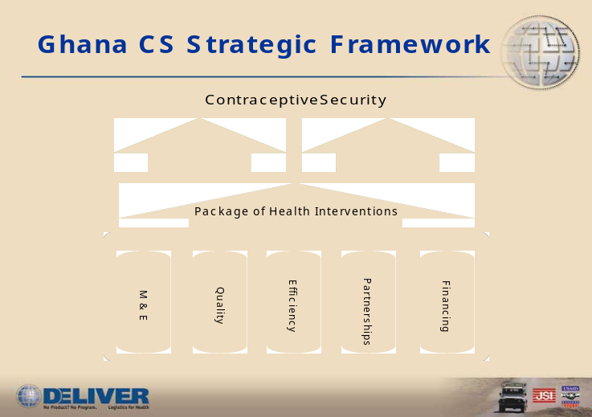

Quality  - Maintaining standards  - Improving acceptability of products to client  - Improving equipment at service delivery points.  - Rationalizing the range & availability of products  - Improving gender & age access  - Reducing barriers to access  - Improving physical access  - Improving provider attitudes and personal biases  Monitoring & Evaluation  - Developing data collection tools  - Launching an M&E plan  - Quarterly and annual reporting  - Regular meetings of ICC/CS and Implentors | Efficiency  - Improving supply chain efficiency  - Improving procurement planning & systems  Financing  - Funding gaps, need and commitment  - Improving advocacy within GoG for contraceptives  Partnerships  - Strengthening coordination mechanisms with partners  - Expand coordination with other sectors,  - market segmentation and rationalization  - Expand use of private & civil partnership  - Improve inter-ministerial collaboration

Short- and long-term activities have been identified to address the above issues. These include some on-going activities and some new activities planned for the future. Key outputs and indicators and responsible agencies and budgets have also been identified.

A. Key Outputs

Quality Activities | Coordinating Agency | Implementing Agency
1- Strengthened public sector procurement | SSDM | SSDM/PU
2- Rationalization of brands and methods of contraception | SSDM | RCH
3- Strengthen forecasting and quantification of needs | SSDM | SSDM/CMS with TA from DELIVER
4- Use of protocols for provision of contraceptives products and services | RCH | RCH/ EngenderHealth
5- Improve skills of public and private providers. | RCH | Overall RCH program/all implementing partners
6- Strengthen regulatory capacity. | GSB | GSB
Efficiency Activities
1- Upgrading physical storage infrastructure | SSDM | SSDM
2- Strengthened use of SOPs for commodity management | SSDM | SSDM with TA from DELIVER
3- Timely clearing of contraceptive commodities at the port | SSDM/ CEPS | SSDM/ CEPS
4- Reduction in illicit cross-border and internal leakage of contraceptive commodities | SSDM/ CEPS | SSDM/ CEPS
5- Procure, train and use information communication technology to add value to the existing supply systems. | SSDM | SSDM
6- Implement fleet management systems | SSDM | SSDM
7- Monitor and evaluate the supply system | SSDM | SSDM
Financing Activities
1- Conduct a willingness and ability to pay study | RCH | DELIVER
2- Introduce price changes | RCH | RCH/GSMF/ PPAG
3- Conduct a market segmentation study | RCH | DELIVER
4- Implement market segmentation recommendations | PHD | MOH/PPME with TA from DELLIVER
5- Address leakage issue through analysis, investigation, monitoring and enforcement. | CEPS | FDB
6- Pilot voucher system for contraceptives | SSDM | GHS/Finance
7- Waive tariffs for contraceptives | SSDM | MOFEP
8- Brand and method rationalization | SSDM/RCH | SSDM/RCH
9- Advocacy to donors to earmark funds for contraceptives in the SWAp | RCH | MOH/PPME
10- Advocacy for widespread financial support across sectors. | RCH | Donors, GoG, NGOs, Private Sector
Partnership Activities
1- Coordinate and advocate with CHPS community mobilization activities at the District Assembly level with DHMTs | GHS/PPME | New USAID CHPS contractor
2- Advocacy work with MOFEP and other Ministries | MOH/PPME | -Deputy Minister of Health  - DG/GHS
3- Public private forum created | GRMA, GSMF | GRMA/ GSMF/ SPMDP
4- Conference to present the CS strategy for policymakers | ICC/CS | RCH, with TA from DELIVER
5- Increase and sustain participation of partners in ICC/CS | PHD | RCH
Monitoring and Evaluation Activities
1- Develop data collection tool | SSDM | GHS/PPME
2- Launch monitoring plan for stakeholders | SSDM | GHS/PPME
3- Write quarterly reports and present at ICC/CS | RCH with TA from DELIVER | RCH
4- Conduct quarterly ICC/CS meetings | PHD | PHD

The development of this comprehensive Strategic Plan required the participation a number of stakeholders. These stakeholders, in addition to others that may be identified, will also participate in the financing support and implementation of the plan. Stakeholders are drawn from a number of different concerned groups and organizations:

Government;

Donors and Partners;

NGOs/Civil Society;

Private Sector Organisations;

Individuals.

Estimated Budget

The amounts listed below are the totals taken from the estimated costs of implementing the activities and subactivities proposed in the Strategic Plan. As the Strategy was being developed, only partial commitments to fund the activities have been secured. Following the adoption of the Ghana National Contraceptive Security Strategy by the Ministry of Health, resource allocation decisions will take place between health partners.

Estimated Budget
Exchange rate 1US$= 9,000 cedis
Strategic Pillar | (Cedis) | (U.S. Dollars)
Finance | 1,890,000,000 | 210,000
Quality and Access | 855,000,000 | 95,000
Efficiency | 31,185,000,000 | 3,465,000
Partnerships | 2,475,000,000 | 275,000
Subtotal | 36,405,000,000 | 4,045,000
Monitoring & Evaluation | 135,000,000 | 15,000
Total | 36,540,000,000 | 4,060,000

The ICC/CS and numerous units within the GHS, including the RCHU, PHD, and the SSDM, have, in large part, been responsible for raising awareness and political support for contraceptive security in Ghana. Following this process, the ICC/CS Core Technical Working Group (CWG) drafted the final strategy for presentation to the MoH/GoG. The Public Health Division, as the coordinating agency responsible for the implementation of the Strategic Plan, will take the lead in identifying an institutional framework within the Ministry best suited for implementation.

THE GHANA NATIONAL CONTRACEPTIVE SECURITY

STRATEGY

A. DEFINITION

Contraceptive Security is achieved when every woman, man and youth can choose, obtain and use the contraceptives and condoms they need for family planning and prevention of sexually transmitted infections. Contraceptive Security is dependent on sufficient funding for procuring commodities, on designing and conducting effective service delivery programs, on rationalizing the role of the public and private sectors, and on the use of up-to-date methods for efficiently managing the logistics supply chain.

B. THE PROBLEM

Th significant unmet need that currently exists, and the anticipated increase in demand for contraceptives, coupled with an ever-growing financial gap, threatens the survival of Ghana’s family planning programme and other reproductive health programmes and services.

C. BACKGROUND

The last few decades have seen an enormous increase in the use of reproductive health services around the world. Yet even as donors, non-governmental organizations, private sector initiatives and program providers work to meet the need for all reproductive health services, new demands continue to drain available resources. In recent years, these stakeholders have become increasingly concerned about observed shortfalls in reproductive health supplies throughout the developing world.

The Programme of Action adopted at the International Conference on Population and Development (ICPD) in 1994 established the right of men and women to be informed about their reproductive choices and health, and to have access to the information and services that make good health possible. The Programme of Action mandated access to a range of reproductive health care services, including health education, information and counseling on sexuality and reproductive health issues. Given the anticipated increases in demand for such services over the next few decades, large supplies of contraceptives and “other commodities essential to reproductive health programmes” will be needed in order to meet the ICPD’s challenging programmatic objectives.

In 1999, 179 countries, including Ghana, ratified an “ICPD +5” target for worldwide contraceptive security:

Governments should strive to ensure that by 2015 all primary healthcare and family planning facilities are able to provide directly or through referral, the widest achievable range of safe and effective family planning and contraceptive methods; essential obstetric care; prevention and management of reproductive tract infections, including sexually transmitted diseases; and barrier methods, such as male and female condoms and microbicides, if available, to prevent infections. – (The United Nations General Assembly Special Session on the International Conference on Population and Development (ICPD), 1999.)

It is widely recognized that population and development are inextricably linked. The central objective of the Government of Ghana’s development agenda as set out in Ghana: Vision 2020 (1996) is to improve the quality of life for all Ghanaians, to generate employment and to reduce poverty. These goals are further reflected in Ghana’s Poverty Reduction Strategy (GPRS –2002) agreed to with international donors. The national goals are translated into policies and strategies in the five-year Programme of Work 2002-2006. This in turn is translated into a framework for action in the Ghana Health Sector Programme of Work (2002).

Ghana’s revised population policy (1994) set new targets within the framework of a national development strategy. One of the targets in the new policy was the reduction of Total Fertility Rate (TFR) to 4.0 by 2010 and 3.0 by 2020. This is to be achieved by attaining a Contraceptive Prevalence Rate (CPR) of 28 per cent by 2010 and 50 per cent by 2020. The attainment of these goals is recognized as integral to Ghana’s national strategy of economic development as outlined in the Vision 2020 Plan of Action. Progress towards these goals has been steady and encouraging, yet much remains to be done to meet the development strategy targets.

Between 1988 and 1993 there was a drop in TFR from 6.6 to 5.5 with an increase in contraceptive prevalence from 5% to 10.5% (modern methods). In 1998 there was a further drop in TFR to 4.6 with a CPR (modern methods) of 13% (GDHS, 1998). In 2002 TFR decreased to 4.4. Preliminary data indicates modern method CPR has increased to 18.7% (GDHS, 2003). Unmet need for contraception remains high. In 1998, 23% of married women had an unmet need for contraception. When combined with the 22% of married women using any method of contraception, potential demand is 45% for contraception. Unmet need is relatively even in rural and urban settings and is highest in the Volta region (28.4%) and Western region (25.7%)
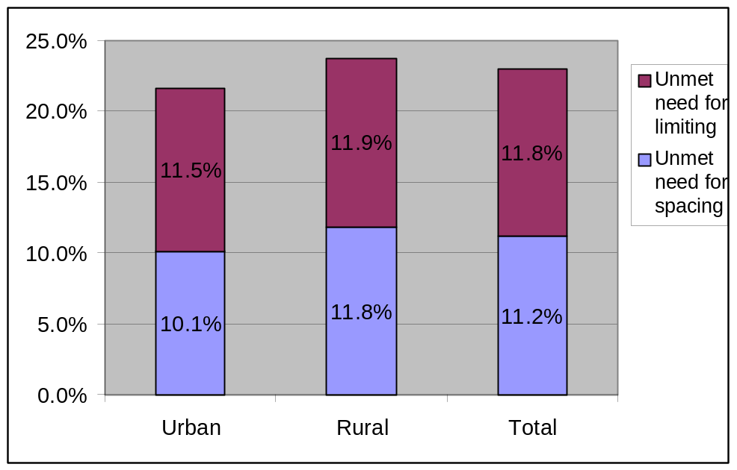
Figure 2: Unmet Need for Contraception Among Married Women 1998
21.6%
23.7%
23.0%
Source: GDHS, 1998

Addressing unmet need is critical for the attainment of the CPR target of 50% by 2020.

Policies and strategies to address this unmet need include providing access to a wide range of quality services and methods through public and private outlets (i.e. increasing method mix through long term and short term methods), dual protection through condom promotion, improving logistics management, financing and cost recovery.

Figure 3 shows the main sources of supply for three modern methods. It shows that the ratio of public to private sources of supply is relatively balanced at 47.3: 51.7. The public sector is the main source of injectables while the private sector is the main source for pills and condoms.
Figure 3: Source of Supply for Three Selected Methods
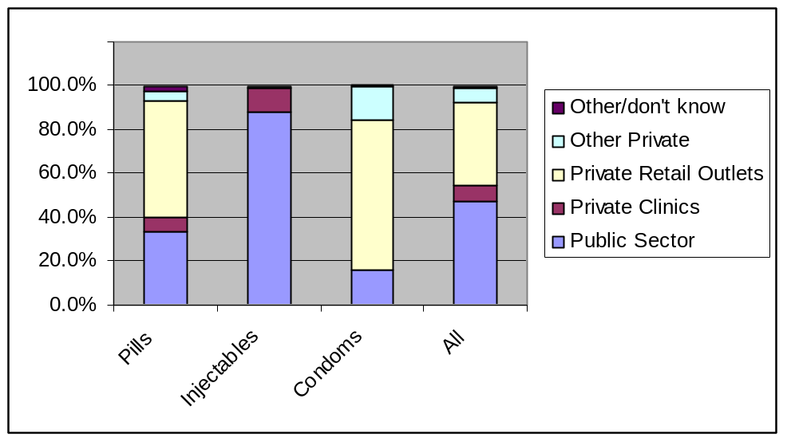
Source: GDHS, 1998

The Ghana family planning programme provides a range of contraceptive products and services (in clinic and non-clinical settings) through three major recipients of donated contraceptive commodities – MOH/GHS (public), PPAG and GSMF (non-governmental and private sectors). Private midwives, medical practitioners, pharmacists and chemical sellers are also major contributors to the program and benefit from donated contraceptives. There is also a growing market for the private commercial sector particularly for male condoms.

The range of products in the country include two brands each of combined oral contraceptives (Lo-femenal/ Microgynon) and progestin only pills (Ovrette and Micronor); two brands of Progestin-only injectables (Famplan/Depo-Provera); a monthly combined injectable (Norigynon); Condoms (male condom and female condoms (introduced in 2000); vaginal foaming tablets (Neosampoon); Implants (Norplant); and intra-uterine devices (Copper-T). Female and male sterilization services are offered in public and private facilities with trained providers. The Ghana Social Marketing Foundation (GSMF) markets and distributes branded products – Champion, Protector and Panther male condoms, female condoms, combined oral contraceptives (Secure) and the progestin-only injection Depo-Provera (Famplan) as well as IUDs and Norplant (see Table 1). The major donors are DFID, USAID and UNFPA. The Government of Ghana has utilized World Bank Funds and other “basket funds” to support procurement of contraceptives. (In 2000 and 2001 a total of $4.2 million was provided by GOG primarily using a World Bank loan).

(Table 1) – Method and Brand
Method | MoH | PPAG | GSMF
Condom | Be Safe  female condom | Be Safe  female condom | Champion  Panther  Protector Plus  Bazooka
Pill | Lo-Femenal  Ovrette  Microgynon  Micronor  Postinor | Lo-Femenal  Microgynon  Postinor | Secure
Injectable | Depo-Provera  Norigynon | Depo-Provera  Norigynon | Famplan
Implant | Norplant | Norplant
IUD | Copper T 280a | Copper T 280a
Spermicide | Neosampoon | Neosampoon | Kamal

The success of a family planning programme is characterized by a growing interest in contraceptive use, which translates to an increase in number of contraceptive users and requires an increased supply of commodities. The population of potential users is also growing. The Ghana 2000 Population and Housing Census indicates an increasing proportion of young people, many of who will enter the reproductive age group and require reproductive health services and products.

Internationally, in the early 1990’s donor support for contraceptives increased, peaking in 1993 at 15% of total population assistance. As global population assistance levels rose briefly following the ICPD, donor support for contraceptives also increased doubling from $83 million to $172 million between 1992 and 1996. However by 1999, the total available financing from donors dropped to $131 million and has continued to decline. The global decline in contraceptive commodities indicates an inconsistent and unpredictable trend in commodity financing by donors at a time when commodity requirements are increasing dramatically. This has been further amplified by the demand for barrier methods to address reproductive tract infections including sexually transmitted infections/HIV/AIDS.

Ghana currently faces an ever-widening financing gap for the purchase of contraceptive commodities. In the year 2002 the funding gap was $400,000. In 2004 the funding gap was reduced to zero, due in part to utilization of health funds, MoH tax revenue and donor commitments. However, in 2005 and 2006 this gap is expected to again widen to $2.5 and $5.3 million respectively. (These figures were based on prevailing pledged or committed funds by Development Partners and Government at that time of this writing).

The Government of Ghana acknowledges that contraceptive security is not strictly a donor problem, and following the initial Sogakope national workshop on Contraceptive Security in 2002, consensus was achieved on the strategic vision of contraceptive Security in Ghana in line with the five strategic pillars of the Health Sector’s Programme of Work namely – Access, Quality, Efficiency, Financing and Partnerships.

III. CONTRACEPTIVE SECURITY STRATEGY COMPONENTS

A. VISION FOR CONTRACEPTIVE SECURITY

Every woman, man and youth can choose obtain and use the quality contraceptives and condoms they need for family planning and prevention of sexually transmitted infections.

B. STRATEGIC OBJECTIVES

- To improve availability of quality and affordable contraceptive products and services
- To strengthen public-private partnership in the supply and delivery of contraceptive products and services
- To implement reliable and efficient systems for the supply of contraceptive products and services
- To achieve sustainable financing of contraceptive products and services.
- To ensure a national capacity to monitor and evaluate the progress on the attainment of CS targets

It should be recognized that all the five strategic objectives are inter-related. Achievement of one would lead to the achievement of the other. For this reason, all the strategic objectives would be pursued concurrently in order to harness their mutually reinforcing potential for achieving the vision.

C. STRATEGIC FRAMEWORK

The National Strategic Plan was developed using the Ministry’s five key strategic objectives as the framework for defining the approach and activities. During the development of the Strategic Plan, a number of CS issues were identified as challenges preventing progress on CS strengthening. The original list of priority CS issues developed at Sogakope in May, 2002 has been modified during the strategic planning process (see Executive Summary). It was recognized that many issues cut across strategic pillars and are, thus, identified more than once. These issues were then categorized within each strategic pillar with appropriate interventions, timelines and indicators. They include the following:

(Figure 4) – Framework and Revised Issues List
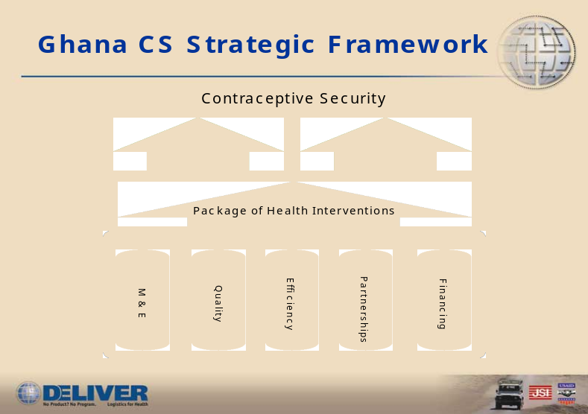

Quality  - Maintaining standards  - Improving acceptability of products to client  - Improving equipment at service delivery points.  - Rationalizing the range & availability of products  - Improving gender & age access  - Reducing barriers to access  - Improving physical access  - Improving provider attitudes and personal biases  Monitoring & Evaluation  - Developing data collection tools  - Launching an M&E plan  - Quarterly and annual reporting  - Regular meetings of ICC/CS and Implementation units | Efficiency  - Improving supply chain efficiency  - Improving procurement planning & systems  - Decrease length of time for port clearance  Financing  - Rationalize pricing structure  - Improve market segmentation  - Diversify and expand financing base  - Quantifying funding gaps, need and commitment  - Improving Forecasting and Procurement capacity  - Rationalize brand and method mix  - Improving advocacy within GoG for contraceptives  Partnerships  - Strengthening coordination mechanisms with partners  - Expand coordination with other sectors, market segmentation and rationalization  - Expand use of private & civil partnership  - Improve inter-ministerial collaboration

1. QUALITY

Strategic objective
The strategic objective is to improve the availability and quality and affordable contraceptive products and services. This is linked to improving the efficiency of the public sector resources for procurement.

Quality Issues
The availability of quality and affordable contraceptive products and services is constrained by weak systems for selecting, forecasting, procurement, distribution and regulation. The selection and procurement of contraceptive products is currently donor-driven. Individual donors tend to have preference for specific brands of contraceptive. The procurement of these brands by individual donors leads to multiple products procured, often from higher cost suppliers. Over time clients also become loyal to specific brands and fail to accept generic versions of the different brands. An analysis is needed to compare prices to determine whether donor bulk procurement is obtaining the lowest price as compared to alternative sources of supply. However, this should not come at the expense of quality. Further, the capacity in both the public and private sectors to accurately forecast contraceptive requirements is weak, leading to over supply of certain contraceptives and shortages of others. Within the public health system, outlets for distributing contraceptives are located mainly by the chemical sellers and midwives, most of who are poorly trained and poorly regulated. The broad strategy for improvement availability of contraceptives is to strengthen the systems and capacity for procuring and distributing the contraceptive products.

Maintaining Standards
Existing international (WHO) and local standards (Ghana Standards Board) must be adhered to in procuring contraceptive products. Quality testing of products should be performed as necessary to ensure compliance with standards.

Improving Acceptability
Client satisfaction with contraceptive products and services needs consideration to improve utilisation of those products and services. Client attitudes can be improved through increased public awareness and correction of misinformation about reproductive health services and products. Counselling of clients about relative benefits of specific contraceptive products improves client attitudes.

Improving Equipment at SDPs
The condition of equipment at SDPs should be evaluated to determine how additional and improved equipment can increase quality health care services.

Rationalizing the range of products
The range of products offered when rendering reproductive health services needs to be rationalised to offer a method mix which covers the needs of clients without risking brand proliferation. It is understandable when different brands of the same product are available due to donor procurement regulations. Apart from that issue, however, competing brands should be discouraged to minimize client and provider confusion.

Activities

Activities | Coordinating Agency | Implementing Agency | Output
1- Conduct a series of meetings and provide appropriate training to integrate and monitor the public sector procurement of contraceptives into the unified sector-wide system. | SSDM | SSDM | Establishment of a unified sector wide procurement system with trained staff able to forecast and procure quality contraceptives efficiently.
2- Review (s) brands and methods of contraception to rationalize and standardize products | SSDM | RCH | Reduction in the brands being procured in the unified system
3- Build public and private sector capacity in forecasting and quantification of needs | Deliver | Deliver | Trained public and private sector capacity to forecast procurement needs
4- Ensure the use of protocols for provision of contraceptives products and services through dissemination, training , monitoring and supervision | RCH | RCH/ EngenderHealth | Improved quality of RHC services through development and dissemination of protocols
5- Improve skills of public and private providers including chemical sellers and midwives in provision of contraceptive products and services. | RCH | Overall RCH program/all implementing partners | Improved quality of provision of contraceptives through training of midwives and chemical sellers.
6- Strengthen the capacity of regulatory bodies to monitor the quality of contraceptive products and services. | GSB | GSB | Strengthened and streamlined quality control procedures at GSB

Keys Indicators
- Reduction in the variety procured in the unified system
- Increased availability of contraceptives in distribution channels
- Increased proportion procured by MOH/Donors
- Proportion of products registered in country

Assumption and Risks
- Willingness of partners to use a unified system
- Acceptance of clients to use standardized /generic products
- Ability of unified procurement system to procure recognized product names
2. EFFICIENCY

Strategic Objective
Implementing reliable and efficient systems for the supply of quality contraceptive products and services. Obtaining the optimum price quality combination.

Efficiency Issues
Currently, the system for contraceptive commodity management is not adequately integrated into the sector-wide procurement and distribution system. Selection, planning, procurement, storage, distribution and the logistics management information system are all outside the sector-wide processes and systems. While this may have worked in the past, it is unlikely to be sustainable under the Sector-wide approach. The focus is to translate the experiences that have accumulated into a reliable but sustainable supply system for contraceptives.

Improving Supply-Chain Efficiency
Integrating the contraceptive commodity management system into the sector-wide system would require investments in both the existing infrastructure and supply management systems. At present, the sector-wide supply system in its current form cannot ensure timely availability of good quality contraceptive products and services. This supply system is plagued by inefficiencies which manifest as wastage and stock outs. Further, providers do not have adequate knowledge and experience of the existing standard operating procedures (SOPs) for receipt, storage and distribution of health commodities. This has lead to inadequate inventory and quality assurance systems that assure the security and safety of products. The existing infrastructure for warehousing is poorly designed and requires upgrading or refurbishment. The fleet management system that exists has not yet been operationalized. As a result, delivery of health commodities is not structured and costly.

Improve Procurement Planning and Systems
Procurement planning between donors and the MoH needs to be improved in order to avoid duplication of efforts and ensure full supply of a number of products.

Decrease Length of Time for Port Clearance
There have been great improvements in clearing commodities from ports in Ghana, although efforts are still on-going to further reduce clearing time. CEPS has been an important partner on the ICC/CS and their efforts in reducing cross-border and internal leakage are appreciated and should be strengthened.

Activities

Activities and Subactivities | Coordinating Agency | Implementing Agency | Output/
1- Upgrading physical infrastructure including installing appropriate storage and handling equipment at storage sites and regular maintenance (capital investment) | SSDM | SSDM | Improved physical infrastructure meeting best practice storage conditions
2- Training and supporting providers in the use of SOPs for managing the receipt, storage and distribution of health commodities | SSDM | SSDM with TA from Deliver | Increased logistics system efficiency, reduced stock outs
3- Ensure timely clearing of contraceptive commodities at the port | SSDM/ CEPS | SSDM/ CEPS | Increased speed of port clearance
4- Prevent illicit cross-border and internal leakage of contraceptive commodities | SSDM/ CEPS | SSDM/ CEPS | Reduced system loss
5- Procure, train and use information communication technology to add value to the existing supply systems. | SSDM | SSDM | Improved supply system efficiency
6- Implement fleet management systems | SSDM | SSDM | Improved efficiency of transport fleet
7- Monitor and evaluate the supply system | SSDM | SSDM | Improved logistics systems indicators

Key Indicators
- Timely delivery of health commodities
- Regular stock status reports
- Reduction in stockouts, overstocks, wastage (thefts, expired)
- Central and Regional warehousing refurbished and computerized
- SOPs implemented
- Decreased vehicle unit costs

Assumptions and Risks
- Weak regulatory environment
- Increased governance and supervision
- Several agencies involves in selection, forecasting, procurement and delivery.

3. FINANCING

Strategic Objective:
The strategic objective is to achieve sustainable financing of contraceptive products and services. This will be achieved through the leadership of the MOH/GHS and its commitment to financing contraceptive needs for the long-term, including management and allocation of funds from GOG budgets and funds from donors, NGOs, private organizations and individuals.

The strategic objective for finance is critical to the success of contraceptive security. In the past the MOH has relied almost exclusively on donor support for the forecasting, procurement and financing of contraceptives (except for the budget years 2000-2001 where the MOH used a World Bank loan to co-finance contraceptives). While there is generally a very favorable political environment for family planning and the use of modern contraceptive methods in Ghana, the Government of Ghana has historically not allocated adequate funds for contraceptives. Static or declining financing from a variety of sources in the face of rising unmet need for contraceptives will lead to greater contraceptive insecurity.

In fact, for many years the GOG has spoken out in support of family planning, recognizing that increased use of contraceptives will lead to improvements in maternal health and reduction in maternal mortality. Thus while the political environment is supportive, continued advocacy is needed to gain widespread support across sectors (e.g. within the different Ministries and Departments, insurance schemes, District Assemblies) to finance the growing contraceptive needs that will be required over the next 7 years and beyond.

The MOH can certainly assume that there will be continued donor support for reproductive health and its required commodities. However, the financial realities of the SWAp, and in the future possibly donor's direct budget support, the MOH/GHS will need to clearly articulate their needs and financial requirements for contraceptives if the MOH is to meet maternal health goals. Advocacy for increased and secure financing of contraceptives as the population of potential users grows will become very important in the coming years.

Financing Issues
The re-engineered system for contraceptive procurement and supply will be operational by the end of 2004, thus creating an integrated essential drug and contraceptive system housed in the Procurement and Supply Division of the GHS. The integration of contraceptives into the essential drug supply chain will create financial efficiencies as well as the benefit of mainstreaming contraceptives into the normal forecasting and financing of health commodities. Cost savings from the streamlined system should be reinvested in contraceptive procurements.

Pricing Structure
The GHS has conducted several studies on pricing of health commodities in general, and one in particular, on individual's "willingness to pay" for contraceptives. While the willingness to pay study was mainly concerned with private sector outlets, public sector services were also surveyed. These studies show that the majority of consumers are willing to pay more than they are being currently charged for many contraceptives in the market and in clinics. To support the findings of these studies in Ghana, many international studies have also shown that if prices are too low, consumers believe that the quality of the contraceptive is poor. Both the public and private sectors should come together to set realistic prices for all commodities to ensure adequate cost recovery while maintaining prices that are affordable across the different income levels of consumers. Collaboration between various levels of government, NGOs, and the private sector on pricing will avoid costly competition between sectors (due to undercutting of prices). The successful stabilization of prices between public and private sectors is a cornerstone of financial viability of the program.

Market Segmentation
Market segmentation is also an important element of financial viability and improving access for those who can pay little. The GOG has instituted a policy of subsidizing products and services for those who can not pay or those people who can only pay a portion of the cost for goods and services in the health sector. The public and private sectors should come to an agreement on how to segment the market for contraceptives and family planning services in a fair and equitable way to meet unmet demand and ensure that paupers can get access to commodities and services.

Financing Subsidies and Health Insurance
Financing the subsidies for the poor and lower middle classes is a critical financial issue underlying the goal of full access to family planning services and products (including male and female sterilization). The MOH will need an analysis of how subsidies will be financed within current and future budget realities. Additionally, health insurance plans must consider covering preventive health services like family planning. For those who can pay insurance premiums, preventive interventions like family planning will in fact pay for themselves. Cost savings from unwanted pregnancies averted, induced abortions averted and an overall improvement in maternal health will directly result in reduced insurance outlays for maternal healthcare.

National Health Insurance
GoG and partner advocacy efforts should focus on securing the inclusion of contraceptive and family planning services on the National Health Insurance schedule of covered commodities and services.

Brand Rationalization
Brand and method rationalization is another way to improve financial sustainability of the program. There is a balance that is required between quality, access and cost of commodities. For example, there are multiple brands and formulations of hormonal methods that are on the market, many could be discontinued at a cost savings to the program. Cost savings could be realized in terms of procuring, maintaining and managing stocks of many brands, advertising many brands and training providers in their proper dispensing. (see Table 1). Client confusion with many different brands and formulation may also lead to discontinuation of methods. A rational approach to introducing brands in the public and private sectors is needed.

Improved Forecasting and Procurement Capacity
The capacity to conduct forecasting at all levels of the MOH/GHS will improve financial planning and efficient allocation of resources. For example, the proper forecasting will lead to optimal levels of stock since overstocking leads to wasting of valuable resources. Improved forecasting, procurement capacity, and practices for international tenders will also lead to getting the best prices for commodities. Several options are available to Ghana for getting the best price including: pooling procurements with other West African countries to buy in bulk; continuing to use USAID and UNFPA as sources since these organizations get the lowest prices due to their worldwide bulk purchases; or other bulk purchase arrangements.

During the transition phase from donor procurement, the MoH should apply for tariff waivers for contraceptives to ensure the importation of contraceptives are duty free.

Donor Support for Contraceptive Financing
Donor support will continue to play an important role in the financing of contraceptives. To help ensure sustained donor financing for contraceptives it will be important to strengthen and further institutionalize the topic of contraceptive security within the partner meetings, health summits, stakeholders' conferences, and other meetings. Diversification of the contraceptive financing base, while difficult in the SWAp environment, is certainly possible and should be pursued. Advocacy and policy strategies should clearly articulate the MOH and donor commitment to financing contraceptives. To this end, partners have already coordinated effectively in the short-term to ensure adequate financing is available for contraceptives. For 2004, the “financing gap” has been reduced to from over $1 million to $0, due in part to effective coordination between donors, MoH and partners through the ICC/CS. Yet the medium and long-term financing gap remains significant without increased and additional commitments from GoG and donors. Many activities planned for the future, including MoH procurement of contraceptives, integration and increased cost recovery will contribute to reduce the projected funding shortfall. However, GoG and partners need to discuss specific steps to address contraceptive financing.

Annex 1 provides a detailed summary of the projected contraceptive requirements for the MoH, PPAG and GSMF for the period 2004 – 2010 and projected contributions.

Recommendations
- The public, NGO and private sectors should segment the market for contraceptives and family planning services in a fair and equitable way to meet unmet demand (ensuring that paupers can get access to commodities and services).
- Realistic prices for all commodities should be set to ensure adequate cost recovery while maintaining prices that are affordable.
- The MOH will need an analysis of how subsidies will be financed within current and future budget realities.
- Health insurance plans must consider covering preventive health services like family planning. Averting unwanted pregnancies, abortions and the overall improvement in maternal health will directly result in reduced insurance outlays for maternal healthcare.
- Brand and method rationalization should be studied as another way to improve financial sustainability of the program
- MOH should apply for tariff waivers for contraceptives now to prepare for future international tenders done by MOH.
- Investigate options for bulk purchasing to ensure best prices
- Diversification of contraceptive financing base, while difficult in the SWAp environment, is certainly possible and should be pursued.

Activities
Activities and Subactivities | Coordinating Agency | Implementing Agency | Output
1- Conduct a willingness and ability to pay study (pricing study) for the public sector | RCH | Deliver | Review of WTP and ATP
2- Review current prices and make recommendations for immediate increase and continue reviews over time | RCH | RCH/GSMF/ PPAG | Revised schedule of prices for contraceptives established and implemented.
3- Conduct a market segmentation study | RCH | Deliver | Market segmentation study identifies opportunities for addressing unmet need through better targeting of public services and greater co-ordination between the public and private sector.
4- Implement recommendations of market segmentation study using a Memorandum of Understanding | PHD | MOH/PPME with TA from Deliver | Opportunities to align public and private sector services to different market segments encapsulated in MOU and being implemented.
5- Address leakage issue through analysis, investigation, monitoring and enforcement. | CEPS | FDB | Reduced system loss
6- Pilot voucher system for contraceptives as done with ITHs | SSDM | GHS/Finance | Pilot voucher scheme tested
7- MOH should apply for tariff waivers for contraceptives | SSDM | MOFEP | Agreement on tariff waivers by MOFEP
8- Conduct meetings to discuss brands and method rationalization and implement recommendations | SSDM/RCH | SSDM/RCH | Number of brands reduced.
9- Advocacy to have donors earmark funds for contraceptives in the SWAp or have new donors contribute directly | RCH | MOH/PPME | Advocacy documents prepared, donor commitments obtained
10- Advocacy for widespread financial support across sectors (e.g. within the different Ministries and Departments, insurance schemes, District Assemblies). | RCH | UNFPA/ USAID | Advocacy material prepared message conveyed to different sectors

Key Indicators
- Financial targets met
- Diversified source of funding obtained
- MOH/GHS procurement plan shows adequate contraceptive supplies
- Cost recovery increased for sections of the market
- Stable pricing structure in operation
- Optimal number of brands in program

Assumptions and Risks
- MOH/GHS and Finance stakeholders will fully embrace the financing of contraceptives
- Increasing demand for family planning
- Unmet need reduced
- Consumers WTP for public services.
- Straight-lined, flat or reduced financing from donors
- Market segmentation continues to be difficult
- Tariffs will not be waived
- CPR falls as prices increase

4. PARTNERSHIPS

Strategic objective:
To strengthen and expand opportunities and mechanisms for coordinating all partners including: inter-ministerial, intra-ministerial, District Assembly, donors, lending institution collaboration and the private and NGO sector.

Partnership Issues

Strengthen Coordination Mechanisms with Partners
A critical component of institutionalizing contraceptive financing and contraceptive security in general is expanding coordination with other sectors and improving inter- and intra -ministerial collaboration. For example, District Assemblies are decision-makers for the health sector at the district, sub-district and community levels. District Assemblies should be sensitized to the need for support of contraceptive and other family planning services. As the Community-based Health Planning and Services (CHPS) initiative expands, districts will support the community health officer and his/her medical supplies, including contraceptives. It is critical that District Assemblies become involved in financing and supplying contraceptives for the public sector.

Improve Inter-ministerial collaboration
Additionally, the Ministry of Finance has been marginally involved in the ICC/CS. The MOF needs to become more involved and understand the importance of contraceptive security so that they can be more supportive of MOH/GHS needs.

Within the MOH/GHS, not all decision-makers place high enough emphasis on contraceptives in relation to other health issues/products. Full cooperation of all health sector decision-makers would create a more favorable environment for contraceptives.

Strengthening coordination mechanisms and increase opportunities with partners including diversification and increase the number of health partners working with the Interagency Coordinating Committee for Contraceptive Security, including pharmaceutical manufacturing groups in ICC/CS meetings.

Expand Use of Private and Civil Partnerships
Advocate with the private commercial sector to become more involved in family planning commodity sales and promotion, showing them the financial gains that can be achieved. Establish a forum for public private dialogue to facilitate the identification and addressing of constraints to further private sector involvement.

Activities
Activities and Subactivities | Coordinating Agency | Implementing Agency | Output
1- Coordinate and advocate with CHPS community mobilization activities at the District Assembly level with DHMTs | GHS/PPME | New USAID CHPS contractor | Increased awareness of CS at the CHPS and District Assembly level
2- Advocacy work with MOFEP, Ministry of Local Government and inter-Ministerial working groups . | MOH/PPME | -Deputy Minister of Health  - DG/GHS | MOFEP recognizes contribution of CS to attaining MDG targets.
3- Forum created for discussions between the public and private commercial sector | GRMA, GSMF | GRMA/ GSMF/ SPMDP | Public private dialogue established
4- Conference to present the CS strategy for policymakers and implementers | ICC/CS | Deliver | CS Strategy event held
5- Increase participation of partners in ICC/CS | PHD | RCH | ICC/CS decisions transmitted to and acted on by partners

Key Indicators
- Increased number of CHPS community mobilization activities
- Increased financial commitment from the MOFEP
- Increased role of the private sector in commodity supply

Assumptions and Risks
- District assemblies will support family planning
- Partners are committed to contraceptive security
- ICC/CS will continue to receive high-level policy leadership

5. Monitoring and Evaluation

Strategic Objective
Ensure a national capacity exists to monitor implementation of the CS strategic plan, monitor attainment of CS targets and react to unforeseen events that could undermine CS.

Monitoring Issues
The ICC/CS will take the leadership role in monitoring the activities of the contraceptive security strategy, with the chair of PHD. The RCH unit will be responsible for coordinating the activities of the strategy and monitoring progress of the activities. Deliver will assist the RCH unit in coordinating and provide technical assistance when required. Individual organizations will be responsible for implementing their own activities and reporting to the ICC/CS. The ICC/CS will meet quarterly.

The monitoring plan will first look at process indicators, mostly when and if activities have been completed. There will be a timeline for the commencement and completion of each activity. Quarterly reports on progress of activities will be given at the ICC/CS meetings. End of year evaluation meeting will review progress of the contraceptive security strategy.

The outcome indicators will be a culmination of the implementation of key activities leading to

Activities
Activities and Subactivities | Coordinating Agency | Implementing Agency | Output
1- Develop data collection tool | SSDM | GHS/PPME | Data collected to monitor CS progress
2- Launch monitoring plan for stakeholders | SSDM | GHS/PPME | Role of stakeholders defined in monitoring
3- Write quarterly reports and present at ICC/CS | Deliver | RCH | Quarterly reports presented and acted upon
4- Conduct quarterly ICC/CS meetings | PHD | PHD | ICC/CS meeting held, well attended and decisions implemented

Key Indicators
- CPR and TFR targets
- Financing gap reduced
- Increased diversity of financing sources
- Logistics indicators: (stockouts, min-max levels, reporting)
- Acceptance and Discontinue rate
- Public sector procurement rate
- Rate of unmet need

Assumptions and Risks
- ICC/CS continues to function with strong leadership and participation of all stakeholders
- ICC/CS decisions are implemented
- ICC/CS has the capacity to identify problems and address them

IV. WORKPLAN AND BUDGET

A. QUALITY

Activities and Subactivities | Estimated Budget  ($) | Timing
1- Conduct a series of meetings to integrate and monitor the public sector procurement of contraceptives into the unified sector-wide system. | -Routine activity- | -Quarterly first year  -Annually, following years
2- Review (s) brands and methods of contraception to rationalize and standardize products | 10,000 | By end June 04
3- Build public and private sector capacity in forecasting and quantification of needs | 5,000 | On –going
4- Ensure the use of protocols for provision of contraceptives products and services through dissemination, training , monitoring and supervision | Routine activity | On going
5- Improve skills of public and private providers including chemical sellers and midwives in provision of contraceptive products and services. | 50,000 | On going
6- Strengthen the capacity of regulatory bodies to monitor the quality of contraceptive products and services. | 30,000 | Overtime

B. EFFICIENCY

Activities and Subactivities | Estimated Budget  ($) | Timing
1- Upgrading physical infrastructure including installing appropriate storage and handling equipment at storage sites and regular maintenance (capital investment) | 2.8 million | By Sept.04
2- Training and supporting providers in the use of SOPs for managing the receipt, storage and distribution of health commodities | 220,000 | By end Dec.04
3- Ensure timely clearing of contraceptive commodities at the port | Routine activity | Ongoing
4- Prevent illicit cross-border and internal leakage of contraceptive commodities | Routine activity | On going
5- Procure, train and use information communication technology to add value to the existing supply systems. | 420,000 | By Dec. 04
6- Implement fleet management systems | Included in SOPs budget | By end Dec.04
7- Monitor and evaluate the supply system | 25,000 | Oct 04 and beyond

C. FINANCING

Activities and Subactivities | Estimated Budget  ($) | Timing
1- Conduct a willingness to pay study (“”pricing study””) for the public sector | 50,000 | Oct. 04- Jan05
2- Review current prices and make recommendations for immediate increase and continue reviews over time | 20,000 | April-June 05
3- Conduct market segmentation study | 50,000 | Oct. 04- Jan05
4- Implement recommendations of market segmentation study using a Memorandum of Understanding | Routine activity | Oct. 04- Jan05
5- Address leakage issue through analysis, investigation, monitoring and enforcement. | 10,000 (Routine activity) | From Q2 2004 -2010
6- Pilot voucher system for contraceptives as done with ITHs | 50,000 | -Quarter2 04 – Quarter1 05  - Quarter2 05 - Quarter4 010
7- Tariff waivers for contraceptives | Routine activity | On going
8- Conduct meetings to discuss brands and method rationalization and implement recommendations | 10,000 | By end June 04
9- Advocacy to have donors earmark funds for contraceptives in the SWAp or have new donors contribute directly | 10,000 | March 04,  June-July 04  Regularly-2010
10- Advocacy for widespread financial support across sectors (e.g. within the different Ministries and Departments, insurance schemes, District Assemblies). | 10,000 | March 04,  June-July 04  Regularly to 2010

D. PARTNERSHIPS

Activities and Subactivities | Estimated Budget  ($) | Timing
1- Coordinate and advocate with CHPS community mobilization activities at the District Assembly level with DHMTs | 210,000 (30,000 / year) | From Oct. 04-2010
2- Advocacy work with MOFEP, Ministry of Local Government and inter-Ministerial working groups. | 10,000 | On-going
3- Advocate with private commercial sector | 10,000 | On-going
4- Conference to present the CS strategy for policymakers and implementers | 45,000 | April 2004
5- Increase participation of partners in ICC/CS | Routine activity | Quarterly  On going-2004-2010

E. MONITORING AND EVALUATION

Activities and Subactivities | Estimated Budget  ($) | Timing
1- Develop data collection tool | 5,000 | May 2004
2- Launch monitoring plan for stakeholders | 5,000 | Quarterly From Quarterly3 04 to 2010
3- Write quarterly reports and present at ICC/CS | Routine activity | Quarterly 2004-2010
4- Conduct quarterly ICC/CS meetings | 5,000 | Quarterly 2004-2010

ANNEX 1: GHANA CONTRACEPTIVE FUNDING DATA 2004 - 2010
 |  |  | TOTAL CONTRACEPTIVES FUNDING REQUIREMENT 2004-2010
 | 2004 | 2005 | 2006 | 2007 | 2008 | 2009 | 2010 | TOTAL
CONDOM | $2,112,100 | $2,707,394 | $2,947,415 | $4,097,936 | $4,735,162 | $5,840,930 | $6,350,460 | $28,791,397
ORALS | $1,984,814 | $2,206,953 | $2,494,249 | $3,259,912 | $3,315,228 | $3,753,835 | $3,975,167 | $20,990,158
INJECTABLES | $2,016,341 | $1,635,755 | $2,164,360 | $2,254,319 | $2,443,971 | $2,633,215 | $2,635,618 | $15,783,579
IMPLANTS | $261,800 | $431,970 | $43,970 | $497,420 | $497,420 | $549,780 | $549,780 | $2,832,140
IUD | $9,739 | $17,674 | $16,952 | $19,477 | $20,920 | $20,559 | $22,002 | $127,323
VFTs | $0 | $0 | $111,584 | $88,352 | $96,096 | $99,264 | $92,928 | $488,224
TOTAL | $6,384,794 | $6,999,746 | $7,778,530 | $10,217,416 | $11,108,797 | $12,897,583 | $13,625,955 | $69,012,821
 |  |  | TOTAL CONTRACEPTIVE FUNDING COMMITMENTS 2004 - 2010
 | 2004 | 2005 | 2006 | 2007 | 2008 | 2009 | 2010 | TOTAL
 | $ 6,384,793 | $ 4,598,525 | $ 2,876,370 | $ 2,876,370 | $ 2,876,370 | $ 2,876,370 | $ 2,876,370 | $25,365,169
 |  |  | TOTAL CONTRACEPTIVE FUNDING GAP 2004 - 2010
 | 2004 | 2005 | 2006 | 2007 | 2008 | 2009 | 2010 | TOTAL
 | $0 | $2,401,221 | $4,902,160 | $7,341,046 | $8,232,427 | $10,021,213 | $10,749,585 | $43,647,651
*Requirements based on logistics data
*Program requirements based on MoH, PPAG and GSMF markets
*Financing commitments for 2007 - 2010 have not been established
*2007 - 2010 commitments projected at 2006 levels
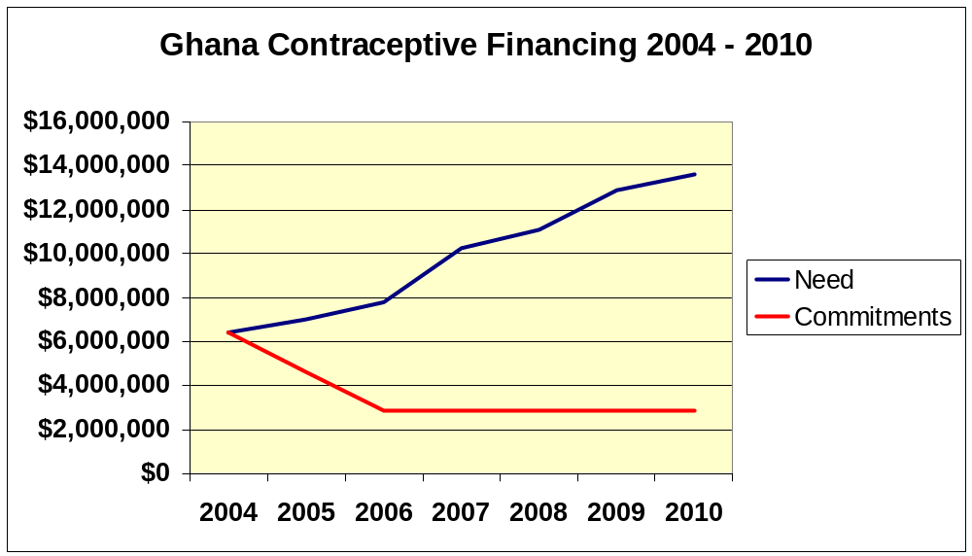

Originally considered under the Access pillar at the initial Sogakope CS Workshop in May, 2002
Not including the cost of contraceptives
The figure for unmet need for contraception is not yet available in the 2003 GDHS preliminary report.
Postinor is currently on order for the MoH.
Phasing out in 2004
As mentioned, during the strategic planning process Access was combined with Quality and Monitoring and Evaluation was added as the fifth strategic pillar.
Originally considered under the Access pillar at the initial Sogakope CS Workshop in May, 2002
Improving and rationalizing procurement is a cross-cutting issue affecting financing, efficiency and quality. Activities related to this issue can be found under the Quality pillar.
Long-term financing commitments by partners is seen as key to CS in Ghana. As such, the Core Technical Group developed a specific set of recommendations.
A detailed monitoring and evaluation plan, including a complete set of indicators will be developed under the direction of the MoH unit charged with coordinating and implementing the Strategy.

