YEMEN
REPRODUCTIVE HEALTH COMMODITY SECURITY
ASSESSMENT

LESLIE PATYKEWICH
TIM O’HEARN
JAMES BATES

YEMEN
REPRODUCTIVE HEALTH COMMODITY SECURITY
ASSESSMENT

LESLIE PATYKEWICH
TIM O’HEARN
JAMES BATES
John Snow, Inc. (JSI) is a U.S.-based health care consulting firm committed to improving the health of individuals and communities worldwide. Our multidisciplinary staff works in partnership with host-country experts, organizations, and governments to make quality, accessible health care a reality for children, women, and men around the world. JSI’s headquarters are in Boston, Massachusetts, with U.S. offices in Washington, D.C.; Concord, New Hampshire; and Denver, Colorado. We maintain offices in more than 20 countries throughout the developing world.

Abstract
Yemen’s Ministry of Public Health and Population Sector’s Population Sector wishes to carry out a diverse program of activities aimed at providing a secure supply of contraceptives for the country. Accordingly, with the assistance of the Royal Netherlands Embassy, the Ministry has decided to sponsor a participatory process for developing a Reproductive Health Commodity Security Framework. The Framework will provide the basis for prioritizing activities to carry out and allocating resources. The first step in the framework development process has been to assess the status of RHCS in terms of six determinants, which are: Financing, Supply Chain, Services Delivery, Coordination and Partnership, Policy and Advocacy and Capacity Building. The assessment reveals a diversity of strengths and weaknesses and concludes with general and specific recommendations for each determinant. Among the most important findings are the following ones: In recent years contraceptive financing for the public sector has been sufficient, but the Ministry is constrained in long term planning by the year to year nature of funding commitments, most of which originate with international donors. The supply chain is not performing well and it is rare for consumers to be able to find the complete mix of contraceptive methods in public sector health facilities. Despite significant increases in the graduation of trained midwives, family planning service delivery capacity is limited to about half of all health facilities. Yemen’s record for putting forth progressive population policies at the national and MOPHP levels has been good, and could be a major enabling factor for making progress in RHCS. This positive development not withstanding, some important policy directives have not been underwritten with resources for implementation. There are deficits in both in individual and organizational capacity at all levels of the system. Historical tendencies of donors to work within selected governorates, and by pass the central Ministry, has made it difficult for the Ministry to develop capacity to support operations at lower levels. With the assessment complete, the next steps are to widely share the results of the assessment and undertake a participatory process for proposing and completing the RHCS Framework.

John Snow, Inc.
1616 North Fort Myer Drive, 11th Floor
Arlington, VA 22209 USA
Phone: 703-528-7474
Fax: 703-528-7480
Internet: www.jsi.com

Recommended Citation
Patykewich, Leslie, O’Hearn, Timothy and Bates, James, 2007. Yemen Reproductive Health Commodity Security Assessment. Arlington VA: John Snow Logistics Services, for the Ministry of Public Health and Population and the Royal Netherlands Embassy in Yemen.

Contents
Contents v
Acronyms ix
Acknowledgements xi
Executive Summary xiii
2. REPRODUCTIVE HEALTH COMMODITY SECURITY 17
2.1 Introduction 17
2.5 Financing 25
2.6 Supply Chain Management 33
2.7 Service Delivery 43
2.8 Coordination and Partnerships 49
2.9 Policies and Advocacy 55
2.10 Capacity 60
2.11 Recommendations 63
2.12 Next Steps 75
References 76
Appendix attached

Acronyms
ASRH adolescent sexual and reproductive health
BCC behavior change communications
BHS Basic Health Services Project
CBD community-based distribution
CMW Community Midwives
COC combined oral contraceptives
CPR contraceptive prevalence rate
CS contraceptive security
CYP couple years of protection
DFID Department for International Development (British Agency)
DH District Hospital
DHO District Health Office
EPI expanded program for immunization
EU European Union
FEFO first-to-expire, first-out
FP family planning
GDP gross domestic product
GCC Gulf Countries Cooperation
GFATM Global Fund to Fight AIDS, TB and Malaria
GHO Governorate Health Office
GTZ German Technical Cooperation
HC Health Center
HCMC High Council for Motherhood and Childhood
HIHS High Institute for Health Sciences
HIV/AIDS human immunodeficiency virus/acquired immunodeficiency syndrome
HMIS health management information system
HRSP Health Reform Support Project
HSR health sector reform
HU Health Unit
IEC information, education, and communication
IPPF International Planned Parenthood Federation
IT information technology
IUD intrauterine device
JSI John Snow, Incorporated
KAP knowledge, attitudes and practices
KFW Kreditanstalt fur Wiedraufbau (German development bank
LAPM long acting and permanent methods
LMD Logistics Management Division
LMIS logistics management information systems
MCH maternal and child health
MDG Millennium Development Goal
MOPHP Ministry of Public Health and Population
MOS months of supply
MMR maternal mortality ratio
MVA manual vacuum aspiration
MWRA married women of reproductive age
NGO nongovernmental organization
NHA National Health Accounts
NPC National Population Council
PAC post-abortion care
PAPFAM Pan Arab Project for Family Health
PHC Primary Health Care
POP progestin-only pills
RH/FP reproductive health/family planning
RHCS reproductive health commodity security
RHSC Reproductive Health Steering Committee
RHWG Reproductive Health Working Group
RNE Royal Netherlands Embassy
SDP service delivery point
SHP sub-health post
SMP Social Marketing Project
STD sexually transmitted disease
TOR terms of reference
UN United Nations
UNFPA United Nations Population Fund
USAID U.S. Agency for International Development
USD U.S. Dollar
VFT vaginal foaming tablet
YR Yemeni Rial
YRH Yemen-German Reproductive Health Project
YFCA Yemen Family Care Association
WHO World Health Organization

Acknowledgements
It would not have been possible to produce this report without the assistance of a number of parties. First and foremost the study team wishes to thank Dr. Arwa Al Rabee, Deputy Minister for the Population Sector for both her leadership and the significant amount of time that she spent in assisting us. We feel particularly fortunate in being able to meet three times with staff from the Population Sector. Staff throughout the Ministry of Public Health and Population also made themselves available, often on short notice. We received the same excellent cooperation from international partners, including UNFPA, GTZ, USAID and the World Bank. Equally important were meetings with staff from local institutions such as the National Population Council, the Yemeni Family Care Association and the Yemeni Midwifery Association. Finally and not least we are grateful to Marieke Boot of the Royal Netherlands Embassy who has also provided technical input and was instrumental in arranging financial support.

Executive Summary
Yemen’s Ministry of Public Health and Population has commissioned an assessment of the determinants of reproductive health commodity security (RHCS). The results of the effort will be used to develop a Reproductive Health Commodity Security Framework, that is, a matrix of activities that the Ministry of Public Health & Population (MOPHP) and its partners can use to set priorities and allocate resources.

Under the supervision of the Deputy General for the Population Sector, a team of three specialists from John Snow, Inc. collected information for the assessment in Yemen from May 18 to June 14, 2007. In doing this work we used such data collection methods as document review, key informant interviews, retrospective data analysis and site visits. Of particular importance were three meetings with the Population Sector staff. We also consulted staff from other branches of the MOPSP; local organizations such as the Yemen Population Council, Yemen Family Care Association, Yemeni Midwives Association, and Higher Institute for Health Training; and international development partners, particularly the United Nations Population Fund (UNFPA), German Technical Cooperation (GTZ), the Royal Netherlands Embassy, the United States Agency for International Development (USAID), and the World Bank..

The study team has organized its findings in terms of six determinants of RHCS, including Financing, Supply Chain, Services Delivery, Coordination and Partnership, Policy and Advocacy, and Capacity Building. The main body of the report provides detailed discussions of each of these topics. The final section of the report presents recommendations. For each of the determinants, there is one key recommendation that is strategic in nature, followed by lists of recommendations for specific actions to carry out.

This assessment is the first phase in a three-phase process for producing the framework. The next two steps are a workshop of stakeholders – most importantly MOPHP staff – to be convened by the Population Sector to consider and clarify the findings, finalize the recommendations, and develop the RHCS framework. A final phase, scheduled for October 2007, during which the “official” five-year framework will be presented and the Population Sector and its partners will commit to a common plan of actions for the next five years.

Below we provide summaries of the findings together with the key recommendations.

Financing
To date, MOPHP and its international partners have provided adequate funding for family planning supplies. However, funding commitments have been short-term in nature. In addition, the Ministry established a recent decree that family planning services and supplies are free to clients as a strategy to reduce barriers in light of high unmet need. The expected outcome of this strategy is an increase in uptake in family planning services and supplies, which will require more supplies and infrastructure. Current funding support may not be sufficient to meet a rising demand for services and supplies. The dependence on donors for reproductive health support is not sustainable; however, the MOPHP has expressed commitment to using government resources to support this program.

Key Recommendation: The overall recommendation is for the Population Sector to develop and implement a long-term approach to financial management and planning for RH programs and supplies.

Supply Chain
Recent studies tell us that in Yemen, most people, most of the time, obtain the contraceptive they need in the public sector. They also tell us that the public sector supply chain is not working well. Donors have tended to concentrate most of their RH resources for capacity building on selected groups of governorates, districts, and facilities, for the purpose of developing viable models that may eventually be implemented nationwide. Both MOPHP and donor staff have noted a general tendency to bypass the central level. One result is that the Population Sector does not have the tools or resources to assure that all levels provide the type of logistics support that is required for quality care. In some cases, donors have alternative logistics systems, complicating the work of MOPHP staff at all levels. While donors have provided some technical assistance, equipment, and other forms of support, it has not been large enough in scale to enable central level supply chain managers to have much impact on the system as a whole.

Key Recommendation: Stakeholders should support an extensive effort to upgrade the operations of the public sector supply chain, nationwide and top to bottom. The availability of an appropriate mix of contraceptives at all times is an absolute prerequisite to good quality family planning services. Despite the many problems that characterize the supply chain at this time, upgrading this system represents one of the best opportunities for bringing measurable improvement. It is a good investment.

Services Delivery
While upgrading the MOPHP supply chain will improve the availability of contraceptives, it will not in itself achieve the main goals, which are responding to unmet need and lowering the maternal mortality ratio (MMR). In order to meet these goals it will be necessary to increase the coverage of good quality family planning services. At present about 45% of health facilities in Yemen provide family planning services, with about 50% of care providers trained in family planning. A national survey reports that unmet demand for family planning is 41% in urban and 54% in rural areas. In general, public confidence in health services is low, with one study suggesting that as many as 73% of patients in some areas are bypassing lower level facilities and seeking care at hospitals. Simply put, all of these trends have to be reversed in order for any investments to be made to improve RH product availability to contribute to achievement of national health goals.

Key Recommendation: Plan and carry out a nationwide program to expand and improve family planning services. Very importantly, this stream of activities must be coordinated with plans for supply chain improvement, so that it is assured that all sites have the complete method mix available before family planning services training takes place.

Coordination and Partnerships
Achieving Reproductive Health Commodity Security inescapably requires ongoing communications with individuals both within and outside the Population Sector. This diverse group includes the MOPHP’s central level offices; intersectoral bodies such the Ministries of Finance and Planning; international partners such as United Nations (UN) agencies, bilateral donors, and development banks; Governorate Health Offices and District Health Management Teams; MOPHP units or programs that could contribute to improving the supply chain; other public service and civil society organizations, such as nongovernmental organizations (NGOs); and those elements of the private sector that contribute to the total market for RH. While the need for coordination within MOPHP, other ministries, or international development partners is obvious, there is much less understanding of how to leverage relations with other potential partners for the benefit of RHCS.

Key Recommendation: Work to map out the network of potential partners at all levels, form specific expectations of how each could contribute to RHCS, and systematically work to realize the potential benefits of these relationships. Use the mapping exercise as an opportunity to establish priorities for staff time and other resources by way of assuring that the most important relationships receive the attention they need.

Policies and Advocacy
Reproductive health policy formation in Yemen is a strong point. At the highest levels the government has recognized the key role that reproductive health and family planning plays in achieving the national goal of reducing maternal mortality. The National Reproductive Health Strategy, a key policy document explicitly recognizes RHCS as a goal. We know, however, that implementation lags far behind and here advocacy plays a central role. It is apparent that the Population Sector has some significant successes in advocacy. Securing adequate contraceptive funding from donors is one example, and a number of our informants expect a new policy allowing community nurse midwives to insert IUDs to be approved soon. Still, achieving RHCS will require more and more successful advocacy, especially if the government’s contribution to contraceptive procurement is to increase, and if real recurrent costs of improved resupply and supervision are to be paid.

Key Recommendation: The Population Sector should use the RHCS framework activity to strengthen its capacity for advocacy. As foreseen in the preceding discussion of Coordination and Partnerships, the concept of advocacy must include the ability to communicate and persuade at all levels of the system.

Capacity Building
Informants from MOPHP and the International Development Partners very frequently identify lack of management systems and lack of staff capacity as the main constraints to progress. Studies of logistics system performance and provision of health services consistently support these assertions. We know that most staff at governorate level and below with supply chain responsibilities feel that they have not had the training required for performing well. We also know that half of all care providers have no training in family planning, with the concomitant result that less than half of all facilities provide these services. And very importantly, Population Sector staff, the ones who will lead the implementation of the RHCS strategy, have told us they feel they do not have the required skills in such diverse areas as advocacy, financial management, and forecasting.

Key Recommendation: All of the preceding sets of recommendations except Coordination and Partnership call for capacity building activities and there is no reason to repeat each of them here. Rather the key recommendation for Capacity Building is to assure that these diverse performance improvement activities are carried out at a good level of quality and in a correctly coordinated manner.

- REPRODUCTIVE HEALTH COMMODITY SECURITY

Introduction
The Yemeni Ministry of Public Health and Population’s Population Sector, in collaboration with its partners, has begun the process of assuring reproductive health commodity security (RHCS) through the development and implementation of an RHCS Framework. The country faces several challenges, including increased demand for services, a growing population, and a significant unmet need for contraceptives. Systems and capacity are weak, and stock outs occur frequently for many reproductive health commodities. Changes in the policy and health context in Yemen pose new challenges and new opportunities to strengthen RHCS.

RHCS is a complex inter-disciplinary concept covering a range of inter-related activities, including financing, supply chain management, services delivery, creation of partnerships, advocacy, and capacity building. A number of stakeholders have important roles to play, including government ministries, development partners, local public service organizations and, most importantly, the people of Yemen and the communities in which they live.

In Yemen, RHCS is defined as existing when every married person is able to obtain and use quality contraceptives and other essential reproductive health products and services whenever s/he needs them. For family planning, choice is also important. This definition implies that supplies must be available, and that they must also be accessible.

Globally, rising demand for contraceptives and other reproductive health supplies, coupled with stagnant donor interest in these commodities, has led to an increased global emphasis on commodity security as a strategic means to ensuring supply availability and accessibility. Commodity security emphasizes strategic planning, a medium- to long-term perspective, and a holistic approach, targeting relevant programmatic areas and sectors comprehensively.

Purpose
Reproductive health commodity security (RHCS) has not, as yet, been addressed in a systematic way by the Ministry of Public Health and Population (MOPHP) of the government of Yemen. While the MOPHP has identified individuals to direct the overall activities of reproductive health and those of the central warehouse that stores these commodities, they have not placed significant attention on the other key issues that effect commodity security, which include, but are not limited to, financing, service delivery, partnership and coordination, advocacy and policy, and capacity building.

The MOPHP has recognized this gap and is interested in developing a joint framework document on RHCS that is endorsed by all relevant stakeholders and outlines the commodity security responsibilities of each partner.

Under the leadership of the Population Sector, a technical assistance team from JSI Logistics Services, funded by the Royal Netherlands Embassy (RNE), is consulting with as many stakeholders as possible to develop the framework. This work is planned to proceed in three phases, which are summarized below:

- The first phase, of which this report is an output, has taken place between May 18 and June 14, 2007. It has consisted of an investigation into the current organization and operations of the public and private sectors with respect to reproductive health and the determinants of contraceptive security and a preliminary report of findings and recommendations. Also this phase has produced an updated forecast of Yemen’s contraceptive needs.

A formal document review, secondary data analysis, key informant interviews, focus group discussions and site visits have taken place. Also during this phase, meetings with Population Sector staff have been especially important. The consultants have gathered most information at the central level, although a GTZ project meeting in Hajja provided an opportunity to meet with Directors of Reproductive Health from seven governorates. Appendix 1 includes a list of all key informants;

- In the second phase, scheduled for August 2007, the Population Sector will convene a workshop of stakeholders – most importantly MOPHP staff – to consider and clarify the findings, finalize the recommendations, and develop the RHCS framework. This workshop will be highly participatory and designed to build ownership with key stakeholders collectively debating and generating the key concepts and strategies of the framework.

- Finally, in the third phase, scheduled for October 2007, the “official” five-year framework will be presented. As noted, the framework will identify activities to carry out for promoting RHCS and it will be organized in a way that facilitates allocation of MOPHP and development partners’ resources for making progress. The methods for carrying out this phase have not been specified, but the consultant team expects that they will pivot around group consensus-building activities with MOPHP staff and focusing on securing concrete, public commitments to detailed action plans and funding scenarios.

Methodology
The methodology for assessing the situation in Yemen has been adapted and based on an endorsed approach to RHCS. This methodology has been utilized in various countries to guide RHCS assessment and improvement processes, bearing in mind that the process is cyclical and that each of the essential elements vary in importance depending on the specific situation within each country. The following framework provides a visual representation of the key elements essential to an integrated and comprehensive approach towards improved RHCS. This framework has been adapted specifically to the Yemeni context.

Figure 1: Yemen RHCS Framework
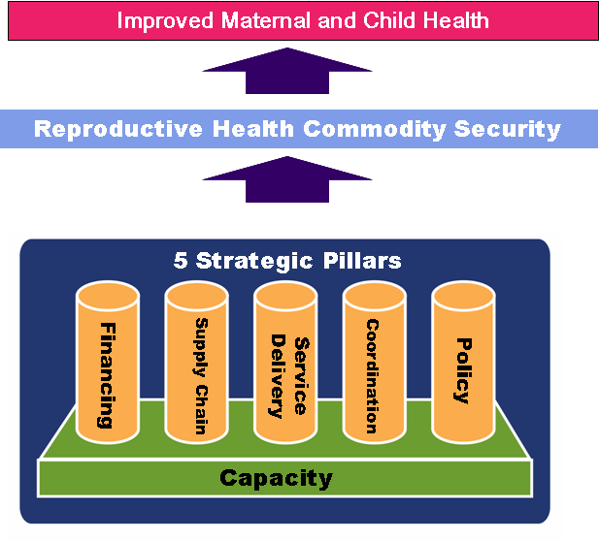
The framework identifies the different elements that must be present in order to satisfy client demand for and use of reproductive health commodities. Working from top to bottom, the logic is as follows: the MOPHP is committed to improving maternal and child health in the country. RHCS is a key condition for achieving these long term goals. In Yemen, the achievement of RHCS requires adequate financing, a rigorous supply chain, quality services delivery, coordinated partnerships, effective advocacy and an enabling policy environment. Each of these components requires strong, sustainable capacity. These terms are complex in that they cover more than one topic, so that

  - Financing includes forecasting, financial management capacity, and funding (including mobilizing and allocating resources from donor and Yemeni sources).

  - Supply chain includes product selection and procurement, the storage and distribution of quality products, and a functioning logistics management information systems (LMIS).

  - Service delivery considers both facility-based and community-based reproductive health/family planning (RH/FP) services and includes staffing patterns and numbers.

  - Coordination examines the effectiveness of MOPHP’s relationships with the key partners including the private sector, non-government organizations (NGOs), and development partners.

  - Advocacy and policy concerns the ability of MOPHP and other stakeholders to provide the policies and leadership required for persuading government and the public of the importance of the importance of RHCS

Finally, capacity, or the ability to work effectively for enacting and implementing the other determinants, underlies the whole scheme.

Assessment Activities and Products
The assessment visit which took place in May and June 2007 included the following specific activities:
- Literature Review: A comprehensive literature review was conducted on the health sector situation, the MOPHP Population and RH program, and various other components of RHCS in Yemen. All of the documents obtained and reviewed are listed in the References.
- Key Stakeholder Interviews: The in-country visit included interviews with representatives from the Ministry of Health, United States Agency for International Development (USAID) and United Nations Population Fund (UNFPA), NGOs, and the private sector (see Appendix 1 for list of interviewees). These interviews provided many of the essential observations that are reported throughout this assessment.
- Forecast of Future Contraceptive Needs: The team also prepared a forecast of contraceptive needs for 2007 to 2011 based on demographic and programmatic information.

Consultants relied on a diagnostic guide for this assessment which is organized according to the key RHCS components and reflects the Yemeni context. The guide provides a series of questions and tables to help assess the current situation and make future projections.

Context
Yemen faces many challenges in the context of health and specifically reproductive health. Poverty, closely spaced pregnancies, and low health awareness all combine to compare the country unfavorably with other countries in the region. Communicable diseases such as malaria and tuberculosis are prevalent, particularly in rural areas. Also common are diarrheal diseases, malnutrition, acute respiratory infections, and complications of pregnancy. Population growth is among the highest in the world at 3.1% per year, adding an additional strain on the already stretched public health system. The contraceptive prevalence rate (CPR) is 23% among married women of reproductive age (MWRA). There are twice as many married women in Yemen with an unmet need for family planning as there are women currently using a method (modern or traditional). In addition, regional disparities are pronounced, with CPR in urban areas at 40.8% and only 17.6% in rural areas.

Figure 2: CPR and unmet need trends (1991 – 2003)
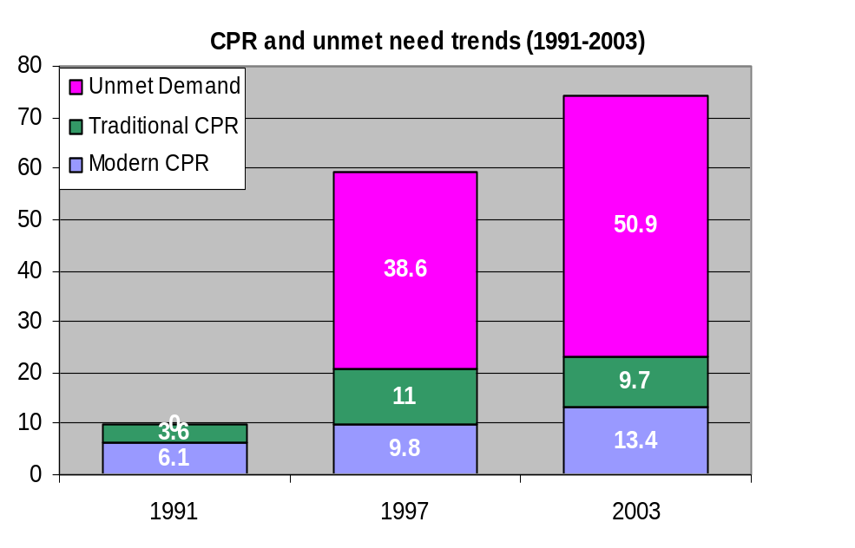
Source: Ministry of Public Health and Population, PAPFAM/Yemen Family Health Survey, 2003

Against this background, it is not surprising to find such discouraging results for important maternal and reproductive health indicators such as a total fertility rate of 6.2, and a maternal mortality ratio (MMR) of 365 per 100,000 live births.
Figure 3: Total Fertility Trends (1991-2003)
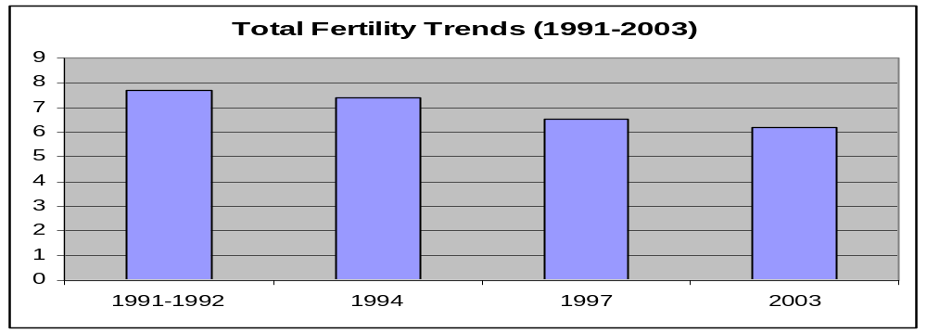
Source: 1991 (YDMCHS), 1994 (Census), 1997 (YDMCHS), 2003 (PAPFAM)

While Yemen is one of the poorest countries in the Middle East, it has recently experienced economic growth, due mainly to exploitation of recently discovered oil reserves. Since 1998, real growth in gross domestic product (GDP) has averaged about 4% annually, achieving a five-year growth rate of about 21% by 2003. This trend notwithstanding, government health spending per capita at $10.76, was only about one-third of total health expenditures with almost all of the remaining two-thirds coming from household expenditures in 2003. Though the government contribution is up from 25% in 1996, it remains one of the lowest in the region.

In 1978, the year of the Alma Ata Conference, Yemen adopted the Primary Health Care (PHC) approach to public health. To implement this approach, the government adopted a traditional facility-based, three-tier health delivery system composed of health units, health centers and hospitals. The system has been gradually expanding and geographical coverage has risen from 10% in 1970 to a theoretical 50% by 2000. The Central Statistics Office estimated that in 2003 there were 68 Hospitals, 112 Rural Hospitals, 569 Health Centers (151 with beds and 418 without beds), 2099 Primary Health Care Units and 438 Maternity Centers.
Table 1: Inventory of health facilities, 2001-2003
 | Hospitals | Rural Hosp | Health Centres W/ Beds | Health Centres w/o Beds | No of PHC units | Maternity Centres | Pharmacies & Drugstores
2001 | 74 | - | 139 | 432 | 1540 | 395 | 2205 | 2001
2002 | 74 | - | 139 | 536 | 1955 | 435 | 2278 | 2002
2003 | 68 | 112 | 151 | 418 | 2099 | 438 | 1952 | 2003
المصدر :مكاتب وزارة الصحة والاسكان بالمحافظات |  |  |  | Source: Offices of Ministry of Health & Population.
(…) لاتتوفر بيانات |  |  |  | (…) Unavailable Data.
(-) لاتوجد بيانات |  |  |  | (-) Never Data.
* مراكز الأمومة والطفولة هي نفس المراكز الصحية بدون أسرة وتؤدي نفس الخدمات |  |  |  | * Maternity Centers are same Health Centres without Bed.
** منها 20 وحدة صحية اولية مؤقتة |  |  |  | ** Provisional data
*** بعض المستشفيات لعام 2003م تم تصنيفها مستشفيات ريفية . |  |  |  | *** Some Hospitals in 2003 are Rural Hosp.

While coverage could be as high as 50% overall, it is estimated that only 30% in rural areas have access. MOPHP has also acknowledged that access is considerably lower when it is measured by real availability of services within health facilities, rather than the mere physical presence of facilities.

In qualitative terms, one MOPHP report has characterized the public sector system as “suffering from numerous structural and service delivery problems, including poor quality services, low staff morale, lack of essential drugs, inadequate operating budgets, under-utilization and leakage of resources.” The same report mentions lack of equity in distribution of facilities and human resources. Thus, despite the sizeable number of government health facilities, with human resources in place, lack of services in practice forces many patients to bypass them. One 1998 study found bypass rates of 42% to 73% for different areas studied.

A 1996 analysis of public health sector employees showed that between 50% and 80% of them received wages that placed them below the poverty level. This exacerbates the problems of workers diverting patients from government facilities to their private practices, and the practice of “under the table” payments within the public sector. Reported widely, though anecdotally, is diversion of drugs, including contraceptives, from the MOPHP distribution system, and their subsequent sale in the private sector. In light of these types of developments, it is not surprising to read that there is a concomitant issue of financial access to the public sector, with the poorest quartile of the population using public sector health facilities 35% to 65% less often than the top quartile. In terms of equity and serving those most in need, these percentages are the opposite of what they should be.

The private medical care sector has been developing rapidly in recent years, particularly in urban areas Data published in 2002 estimated that there were in the private sector 92 hospitals, 336 polyclinics, 114 health centers, 534 doctors’ offices and almost 2000 retail pharmacies. While the private sector may be an important and growing source of health services, key informants suggested that its contributions to family planning have thus far been limited. Furthermore, while low quality of care is an acknowledged problem in the public sector, it is also believed to be widespread in the largely unregulated private sector.

The private sector provides little in the way of such targeted services as family planning, antenatal care, or health education. The distribution of private sector facilities does little to alleviate problems of access, as they are often set up on the door steps of public sector facilities. A 1996/97 survey of four governorates found that those districts with the highest numbers of government facilities also had the highest numbers of private facilities, while those with the lowest numbers of government facilities contained the least number of private facilities. Finally, the private sector is essentially competing with the public sector for limited qualified health personnel.

Against this background of inadequate performance in both the public and private sectors, MOPHP is currently in the midst of a health sector review process. The Policy Unit within the MOPHP is guiding this process that is looking at coordination issues, roles and responsibilities and staffing patterns as well as opportunities for integration and decentralization. All of these aspects of reform have significant implications for RHCS.

Financing
Sustainable and consistent funding for contraceptives and other supplies is critically important as Yemen works towards increasing CPR and meeting existing demand. This section focuses on the capital required for assuring RHCS considering this important determinant in terms of its sources: public sector budget, donor assistance, and household spending. This section also looks at background information, trends, and patterns that provide insight on the government’s ability to meet future funding needs.

The last National Health Accounts (NHA) estimate was for the fiscal year 2003. While this information is for health generally, it does provide some understanding of the relative roles of public and private sector spending, as well as household contributions. It shows that private expenditures make up 65% of all expenditures on health. Of this private expenditure, household spending makes up an astounding 96%. In interpreting the importance of this contribution, however, it is important to remember that households are usually not inclined to spend their money on preventive services, including family planning.
Table 2: Government and Health Expenditure Indicators (2003)
Indicators | Value
Total expenditure on health as percentage of gross domestic product | 5.2%
Public health expenditure (% of GDP) | 1.8%
General government expenditure on health as percentage of total expenditure on health | 35%
Private expenditure on health as percentage of total expenditure on health | 65%
General government expenditure on health as percentage of total government expenditure | 4.9%
Out-of-pocket expenditure as percentage of private expenditure on health | 95.7%
Source: National Health Accounts team and Partners for Healthy Reformplus, “Yemen National Health Accounts: Estimate for 2003,” Republic of Yemen, Ministry of Public Health and Population, Sana’a 2006.

The findings highlight how little the government is contributing to health. This is particularly apparent when looking at Yemen compared to other countries in the region.
Figure 4: Health Financing Indicators, 2003
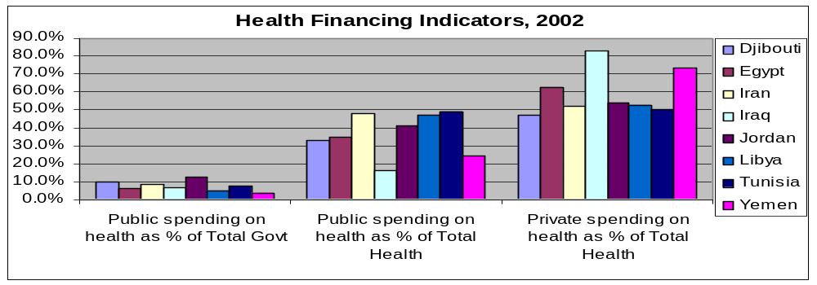
Source: National Health Accounts team and Partners for Healthy Reformplus, “Yemen National Health Accounts: Estimate for 2003,” Republic of Yemen, Ministry of Public Health and Population, Sana’a 2006.

The development of the 2003 NHA is a considerable achievement, and yet the general nature of the main findings also reminds us of the difficulty of obtaining detailed information on funding specific to family planning, contraceptives or reproductive health. It is for this reason that many discussions about family planning funding are specific to family planning commodity costs – as this is one component where the financial information is relatively easy to quantify.

Funding for Public Sector Contraceptives
Historically, funding for contraceptives has come from a variety of sources which have included the RNE, UNFPA, the World Bank, Department for International Development (DFID), the Social Fund for Development, and USAID. In Yemen at this time, there does not yet exist one reliable and consolidated source of information for different funders’ contributions. The consultant team relied on data provided by the different funding agencies, and in some cases even on the memories of staff for information. This introduces some confusion in the funding history and highlights the need for central MOPHP monitoring and management of funding. What we have been able to piece together for the period 2004 – 2008 is shown in Table 3, below.
Table 2: Funding trend for public sector contraceptives (US$)
 | 2001 | 2002 | 2003 | 2004 | 2005 | 2006 | 2007 | 2008
MOPHP |  |  |  |  |  |  | $105,820
Social Fund for Development |  |  |  | $200,000
NPC |  |  |  |  |  |  | In kind
UNFPA (Dutch) | $945,453 | $1,034,150 | $1,129,272 | $1,247,014 | $1,286,109 | $1,470,986 | $1,653,338
UNFPA (regular) |  |  |  |  | $248,561
DFID |  |  |  |  | $300,000
USAID |  |  |  | $100,000
World Bank |  |  |  | $600,000 | $200,000 |  |  | $2,500,000
GTZ |  |  |  | $63,500
TOTAL | $945,453 | $1,034,150 | $1,129,272 | $2,210,514 | $2,034,670 | $1,470,986 | $1,759,158 | $2,500,000
Source: UNFPA and Ministry of Public Health and Population

The table shows that historically the MOPHP has done an excellent job mobilizing resources to meet their requirements. However, due in part to development partner procedures, the Ministry is limited in its ability to conduct long term financial planning. As the table shows, RNE, through its contributions to the UNFPA trust fund, has been the main source of funds. In 2007, the World Bank committed approximately $2.5 million (US$) for commodity procurement. This funding and the procurement/shipment will have to be completed by the end of 2008.

The MOPHP Population Sector has indicated interest in committing internally generated funds to support the funding and procurement of RH including family planning commodities. They would like to model this effort on the positive experiences of the immunization program. In 2007, the Population Sector was allocated 35 million Yemeni Rial (YR) (~US Dollar 185,000) for reproductive health of which 14 million YR (~USD74,700) is to be dedicated to operational costs and the remaining 20 million YR (~USD105,820) is to be used for the procurement of family planning commodities. While it is evident that this amount only represents a small portion of the total public sector FP needs, it may indicate a trend for future (and perhaps) increasing funding. Because of the limited amount allocated to cover the Population Sector operating costs, the sector is advocating that the essential drug supply line item be used to fund the 20 million in family planning supplies. This would essentially free up this 20 million YR so that the Population Sector would be able to use these funds for operating costs.

Forecast Findings and Requirements
Typically, forecasting commodity requirements has been supported by UNFPA with some additional support from USAID. Although Population Sector staff play a role in forecasting, especially in terms of providing data, this role appears to be limited. One of the reasons for this is lack of forecasting skills.

As part of the RHCS framework development process, JSI consultants conducted an updated forecasting activity. The complete forecast is included in Appendix 2. The overall objective of the JSI supported forecasting activity was two-fold: 1) to estimate contraceptive requirements for MOPHP’s public sector program, and 2) to develop a procurement and re-supply plan for contraceptives for the next five-year period. Given that a primary goal of contraceptive security (CS) is to ensure that people can choose, obtain, and use a range of affordable contraceptive methods, it is essential to have an accurate national forecast and plan for re-supply quantities and shipment schedules to meet the national demand. As such, the quantification exercise focused on conducting an accurate estimation of the quantities of contraceptives needed to support the MOPHP’s family planning program (public sector) for the period of five years (June 2007 to the December 2011). The resulting demand forecast will allow the MOPHP to plan and maintain a full supply of contraceptives for all users and avoid gaps in the supply chain, as well as keep and manage established MOPHP inventory levels.

Ideally, a contraceptive forecasting exercise involves using historical logistics data to estimate future needs, validated by service statistics, adjusted to reflect program plans, and reality-checked against demographic data. Following a review of the quality and availability of data necessary for different forecasting methodologies, the JSI consultants determined that to develop a forecast estimating consumption using logistics data or service statistics data was inconsistent and unverifiable. Both of these methodologies use trends in historical data to predict future patterns of contraceptive consumption, and they can be highly reliable when data are timely, complete, and accurate. That not being the case in Yemen, we felt that that to provide the most appropriate forecast, it would be best to use a population data-based forecasting method using demographic data from the Family Health Survey and other sources of population and family planning data to estimate future contraceptive demand. The following table outlines the commodity needs through 2011. We strongly caution that demographic-based forecasts tend to be on the high side, and need to be carefully and frequently validated against logistics and service data as they become available. Furthermore, it bears underscoring that a demographic forecast is not a long-term procurement plan, but it is an estimate of future needs that can be very useful for strategic planning, logistics system design, resource mobilization, discussion around market dynamics, and long-range financial planning.
Table 3: Five-Year Forecast in Units – MOPHP
Summary of Total Contraceptive Need for Married Women of Reproductive Age (MWRA) in Union for the Public Sector | Units | 2007 | 2008 | 2009 | 2010 | 2011
Pills | Packs | 1,954,472 | 2,068,795 | 2,188,329 | 2,313,285 | 2,443,886
Microgynon (estimated at 61% of pill mix) | Packs | 1,192,228 | 1,261,965 | 1,334,881 | 1,411,104 | 1,490,770
Micronor (estimated at 39% of pill mix) | Packs | 762,244 | 806,830 | 853,448 | 902,181 | 953,115
IUDs | Pieces | 18,363 | 19,437 | 20,560 | 21,734 | 22,961
Injectables (Megestron + Syringe) | Vials | 99,939 | 105,785 | 111,897 | 118,287 | 124,965
Condoms | Pieces | 235,374 | 249,142 | 263,537 | 278,586 | 294,314
Implants | Sets | 1,080 | 1,143 | 1,209 | 1,278 | 1,351

The table below translates the contraceptive requirements into financial requirements. These estimates are based on UNFPA prices. Funding is available to meet the 2008 requirements through the World Bank contributions. As noted above, however, thus far commitments have been made on a yearly basis, leaving the Population Sector in a position in which future funding and the security of the contraceptive supply are uncertain.
Table 4: Estimated MOPHP Contraceptive Financing Requirements
 | 2007 | 2008 | 2009 | 2010 | 2011
Pill Requirements
Microgynon (estimated at 61% of pill mix) | $ 298,057 | $ 315,491 | $ 333,720 | $ 352,776 | $ 372,693
Micronor (estimated at 39% of pill mix) | $ 343,010 | $ 363,074 | $ 384,052 | $ 405,982 | $ 428,902
IUD Requirements | $ 4,591 | $ 4,859 | $ 5,140 | $ 5,433 | $ 5,740
Injectable Requirements | $ 100,939 | $ 106,843 | $ 113,016 | $ 119,469 | $ 126,214
Condom Requirements | $ 5,178 | $ 5,481 | $ 5,798 | $ 6,129 | $ 6,475
Implant Requirements | $ 22,683 | $ 24,010 | $ 25,397 | $ 26,848 | $ 28,363
Total MOPHP | $ 774,457 | $ 819,758 | $ 867,123 | $ 916,637 | $ 968,387
Total MOPHP (incl. 8% Shipping Cost) | $ 836,414 | $ 885,339 | $ 936,493 | $ 989,968 | $ 1,045,858

The most striking finding that emerges from comparing tables 3 and 4, is the disparity between the projected value of contraceptives required for 2008 (USD 885,339) and the amount purchased with World Bank funds in 2007 (USD 2.5 million). The large amount of funding committed for 2007 is a unique occurrence. The World Bank funded “Health Reform Support Project” is expected to end in December 2007. The project was projected to have excess funding and program managers made the decision to allocate funds (USD2.5 million) for family planning commodity procurement. However, according to World Bank requirements, all funds will have to be disbursed and goods (i.e., family planning commodities) purchased must be received by the end of 2007.

Financial Management Process
In addition to funding limitations, there are a number of financial management processes and procedures that challenge MOPHP’s ability to manage and leverage required funding. Many of these barriers are not specific to reproductive health. However, they are contextual factors that will need to be addressed in order to improve the accountability and management of reproductive health funding. For example, the current MOPHP budget is organized according to established government-wide line items put forth by the Ministry of Finance. The current nomenclature does not reflect MOPHP functions nor does it allow for evidence-based budgeting and routine monitoring and management, which greatly constrains the Population Sector’s ability to respond to specific needs in a timely manner. It also results in specific line items (for example, Research) being unspent. Currently, the Policy Division, the Population Sector, and other internal MOPHP stakeholders are advocating for changes in the budget structure to better reflect MOPHP’s overall needs.

The lack of clarity in roles and authority for decision making further challenges the efficient financial management of the reproductive health program. For example, it does not appear that any one position is responsible for monitoring and managing the various sources of funding for contraceptives. The above table highlights this issue as the information is gleaned from numerous sources and likely includes gaps and errors. Without the management of this information, it is difficult to reliably lobby for funding and plan for supplies.

With health sector reform, additional challenges may develop. For example, governorate level budgets will have to be carefully coordinated and planned with the central level. Furthermore, if family planning and reproductive health are integrated into an essential drugs package in terms of financing, there is a real threat that it may not be given priority. Managers will be increasingly called on to make difficult decisions regarding allocation of limited funding. Global experience suggests that such decisions are not likely to prioritize preventive services and supplies such as family planning.

Similarly, as the current example and experience from other countries highlight, using internally generated funds raises an additional set of challenges. Most notably, the release of funding is often unpredictable in terms of timing and amounts. In 2007, the Population Sector has already experienced this challenge. According to stakeholders, the Population Sector received 35 million YR for operating costs and the procurement of contraceptives. However, there appeared to be no formal understanding of either the funding amount or the process for allocation and disbursement. As a result, those who are key sources of information for procurement plans and needs did not know that the MOPHP was engaging in their own procurement. In addition, the release of the operating budget appears to be a lengthy and challenging process.

Maximizing Resources
An important strategy for RHCS is improving efficiency of available resources to stretch limited budgets further. Some key areas where it may be possible to make efficiency improvements are:
- Improved monitoring and management of existing financial resources;
- Understanding the cost implications of RH program goals;
- Streamlining procurement and customs operations; and
- Engaging the total market in achieving national goals.

Financial management
As indicated above, there are a number of challenges that limit the MOPHP’s ability to effectively manage the funding requirements and budgets for the RH program. Most notably, there is lack of clarity in terms of who has the authority and capacity to make decisions and the current budget structure is not conducive to results based management of the RH program.
MOPHP has limited capacity to reliably determine funding requirements. For example, there is limited internal capacity to forecast for RH commodity requirements without outside assistance. In addition, the MOPHP Population Sector has no clear financial sustainability plan that outlines long-term funding requirements. In other countries, such plans have been helpful for identifying funding gaps and providing bases from which to advocate for more resources. Such advocacy takes place at a number of levels including the MOPHP, the Ministry of Finance, the Ministry of Planning and, not least, with donors. It would also hold stakeholders accountable to certain commitments and help coordinate support from varying sources to prevent redundancy and gaps.

Cost implications of RH policies and goals
The MOPHP is currently drafting an RH Strategy for 2006 – 10. Within this strategy, the Ministry establishes ambitious goals and objectives. For example, the MOPHP expects to increase CPR to 35%, increase the percentage of health facilities providing quality family planning service, improve the coverage of remote areas, improve statistics, and reduce stock outs.
While these objectives are critical in addressing the current and future needs of clients and will directly contribute to larger national goals, each has financial implications and will require investment in training, the logistics system, and other RH components. Similarly, many stakeholders have discussed the need to expand the method mix and to increase access to IUDs. While such a strategy will require upfront capital investment in training and demand creation activities, in terms of commodity costs it may allow the government to maximize resources. While choice should never be compromised, it is important for the MOPHP to understand the cost implications of varying method mix scenarios and the financial requirements of the methods in the mix. The graph below shows how a hypothetical increase in the use of injectables and a corresponding decrease in the use of IUDs would result in an estimated USD 3.6 million in additional procurement costs over 10 years.
Figure 5: Commodity Cost Scenarios Associated with IUDs vs Implants
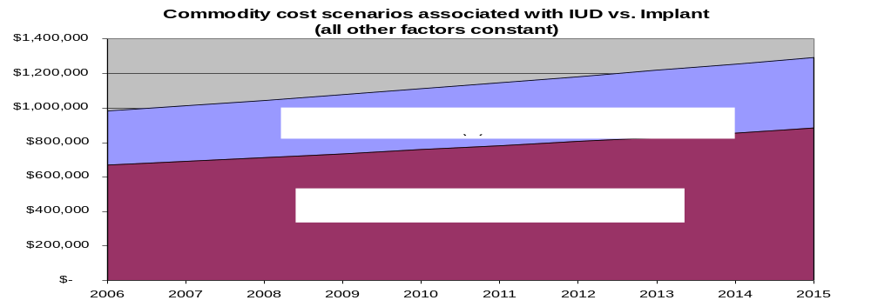
Similarly, in August 2006, there was a ministerial decree establishing family planning products and services as free. This policy action is deemed an important step in reducing access barriers for clients. However, as of yet, it does not appear the government has considered the follow-up actions required for this decree to be effective. Thus far, it does not appear that this policy change has been widely disseminated to the community level and therefore it is not reaching the intended beneficiaries of this change – the current and potential users of contraceptives. Again, upfront capital investment is required to inform clients and educate service providers. Global experience suggests that eliminating service product fees may bring an increase in demand, and this, in turn, will require additional funding for contraceptives as well as for logistics and service provider capacity.

Procurement and customs
As the government relies on external support for the provision of family planning supplies, procurement is currently done through these respective donor mechanisms. However, there still remains a need to coordinate these varying procurements, and to have procurement planning and program management staff who are trained to comply with different funders’ regulations, such as the stringent rules for World Bank-financed procurement in the health sector.

Total market approach
The draft Reproductive Health Strategy endorses collaboration with the private sector, and uses the term “total market approach.” However, as one report notes, the “role of the private sector either as a partner to, or agent for, the public health sector remains largely unexploited. Such linkages that do exist are informal and largely unregulated, and are characterized by an extensive satellite network of pseudo private services, owned or operated by public sector employees. Considerable resources are expended by households on private services of unproven quality and cost effectiveness.”

The private and NGO sectors are important contributors to national RH goals. They are equally important in reducing the financial and resource burden on the government to reach these goals. While the government has taken some steps to engage the NGO and private sectors through such things as training of and waiving of customs for socially marketed products, it does not appear to be a well delineated or coordinated strategy. Such a strategy would help rationalize markets and reduce overlap.

In further examining the total market, it appears that the true commercial sector may not be optimally tapped. Engaging this sector could further diversify and expand the coverage and availability of contraceptives. The primary goal of such a strategy would likely provide increased access to services and choices to those with the ability and willingness to pay. It would also help rationalize the public sector’s limited resources, allowing the public sector to focus more intensively on the poor and underserved.

Many of the opportunities to better tap into the comparative advantages of the various private sector channels are method specific. For example, there is likely not a significant market for female sterilization in the private sector both because of the costs and skill required for such a method as well as the limited number of acceptors of this method (CPR for female sterilization = 1.7%). However, there may be significant private sector market potential for pills with examples of success generated in numerous countries. In Yemen, pills are the most popular modern method (CPR= 6.3%) and the skill required for resupplying them is relatively modest. Furthermore, there appears to be moderate gain in the pill market for subsidized socially marketed pills. Social marketing helps transition users and prime the market for the true private sector. To date, it appears that the true private sector has not seen such positive results. One stakeholder reported that due to poor uptake, Wyeth has stopped distributing family planning products. While this may be due to a lack of existing demand or income for the true commercial sector, it may also be due to the fact that the leakage from the public sector is seriously undermining any potential growth for the private.

The figure below shows the current source mix as well as the mix with an increase in private sector provision of pills using the current CPR and illustrates the cost savings for the government. In this scenario, increased reliance on private sector channels for providing oral contraceptives would produce a savings to the public sector of USD 3.3 million over ten years. This savings only reflects commodity costs. There would also likely be a savings in terms of service provider time. In serving fewer clients for resupply methods, public sector providers would presumably have more time to dedicate to other responsibilities (i.e., outreach, counseling on long acting permanent methods (LAPM), etc.).
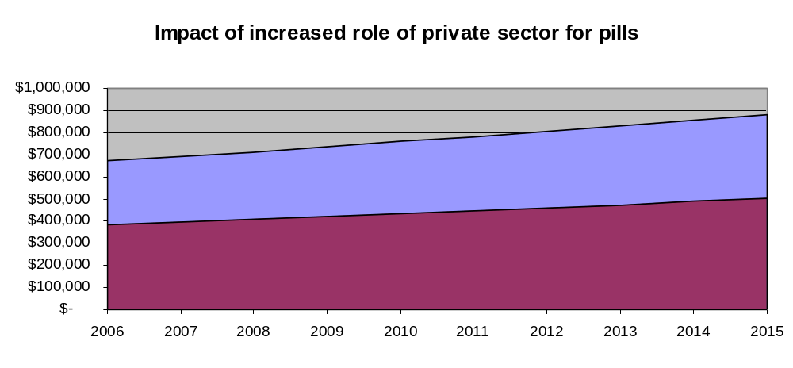Figure 6: Impact of increased role of private sector pills
Cost associated with increased private sector source of pills (public sector: 25%)
Cost associated with constant source mix for pills (public sector: 52%)

SUPPLY CHAIN MANAGEMENT

This discussion covers the management and distribution of reproductive health commodities including contraceptives. We base the assessment on the key elements of a functioning logistics cycle as shown below:
Figure 7: Logistics Cycle
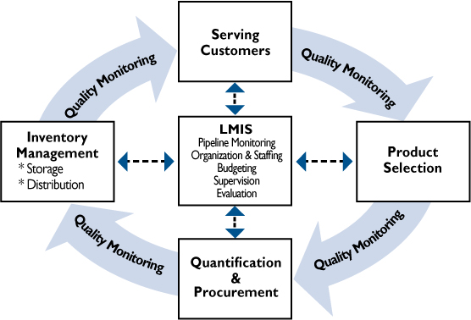

Source: USAID | DELIVER Project

According to the 2003 Yemen Family Health Survey, the majority of family planning users rely on the MOPHP as their source for contraceptives. It is therefore not surprising that the MOPHP system is of most concern to the Population Sector. As such, most of the discussion in this section is dedicated to the public sector’s logistics function with less attention on the Yemen Family Care Association (YFCA) and the Social Marketing Project (SMP) systems.

For the public sector, we review the intended design of the logistics system as compared to how the system is actually working in practice.

Ministry of Public Health and Population

Structure
The figure below shows the structure of the MOPHP distribution system.
Figure 8: Diagram of Public Sector Contraceptive Distribution System
Central Level
Ministry of Public Health & Population
Governorate Health Office (GHO)
District Health Office (DHO) Stores
Health Center (HC)
Health Unit (HU)
District Hospital (DH)
Government Hospital
Client
Source: Ministry of Public Health and Population, Manual of GHO Contraceptives Supply System

To give a sense of the breadth of the logistics system, we note that below the central level there are 21 governorates and 336 districts. The system of central, governorate and district storage facilities is intended to serve as a network of almost 3,000 health facilities.
The system consists of customs plus four tiers of storage. The tiers are the central warehouse, governorate storage facilities, district storage facilities, and the health facilities. For all levels below central, we use the term “storage facilities” rather than “warehouse” because these sites vary in nature, some being small warehouses, some storerooms and some just cabinets or drawers.
According to a translated version of the Manual of System of the Governorate Health Office (GHO) Contraceptive Supply, contraceptives are ordered using the “requisition and supply” form. Commodities are intended to be issued every 6 months from the central to governorate level, and every three months from both the governorate level and district level. The current system design includes safety stocks with a minimum pipeline of 19 months and a maximum of 33. For each tier, the min/max levels are set at 9/15 months for the central level, 5/9 for governorates, 3/6 for districts and 3/2 for facilities. These levels are extremely high and lead to very expensive pipelines, with more storage space required, more materials handling, and more cash tied up in inventory than may be necessary.
The manual details the role of the supervisor with respect to logistics. Specifically, the manual indicates that the supervisor’s role is to “deliver” contraceptives, collect information, reports and specify needs for contraceptives, train staff and provide feedback information.

Function
Before discussing specific findings, we urge readers to bear in mind the following: the responsibility of assuring the supply of contraceptives to almost 3,000 health facilities is immense. Most staff with logistics responsibilities have never received the training, equipment, money, and other resources that are required for operating an effective logistics system. Many have performed respectably under the circumstances and it is a wonder that the situation is not worse.

We are fortunate to have as a resource three surveys carried out by MOPHP in collaboration with UNFPA, GTZ, and USAID within the last three years. Taken together they provide a good picture of the contraceptive logistics system as it actually functions within the MOPHP system today. It is not surprising that the findings are very similar, and it is not necessary to consider all three in detail. The discussion that follows is based primarily on the GTZ study. Where there are contrasts or additional findings from the other two studies, we add these in. The GTZ study was conducted in August 2005. The findings are based on a purposive sample of 129 health facilities and storage sites in Abyan, Al Mahweet, Amran, Hajjah, Ibb, Marib, and Sana’a. The sample included 7 GHO warehouses, 32 district storage facilities, 29 district hospitals, 24 district capital-located health centers, 11 other health centers, and 30 health units.

This section also includes anecdotal evidence from a focus group discussion with Directors of Reproductive Health from seven governorates. These key informants represent governorates that include both districts that are donor supported as well as districts that are not supported. Invariably, the directors responded to questions concerning the functionality of the logistics system in two ways: one response described the donor supported districts while the other described a very different situation for those not supported by donors. In addition to characteristics of “haphazard” and “unfair mechanisms” for supply, the directors also suggested that it is difficult to manage the multiple systems.

Forecasting and financing
Forecasting and financing of supplies as part of the logistics system have been addressed in the Financing section of this assessment. However, it is worth noting that in addition to the financing needs related to commodities, there is also the issue of financing the logistics system itself. In many countries, all attention is focused on the cost of the product alone, while investment in these very important functions is often overlooked. Such things include customs clearance, storage, transport, inventory control, record keeping and reporting, and product quality assurance activities —all of which require financial support in addition to the cost of the product itself.

Procurement and product selection
According to stakeholders, only products on the National Essential Drug List and registered with the Supreme Drug Authority can be procured. For family planning, the EDL includes
- Ethinylestradiol/levonorgestrel (30/150 mcrgr)
- Ethinylestradiol/levonorgestrel (50/250 mcrgr)
- Norethisterone
- Copper containing intra-uterine device (IUD)
- Condom
- Spermicide

Neither implants nor injectables are included on this list. However, stakeholders report that product registration is a relatively fast process.

In the past, MOPHP has relied heavily on UNFPA to execute procurements. Experts brought in by UNFPA, and to a lesser extent USAID, have worked with the Population Sector staff to prepare the procurement quantities. UNFPA-Yemen then works with UNFPA’s central procurement to purchase the requested supplies. After the quantification is completed it takes about one month to plan to order and approximately two months for the order to be submitted to the shipper and confirmed, and finally about two months are needed for the product to reach Yemen. This gives a relatively short total lead time of five months. While nearly all contraceptives are purchased by outside agencies at this time, there is a plan to purchase both contraceptives and other RH supplies using internally generated funds (MOPHP, Social Fund, and National Population Council (NPC)). Unfortunately, we were unable to assess the capacity of the MOPHP’s procurement system, but it will be important to do so within the context of the RHCS framework. However, whether the MOPHP coordinates or conducts procurement, there is need for increased capacity and for the roles and responsibilities of this function to be clarified. Currently, it does not appear that there is one person/unit with the authority and capacity to take on this role. Similarly, it does not appear that there is a coordinating mechanism and indicators that such a person could and should use to monitor the status of these procurements. For example, in 2005 USAID donated pills for the RH program. However, the brand was inconsistent with those already in use and these contraceptives were rejected by consumers. Similarly, UNFPA is procuring using World Bank funds and is operating on the assumption that this procurement reflects the total supply for the public sector. However, the MOPHP has also received internally generated funds for procurement for 2007/2008. Although the status of this procurement is unclear, it would be important for this amount to be factored in when planning for the World Bank supported procurements. Furthermore, experience from other countries has shown that World Bank procedures can be very complicated. This further supports the need to build procurement management capacity within the MOPHP.

The process of customs clearance is currently not efficient, and is the subject of complaints by both the Population Sector and donors who reported problems including customs staff not being able to process documents written in English and the large number of signatures required. Clearance delays have been up to six months, which raises the problem of exorbitant demurrage fees. However, other programs are experiencing more positive results. For example, the expanded immunization program (EPI) developed interventions to specifically address the customs clearance issues. The program targeted customs staff in an effort to show them the value of vaccines and the importance of their role in vaccine program successes.

Storage
There appear to be widespread issues related to storage practices. The GTZ survey gathered data on 18 indicators of good storage. According to the survey, an overwhelming 121 (94%) health facilities and storage sites do not apply or know of the practice of First expiry, First out (FEFO). Other examples of problems with storage include the following: 82 (63%) sites had a store-in-charge who was not familiar with recommended storage conditions of different contraceptives; 38 (29%) storage sites were poorly kept (ex, not clean, free of debris); 51 (40%) did not have ventilation; and 20 (27%) did not have cabinets or shelves for storage. This was confirmed by Directors of Reproductive Health from seven governorates who said that some of their districts lack cabinets.

Not revealed by the surveys, but rather by interviews and a site visit, are pressing central level storage problems. The warehouse where incoming contraceptives are stored is clean and well equipped with pallets and racks and conditions have greatly improved. However, overall central storage arrangements are not satisfactory. The warehouse is now full from floor to ceiling. This existing store is rented, using funds available through UNFPA. It sometimes occurs that the landlord locks the premises, claiming that the rent is late. Occasionally in the recent past the electricity has been cut for the same reason. Of further concern is that consignments of contraceptives purchased with World Bank credits under the soon to expire Health Reform Support Project (HRSP)' are beginning to arrive and there is simply no space for them. World Bank staff have stated that there may be funds available to rent storage space for this incoming stock. However, it seems that the Population Sector has yet to start the process for facilitating this resource.

Several stakeholders mentioned the possibility of integrating family planning within the essential drug program. Essential drugs are now managed by the Drug Supply Department, which anecdotally appears to be limited in its operations. However, this program has a central warehouse, four regional ones, and storage facilities in most governorates. Although we were not able to further investigate, it is possible that these spaces could be of use for contraceptives.

Inventory management
The GTZ study did not directly describe the status of inventory management strategies such as “push/pull” systems or use of “safety stocks” or “min/max” levels. However, in a situation characterized by variable ordering/reporting periods, lengthy stockouts for most products, and staff who are not familiar with the system manual, it is difficult to imagine that a min/max system could work in these circumstances. The staff in charge of contraceptive logistics at central level have stated that they do not consider this aspect of the system design to be operational.

While it is a positive development that the current system design includes safety stocks, the levels that have been set are very high with a minimum pipeline of 21 months and a maximum of 32. In many countries it has been possible to operate on pipelines of 12 and 18 months respectively. This would greatly reduce inventory holding costs.

There are widespread problems with record keeping. The GTZ study assessed the completeness of record keeping using two methods. The first method was to compare the results of physical counts with entries in stock records. Taking into account all contraceptives in the mix, differences between the counts and the records were prevalent in almost all facilities visited. However, good record keeping was documented in at least five sites. The second method was to ask staff to locate all of the Mycrogynon within their facility. In fact at only 17 sites were staff unable to do so, and only half were able to state the correct amount in stock by consulting records.

Distribution
It is difficult to characterize the distribution component of the logistics system. The information available on quantities of contraceptives distributed by the MOPHP to the governorate level is relatively complete. In 2006, the system distributed to the governorate level 1,808,018 cycles of oral contraceptives, 906,268 condoms, 28,200 IUDs, 289 implants, 233,610 injectables and 763 vaginal foaming tablets (VFTs). However, issues data is not available below the governorate level and data from the three surveys, and from direct observation, make it clear the contraceptive distribution does not function as intended.

The tiers, or levels, of the system are linked by a variety of transport arrangements. According to the GTZ report, in almost all cases, including from the central store to the GHOs, it is the lower level (receiver) who picks up supplies as opposed to being delivered by the higher level. The means of transport is usually a rented car. In Abyan public transport is often used. When asked, staff at about one- third of sites stated that they would prefer to have stock delivered. Another third stated that they would prefer it if they received the funding to support the transport on a regular basis. Staff at eight sites stated that supplies should be delivered on supervisory visits. The preference for having stock delivered was highest at the relatively remote health units, with 21 of 30 (68%) of staff saying that this would work best for them. There is one seemingly positive outcome associated with requesters picking up their own supplies, that is, 110 or 85% of requesting sites have their stock in hand within one week of preparing their orders.

A mix of order intervals is used within governorates, with some sites ordering monthly and others ordering less frequently using periods of between one and three months. This means that for the system as a whole there is not a standard order interval, which makes it difficult to implement such concepts as buffer stocks and min/max levels, and this in turn makes it difficult to guarantee continuous stock availability. A visit to a health unit confirmed this as service providers described that they had no specific ordering period and that they “request when they are low.”

Not explicit in the GTZ study, but often described elsewhere anecdotally, are complaints that local budgets are not sufficient to cover the cost of transport for reproductive health products. Based on information provided by 101 sites, the average cost per transport between GHOs and lower level facilities is about YR 2,350 (~USD 12). Some donors are currently working with the MOPHP to develop and support distribution plans. The status of these efforts could not be determined during the assessment visit.

Because of the vertical nature of the health programs, it appears that many district and health facility staff tend to manage the transport and storage of the contraceptive separately from other stock. For example, it was reported that supplies from different programs such as EPI and family planning are delivered in separate vehicles to districts and health facilities, a practice that tends to increase overall transport costs – a further constraint given the limited transport budgets often cited as a main cause for infrequent supervisory and resupply visits.

Logistics management information system (LMIS)
Most sites report logistics data. This is a positive finding. The GTZ study found that 106 (82%) facilities did forward reports. About half of the reports are monthly and about half are quarterly. About 80% of the reports submitted contain data on numbers of clients served by method and/or quantities of individual contraceptives dispensed to users or issued from storage sites. These reports are handwritten. One obvious cause of concern is that, as previously indicated, stock records are often inaccurate, and this makes the quality and completeness of the data in the reports doubtful. Still, to conclude on a positive note, it does reflect well that such a high percentage of sites do report.

What actually happens to logistics reports is something of a mystery, and the GTZ study unfortunately sheds no light on this. At central level, logistics staff report that the only logistics information they have for governorate level or below is what the central level issues to the governorates. There is no information on issues and balances below the central level. Through the logistics information system no information on quantities of contraceptives dispensed to users rises to central level. However, dispensed to user data does reach the central level through the health management information system (HMIS) system, serving as the basis of many of the Logistics Unit’s decisions and management. However, because reporting rates for the HMIS information is not known, the confidence in this information is also questionable.

Despite the limitations in the types of logistics data that flow up through the distribution system, what is available at the top is aggregated and stored in an electronic database. Most available data have to do with receipts and balances at central level, plus issues from central level to governorate level. Central level logistics managers also track the status of incoming shipments, using information supplied by UNFPA. However, this does not appear to be routinely done nor do all the decision makers who need this information receive it.

Capacity and supervision
While training and supervision are not sufficient, there are some positive developments. The GTZ study found that for the sample as a whole, a high 87% of all staff interviewed said they were satisfied with the working environment in general. Furthermore, average duration in post was 6.6 years, meaning that staff turnover does not appear to be a major problem. Nested within these positive findings, however, is the fact that 83% of all staff interviewed felt that their knowledge of contraceptive logistics is insufficient to deal with the daily work.

Overall, only about 50% had ever received any training related to their responsibilities for managing contraceptives. Of those who had received training, less than 50% had received training for such tasks as ordering and receiving, storage, dispensing to clients, distributing to other facilities, calculating needs, and reporting. For dispensing and distributing the percentages were particularly low at 32% and 24% respectively. Although 77% of those interviewed felt they knew how to calculate contraceptive needs, less then 5% could correctly define such terms as “average monthly consumption” or “safety stock.”

Only about 30% of all facilities reported having ever received a supervisory visit. However, responses varied considerably between governorates. In Abyan, Ibb, and Marib, about 80% of facilities have received supervision specific to logistics. Only three of all facilities visited in Amran, Hajja, and Sana’a reported such supervision in only two to three facilities. At the health facilities level, almost all supervision comes from the GHO. Only eight facilities in the sample overall reported ever having received a supervisory visit from district level.

In response to identified weaknesses in logistics capacity, the Population Sector developed a system operations manual (“Manual of GHO Contraceptive Supply System”) and in 2004 had planned, in collaboration with UNFPA, to begin a nationwide training effort. The plan was not carried out. It also does not appear that the manual has been formally reviewed for quality and technical rigor. While not focusing exclusively on this aspect during our assessment, we were able to have the manual translated and can provide the following observations:

- While the manual is a “good start,” it does not appear that it is a fully developed, useful tool for the work place.
- It contains a good deal of useful information, including organograms and flow charts, job descriptions, forms, and problem solving exercises. It also has “trouble shooting” tables that give options for solving common problems.
- However, a serious shortcoming is that it does not yet effectively convey that contraceptive management is a recurring cycle of activities such as receiving, storing, controlling, issuing, ordering, and reporting.
- Although most of these topics are covered, the steps for the activities are not complete and in some cases they may be stated too briefly to be well understood.
- It does not appear that it would take significant effort or time to revise the current draft into a more useful manual. However, doing so should likely be a participatory approach to garner necessary input from all levels of the supply chain.

In addition to ensuring the quality of the content, the manual must be available for staff to use. According to the GTZ study, copies of the “Manual of GHO Contraceptive Supply System” were found in over half of the facilities visited. Most staff interviewed, however, were not familiar with it. For example, it was found in six of the seven GHO warehouses, but only two persons at that level were familiar with its contents. At the health unit level, four of the 30 (13%) sites visited had a copy, but no staff member interviewed was familiar with its contents.

In general, it appears that capacity is not addressed in a sustainable way. Currently, it appears that the donor-supported districts are receiving training and supervision while those that are not supported lack this attention. In addition, there appears to be no routine inclusion of logistics skills in the pre-service training for service providers.

Product availability
Product availability is a basic criterion for RH commodity security. The GTZ survey found that while contraceptive pills were available in more than 90% of facilities visited, they were not available at the time of visit in facilities in Amran, Sana’a, and Ibb. The male condom was not available in 15% of facilities in all governorates. Depo Provera was not available in 25% of visited facilities in Amran and Sana’a governorates and 37.5% in Hajjah. The IUD was not available at more than 60% of all facilities; implants were only available in one of the visited facilities in Abyan and Al-Mahweet and in only three facilities in Hajjah. Neither of these two contraceptives was available in all facilities at the time of visit. Very significantly, no facility had the complete contraceptive mix in stock.

The GTZ survey found stockouts for the six months preceding the survey in all governorates for Microgynon (mean 43 days) Micronor (40 days), for IUDs in Sana’a and Al Mahweed (48 days), and Depo Provera in Amran and Abyan (46 days).

In addition to the contraceptives and RH commodities, other supplies, equipment, and furniture are essential for quality RH/FP services. According to the GTZ survey, all governorates surveyed had facilities which did not have syringes to supply Depo Provera at the time of visit. A UNFPA assessment of maternal and neonatal health needs in which a total of 169 facilities were surveyed also examined the availability of these essential supplies. In the following table, we see that most of the sites were stocked out of IUD insertion (93%) and removal (95%) kits. Anecdotal evidence supported this finding and also highlighted a general lack of MVA equipment.
Table 6. Availability of equipments/furniture
 | HC (n= 52) |  | HU (n=67) |  | Total |  | NB
Item | Yes (%) | No (%) | Yes (%) | No (%) | Yes (%) | No (%)
Bed for IUD insertion | 12 | 88
IUD implant kit | 7 | 93
IUD removal unit | 5 | 95
Cupboard to keep contraceptive equipments and methods | 47 | 53 | 45 | 55 | 46 | 54
Container for sharp tools | 15 | 85 | 22 | 78 | 18 | 82
Source: UNFPA MNH assessment

Other Logistics Systems

Yemen Family Care Association
The Yemen Family Care Association (YFCA), the national affiliate of the International Planned Parenthood Federation (IPPF), introduced family planning and public service contraceptive distribution in the country in the 1970s. Currently, it receives product from UNFPA, IPPF, and Organon. YFCA receives approximately 20% of its supplies through the MOPHP.

In 2006, YFCA distributed 229,328 cycles of oral contraceptives, 17,995 condoms, 2166 IUDs, 851 injectables, and 948 VFTs. The volumes received from IPPF and Organon are not great. A grant from IPPF provides such items as VFTs and diaphragms, which support the YFCA’s desire to assure choice in its method mix.

YFCA stores its incoming supplies at its central storage facility and distributes them through 11 health facilities that it manages directly. According to the 2006 annual report, these facilities, in turn, redistribute to 76 additional facilities including sites managed by YFCA, MOPHP, and NGOs. However, YFCA staff have stated that their system ultimately reaches about 250 facilities, which means that there is redistribution taking place that is not reflected in the report .While we did not examine the operations of the distribution system, it is a positive indicator that YFCA tracks the quantities of different products distributed to and through its 11 centers, suggesting an LMIS that functions at least to the second tier of distribution.

Social Marketing Program
The Social Marketing Program (SMP) is implemented by Mary Stopes International with funding from Kreditanstalt fur Wiedraufbau (KFW). Using these funds, the country office purchases its own contraceptives. To do so, SMP uses international competitive tendering. Subsequently, YFCA sells the stock at moderate prices to local wholesalers. In 2006, the SMP sold 354,350 cycles of oral contraceptives, 739,699 condoms, and 17,499 IUDs. According to SMP, they target largely middle- and low-income consumers.

The SMP outsources storage and distribution management to a private company, NATCO, which distributes product through 186 wholesalers and 499 retail sales points. There are three classes of wholesalers with the largest ones having the capacity to deliver to rural areas, while the smallest are passive operations who serve those retailers who come to them. The project itself employs a team of detailers who promote the SMP brand – Protec – face-to-face to doctors, midwives, and retail pharmacies.

In Yemen, SMP regulates the prices of its drugs and commodities. The SMP price structure includes 10% mark-ups for the prime vendor and wholesalers, plus a 20-25% mark-up for retailers, depending on the product. In addition to managing distribution, NATCO also manages the return of revenues. SMP staff highlighted the issue of donated contraceptives leaking from the public sector and undermining their competitive position in the marketplace.

Service Delivery
Similar to many countries, Yemen is faced with human resource challenges in delivering health services to the population. These challenges are not only in having the right mix of trained service providers but also having those who have adequate skills to efficiently provide all RH/family planning services. While human resources is a cross-cutting issue and one that affects all health programs and disease burdens, this assessment examined the impact on family planning, specifically focusing on two key issues: staffing levels and patterns and the capacity of those staff in place. The draft RH Strategy has identified several approaches for addressing these issues, including:

- Increasing the percent of trained community midwives (CMWs) employed through the government, with priority given to remote areas.

- Increasing the number of trained FP service providers, especially female.

- Improving service providers’ skills in counseling and quality management.

- Implementing a policy for CMWs to insert IUDs.

- Routinely using data to monitor and manage service provision.

Staffing
The distribution of staff ranging from hospitals down to the health unit level shows a wide disparity in staffing patterns both in quantity and the range of skill levels in the public sector. As indicated in a survey of Yemeni midwives in five governorates, the cadre of staff at the lowest service delivery point (the health unit) is typically limited to community midwives and morshedas (female paramedical workers) and, to a lesser extent nurses and trained midwives.
Figure 9: Number of Cadre by Health Facilities Type

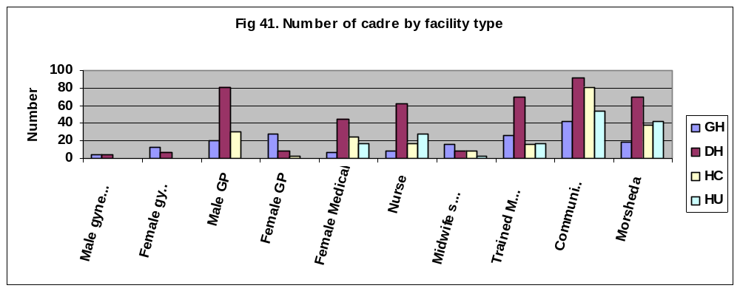
Source: UNFPA Needs Assessment of Maternal and Neonatal Health

Approximately 45% of health facilities in Yemen provide family planning services. In terms of the numbers of service providers available for family planning and reproductive health service provision, the country is showing improvements for several cadres of staff. According to the MOPHP (census figures), the numbers of medical assistants and qualified midwives have both increased from 2001 to 2003. However, the same data indicate that the number of qualified nurses has decreased.
Figure 10: Trends in numbers of health care providers
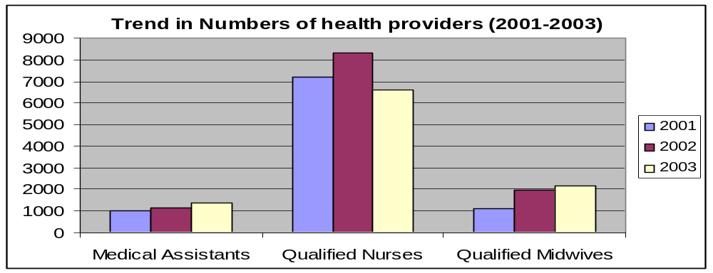
Source: CSO Health Statistics, Office of Ministry of Health and Population

For midwives, this trend is confirmed in a study of five governorates which indicates that there has been a dramatic increase in the numbers of graduates. However, a World Health Organization (WHO) study (2004) indicates that the number of midwives in Yemen is just .02 per 1,000 people.
Figure 11: Numbers of midwives in 5 governorates by graduation year

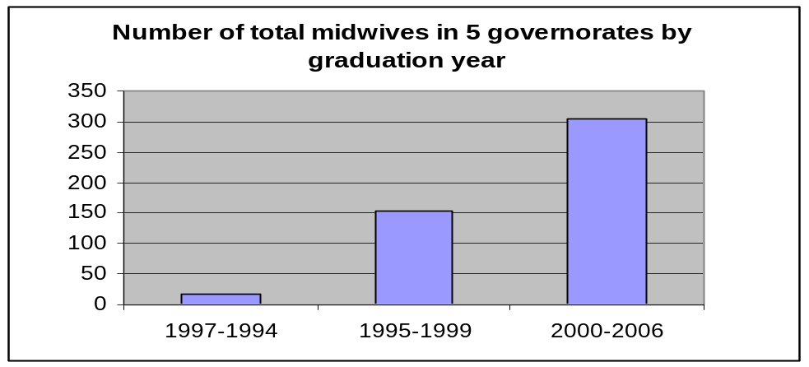
Source: Survey of Yemeni Midwives in targeted governorates, BHS Project, USAID.
As indicated, the national Family Health Survey reports that unmet demand for family planning is 41% in urban and 54% in rural areas. This disparity suggests that the high unmet demand for family planning in rural areas may be due to insufficient numbers and inadequately devolved staffing patterns.

Several projects are working in partnership with the MOPHP to increase coverage of family planning services in rural areas. Community-based distribution (CBD) of family planning was piloted by the YG-RHP in 17 villages in eight districts in five governorates. In this two-year pilot, 34 CBD volunteers were recruited, trained, supervised and provided with a tool kit (containing behavior change communication (BCC), referral cards, and supply of combined oral contraceptives (COC), progestin only pills (POP), condoms, and clean delivery kits).

The strategy of deploying CBDs is a proven model throughout the world and is an effective means of increasing FP access to hard to reach or rural populations reducing barriers (i.e., geographical, cost, transport) to uptake. The initial findings from the pilot show some positive results. However, again borrowing from international experience, the sustainability and quality aspects should not be overlooked as there is ongoing need for refresher training and close ties with health facilities through active supervisory links. Furthermore, the costs associated with this project were great and unless strategies are adopted to lessen the level of investment required, it may prove too costly in reality for replication and scale up.

The draft RH Strategy highlights the importance of increasing access and coverage to family planning by enabling CMWs to insert IUDs. While ensuring that supportive legislation and regulations are in place is a policy function, there will also be a need to roll out a training for this cadre once this policy has been changed. Similarly, there may be opposition to this devolution among higher cadre of staff. IUD insertion and removal are often sources of revenue for public and private sector doctors and nurses and therefore these service providers may resist devolving this function to CMWs. Furthermore, as seen in the product and equipment availability section, numerous sites already lack the equipment needed for insertion and removal. This is an important consideration when selecting and training CMWs in IUDs.

Quality of Care
In addition to staffing patterns, the quality of service provided at MOPHP facilities may also be a contributing factor to unmet demand. This is discussed below in terms of training, supervision, and sources of service.

Training
The recent study in five governorates indicates that the percentage of staff trained in family planning was low for all cadres of staff. Overall, only about half of all health workers are trained in family planning.
Figure 12: Percent of staff trained in infection prevention and family planning
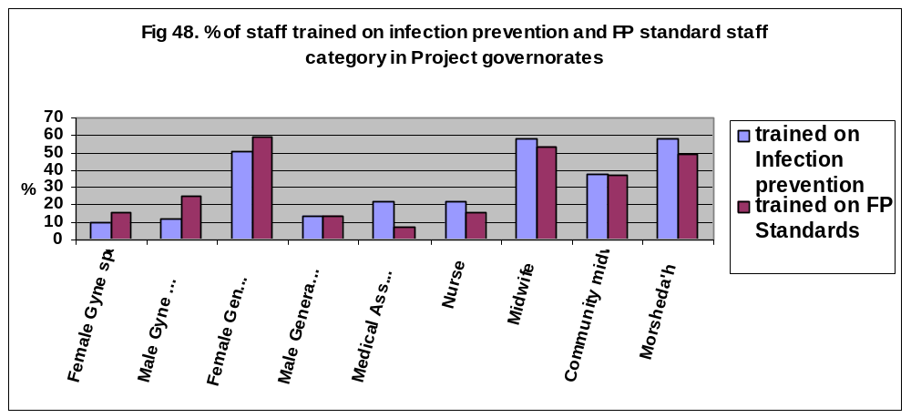
Source: UNFPA Needs Assessment in Maternal and Neonatal Health

Informants report that clients bypass the lower level health facilities because they lack confidence in the skills or in the assurance of product availability. A 1998 study found bypass rates of 42% to 73% for different areas studied. In addition to imposing significant geographic barriers and constraints on the client, this is also an indication of the perception (whether true or not) of poor quality services. Outreach and client-focused strategies are important ways to change these perceptions.

Similarly, according to the most recent Family Health Survey, side effects are a main reason reported for non-use of family planning. Again, client perceptions are an important indicator for training needs. This is supported by anecdotal evidence from informants indicating that service providers themselves harbor myths and misconceptions about certain methods and this information is often transferred to the community. Many stakeholders advocated for refresher training that focuses on Contraceptive Technology updates and counseling to address these issues.

With the existence of numerous projects focused on select districts, training interventions have thus far appeared to be ad hoc, limited in scope, and dictated by donor project interests. Again due to lack of resources and capacity at the central level, there does not appear to be a comprehensive national training plan which prioritizes needs, coordinates inputs, standardizes strategies and, finally, links service delivery directly to the logistics system.

Supervision and Guidelines
Supervision and routine on-the-job training are important strategies for capacity building and quality assurance. They serve to provide health providers with feedback on their performance and allow supervisors to monitor problems and resolve issues in a timely manner. As mentioned, inadequate staffing levels obviously also inhibit adequate supervision. Interviews with health facility staff and other stakeholders revealed that supervision does take place but is often infrequent due to limited transport and time. Supervision specific to RH/FP is also limited due to the vertical nature of programs and is typically focused on sites within the donors’ “supported” districts. It was reported that higher level staff combine supervision with distribution of commodities – so if district or governorate staff are delivering vaccines, they focus their feedback on the immunization functions of the site. The Midwives Survey also noted that most care providers had stated that the limited number of supervisory visits they had received were always from the governorate level and never from the districts. Financially and logistically, it will never be possible to achieve adequate coverage from the governorate level and the general tendency for district health offices not to supervise needs to be corrected.

The Population Sector is currently updating the National FP Guidelines. At present, the guidelines include by five manuals: Criteria for Family Planning Services, Manual for the Supply System, Manual for Referral of Family Planning Services, Manual for Education and Communications, and Manual for Preventing Infections. The graph below shows the availability of the existing standards and guidelines by governorate. Availability differs according to health facility type with lower levels of the health system having less availability of these standards than the higher level facilities. For example, only 17% of health centers and 24% of health units have the Manual for Referral.
Figure 13: Availability of Services’ Standards in Five Governorates
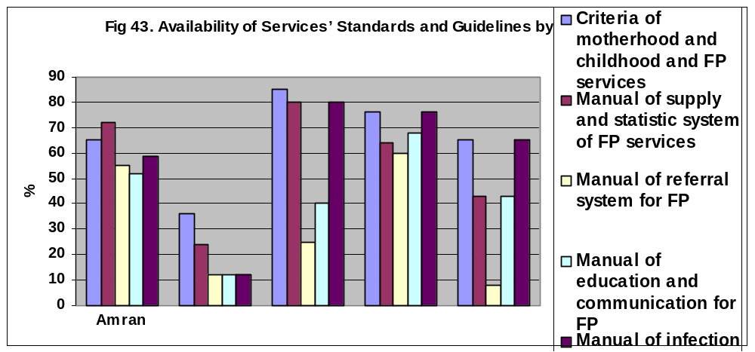
Source: UNFPA Needs Assessment of Maternal and Neonatal Health

Source of service and contraceptives
The private sector has an important role to play in increasing access to quality service provision. According to the most recent national survey, the public sector is the major source of supply with 52% of all MWRA relying on the public sector, followed by NGO/private doctors/hospitals (22%), and pharmacies (21%). Similarly, by method, the public sector serves as the major source for all methods but condoms whose users rely largely on pharmacies. Pharmacies are also a significant source for pills (33%) and this may represent a growing market for pills (as the source of both pure private and socially marketed pills).
Figure 14: Sources of Supply
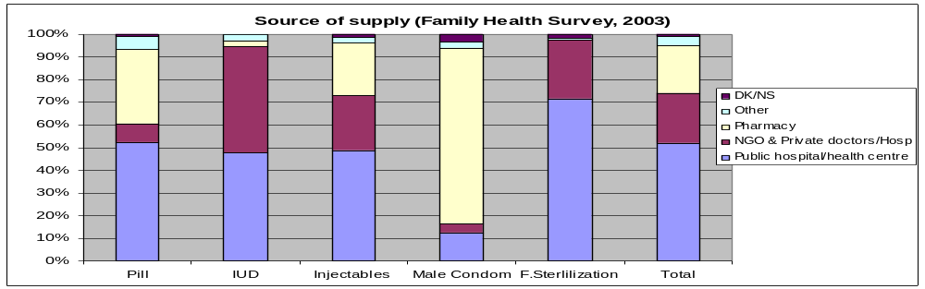
Source: Ministry of Public Health and Population PAPFAM. March 20, 2005. Summary Report of the Yemen Family Health Survey 2003, Draft 20.

Marie Stopes and YFCA have mandates to provide additional sources of service and supply delivery for the client. Marie Stopes as part of the Yemen-German Reproductive Health (YRH) Program focuses on increasing service and supply provision through the private sector. Interventions focus on training and counseling skills targeting public service providers (knowing that many also have private services), pharmacy workers and drug retailers. Marie Stopes also conducts research to better understand client knowledge, attitudes and practices, and develops behavior change interventions and information, education, and communication (IEC) campaigns. Because these IEC campaigns on radio and TV are generic in their messaging, they serve to raise the general awareness of the public.

The IPPF affiliate, Yemen Family Care Association (YFCA), is a well known NGO. YFCA was the first public service organization to distribute contraceptives in Yemen. Currently, they reach a reported 250 sites nationwide, through a network of fixed and mobile clinics. YFCA provides maternal and child health (MCH) and RH services including adolescent sexual and reproductive health (ASRH) and post-abortion care (PAC) and have implemented community-based distribution activities. They also provide training of trainers activities focusing on HIV/AIDS awareness.

Coordination and Partnerships
In common with most other public health activities, forward progress in RHCS depends heavily on collaboration between individuals and organizations. When the term “partner” is used in a development context, most people think first of the international partners, or donors, that work with ministries of health to support mutually agreed upon activities. Given the importance of these partners as investors and technical innovators, this is natural, but donors are not the only partners that contribute to RHCS, and in many ways they are not even the most important ones. Other partners – active or potential – include:

- MOPHP central level units outside the Population Sector, such as the Directorates General of Finance, Planning, and Primary Health Care.

- Intersectoral bodies such as the Ministries of Financing and Planning, both of which influence the resources that can be made available to the Population Sector and RHCS.

- International development partners including UN agencies, development banks, and bilateral donors.

- Governorate Health Offices and District Health Management Teams, and through them, ultimately health care providers and communities.

- MOPHP programs and units at any level that are involved in logistics and may be candidates for sharing such resources as storage space, transport or information.

- Other service providers that could contribute to improving RHCS such as the Yemeni Population Council, the Yemen Family Care Association, the Yemeni Midwives Association, pharmacies, and private clinics.

Below we briefly discuss the effectiveness of these organizations in coordinating and partnering and attempt to identify gaps or weaknesses in coordination efforts.

Ministry of Public Health and Population
According to Article 23 of the “Organizational Bylaws of the Ministry of Public Health and Population” for 2004, the General Directorate of Reproductive Health is responsible for, among other components, coordination with partners and stakeholders. Due to the nature of RH services as well as the strategies adopted by the Population Sector, there is need to coordinate and collaborate with numerous partners.
Figure 15: Organogram of the Ministry of Public Health and Population

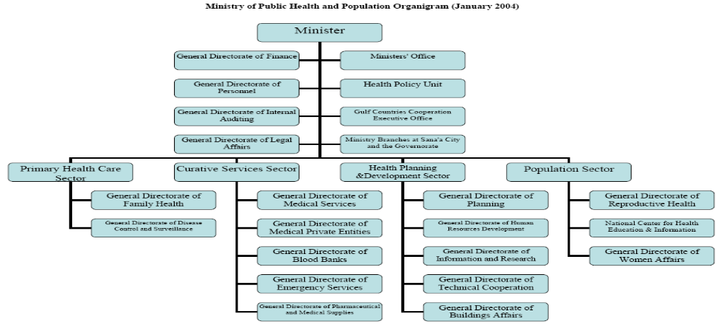
Source: Organizational Bylaws of the Ministry of Public Health and Population

As seen in the organogram above, within the MOPHP, the Population Sector must collaborate programmatically with the other sectors: primary health, curative (especially related to the Medical Private Entities, emergency services, and pharmaceutical and medical supplies), and health planning and development. In addition, there is obvious need to work closely with other units, specifically, those of finance, policy, and personnel. In the course of this section, we will see that in some cases the Population Sector has been a very effective coordinator, while in other cases, less so.

Coordinating mechanisms
The need for collaboration among these and other key stakeholders has been identified and resulted in the development of Terms of Reference for a Reproductive Health Steering Committee (RHSC). According to the TOR, the RHSC is supposed to be a high level group that meets twice a year to oversee population program issues and contributions, policy and strategy guidance, harmonize efforts, and “Strengthen inter-sectoral coordination and cooperation among different ministries and intra-sectoral coordination and cooperation within the different sectors and departments of the MOPHP”. Membership includes key ministries (i.e., Finance, Social Affairs, Religious Affairs, Information, and Education) as well as the National Population Council, High Council for Motherhood and Childhood (HCMC), Yemeni Women Association, Social Fund for Development, a representative of the Health and Population Committee at the Parliament, the Higher Institute for Health Sciences, donors and others. According to stakeholders, this Committee does not meet as scheduled and its impact, if any, is difficult to assess.

However, a more technical group that mirrors the RHSC mandate is active. The Population Sector chairs the Reproductive Health Working Group (RHWG), a seemingly open forum that meets monthly under the guidance of the Population Sector. In addition to routine discussions, this group establishes subgroups as needed. To facilitate coordination, the RHWG has produced a spreadsheet-based map of RH activities that shows the types of programs that various partners support at both central level and by governorate. Activities are grouped under the following main headings: Institutional and Human Capacity Building, Norms and Regulations, Service Delivery, Reproductive Health Commodity Security, and Behavior Change Communication. The map, which seems to be an effective coordination tool, is periodically revised; the latest edition is dated March 2007.

The RHWG does appear to meet routinely, and in some cases, forward motion on pending activities appears to be good. This has been the case with the commitment of funding for contraceptive procurements and the development and approval of the RHCS terms of reference (TOR). In other cases, however, the RHWG appears to be unable to overcome bureaucratic delays, as has apparently been the case with the seemingly simple need to print Reproductive Health Registers. This item appeared on the agenda February 2007, only to be brought up again and discussed at length again in June, with little movement in between. The RHWG meetings also appear to focus largely on topics of immediate interest with more routine issues seeming to fall off the agenda. For example, the RHWG would seem to be an ideal venue for sharing and coordinating routinely collected data on funding (commitments, allocations, and disbursements), procurement (shipment schedules and amounts as well as storage issues), and logistics and service statistics.

International Development Partners
A number of international development partners currently work in reproductive health. These include UNFPA, UNICEF, World Bank, the European Union (EU), GTZ, KFW, RNE, DFID, and USAID. These partners appear to value and support the Population Sector’s role in coordination and oversight of the reproductive health programs. As noted above, some of them are very active in the RHWG, have developed coordinating mechanisms such as the partner matrix and, for the most part, understand the value and contribution the respective partners play and make efforts to share information and coordinate strategies. However, according to MOPHP staff at both central and governorate levels, it is also the case that some of the donor partners bypass the national systems and central level management in their support to governorates. This tends to create redundancies in systems and gaps and overlaps in strategies and target areas. For example, some have reported that the donor practice of focusing on selected districts has in some cases led to the creation of divergent logistics systems in “supported” and “unsupported” districts, a practice that has increased work loads, complicated planning and management, and created perceptions of inequity.

Governorate Health Offices and District Health Management Teams
Regardless of what planning takes place at the central level, RHCS will produce no impact independently of governorate and district inputs. This would be true in any case, but the importance of the fact is re-emphasized by MOPHP’s health sector reform (HSR) efforts, with decentralization and integration being key strategies in this effort. Such important activities as LMIS, storage and transport of RH supplies, improving health workers’ family planning skills, and implementing community-based distribution programs will take place at these levels. And although some of the development costs of these and other activities may be shared by the international partners, the ongoing recurrent costs of maintaining improvements – for transport and supervision, for example – will need to be supported by the governorates and districts.
.
To bring about and sustain improvements in contraceptive supply chain management and family planning services, the Population Sector will need to work with the GHOs to assure that adequate funds are available for training and supervision. Within the context of HSR, if family planning and reproductive health are integrated into an essential drugs package in terms of financing, there is a real threat that as preventive care they may not be given priority. Global experience suggests that such decisions are not likely to prioritize preventive services and supplies. To avoid, or at least contain, these types of problems, it will be necessary for the Population Sector and RHWG to develop effective ways of influencing practices at these lower levels.

Total Market Coordination
The total market concept was addressed in the Financing Section as a strategy for maximizing resources. The following focuses on the coordination aspect of total market strategies.

A total market approach refers to the need to not limit family planning/reproductive health efforts to the MOPHP system, but to also take into account the NGO and private sectors as important resources and contributors to national RH goals. Rather than approaching family planning supplies and services from the perspective of one sector (public, social marketing, private, etc), a total market approach allows stakeholders to take a step back to look at the larger picture and how all relate in consideration of overall impact on family planning. This approach has been used in several countries (Philippines, Bangladesh, Latin America, etc..) to guide public sector priorities, achieve national family planning goals, and advocate for increased private sector participation in the development of national contraceptive security strategies. Beyond research, advocacy and consensus building, the whole market approach is also about monitoring equitable access to products and services, growing the overall market for contraception, monitoring and collaborating with the private sector, as well as achieving national family planning goals.

The Reproductive Health Strategy identifies a “total market approach” as one of the methods to be employed to achieve the Populations Sectors goals. As part of a well orchestrated total market approach, the public sector has certain roles and responsibilities. For example, the public sector engages and coordinates key stakeholders, regulates and ensures quality, promotes an enabling environment for commercial and NGO participation, and provides a safety net.

Engages and coordinates key stakeholders
In a total market approach, the public sector takes on a stewardship role in which it has the responsibility of monitoring RHCS at all times and coordinating collaborative approaches with stakeholders. While the Population Sector should be applauded for its efforts to engage the NGOs and social marketing sectors in the RHWG and other coordination efforts, it does not appear that the sector is fully taking on its stewardship role. In a whole market approach, it is ultimately the public sector’s responsibility to ensure that family planning goals are achieved by ensuring that all sectors and services are orchestrated in a way that maximizes resources and ensures that coverage of services and supplies is not lacking for any population segment. This is not an easy task and it requires Population Sector resources and an understanding and appreciation of the contributions of the various sectors. These roles vary from country to country and even within sectors and therefore without more market segmentation analysis in Yemen (which exceeded the scope of this assessment), it is not possible to fully assess the current situation. That said, the following table, which lists family planning methods available by source (and for private, also includes anecdotal prices), can be a useful tool for understanding the complete method mix available in country as well as how sectors are complementing each other.
Method | Public sector | YFCA | Private sector | Range of costs at private (YR)
Combination pills | ✓ Microgynon 30 | ✓ Microgynon | ✓ Microgynon  Yasmin  Gynera  Protec* | 640-650  1800  1050  100
Emergency contraception | X | ? | ?
Progestin only pills | ✓ Micronor | ✓ Micronor | ✓ Micronor  Exluton | 650-100
Injectable | ✓ Megestron |  | ✓ | 150
Male condoms | ✓ Generic |  | ✓  Protec*  Sure  Simplex  Preventor  Thiqa* | 50 (for 3)  50-100 (for 3)  80 (for 3)  80 (for 3)  50 (for 3)
Female condoms | X | ? | ?
Implants | ✓ Implanon |  | ✓ Implanon | 250-20,000
IUD | ✓ Copper-T |  | ✓ Protec*  (private hospitals) | 500  3000-10,000
Spermicides | X | ✓ Pharmatex Foaming Tab
Female Sterilization | ✓ | ✓ | ✓ (private hospitals)
* socially marketed/subsidized product

Ensure quality controls and regulation
In addition to overall stewardship, the public sector also takes on the responsibility for ensuring quality controls and regulations of both services and products. Therefore, as their role in providing services may decrease as other sectors increase their market share, the public sector remains important, as it is responsible for overall quality assurance. In Yemen, the Supreme Drug Authority and the General Directorate of Medical Private Entities are two organizations that should potentially be engaged in total market considerations. Unfortunately, we were unable to meet with either during the assessment visit. However, at this point, it does not appear that they have the needed capacity for these roles as there were reports of unlicensed (and ineffective) family planning product on the market.

Promote enabling environment for private and NGOs
At the same time, it is important for the public sector to also create an enabling environment for private suppliers and service providers. Restrictive importation and tax regulations may limit the number of products available on the market or create artificially high prices. Public sector policies, such as untargeted free programs, or inefficient systems, such as weak supply chains, can also lower demand for contraceptive products and services in the private sector. According to a recent WHO/UNFPA report, there are very few policy barriers to the private sector. In addition, the government has taken some steps to reduce any existing barriers, such as waiving of customs for socially marketed products. However, leakage from the public sector supply chain is reported to be a serious threat to the development of the true commercial sector in Yemen.

Serve as a safety net and extend coverage
Similarly, once the market is segmented, it would be the responsibility of the public sector to act as a safety net, offering services to groups that, for whatever reason, are not accessing the intended sector. For example, if it were expected that private pharmacies would focus on provision of pills and condoms to urban women, the public sector should still offer these as part of an appropriate method mix so that those who are not accessing the pharmacies, for whatever reason, will still have access to these methods. Similarly, certain hard–to-reach populations often have the highest unmet need and are the most difficult and expensive to reach. NGOs and the commercial sectors may not deem it to be economically viable or have the capacity to target such groups. In such situations, it would be the responsibility of the public sector to reach these segments with services and supplies.

Other Potential Partners
There are two important reasons to form partnerships with other national organizations. The first is that the Population Sector will need their assistance to carry out specific parts of the RHCS framework. The second is that it may be reasonably expected that the international partners will provide resources for implementing parts of the RHCS framework, and sharing these resources with qualified national organizations can help build their capacities and make them more useful assets for future population activities. Organizations such as the Yemen Family Care Association (YFCA), the Higher Institute for Health Services, and Yemeni Midwives Association are all examples of potential partners who already assist, but could in the future play important new roles in a range of activities including policy formation, demand creation, curriculum development, training, and contraceptive distribution.

YFCA is a well known NGO. They directly operate a network of fixed and mobile clinics that provide MCH and RH services, including ASRH and PAC. They also focus on HIV/AIDS awareness raising activities. YFCA was the first public service organization to distribute contraceptives in Yemen and now they reach a reported 250 sites nationwide.

The High Institute for Health Sciences (HIHS) is one of the most important potential partners for RHCS. This organization trains paramedics, midwives, physiotherapists, and laboratory technicians. Importantly, they have main campuses in Sana’a and Aden with branches in 18 additional governorates; only Al-Jauf and Rema are not represented. They have experience in health worker training, curriculum development and supervisory systems. HIHS stakeholders said it would be feasible to develop a logistics management training, if they were supported in this undertaking. They also indicated that it would be feasible to add a supply management module to the midwives training curriculum. Finally, and significantly, they have provided health worker training to development assistance projects on a contract basis, most recently to the USAID sponsored Basic Health Services (BHS) Project that operates in five governorates.

The Midwives Association’s objectives focus on professional advocacy. Most of their members are employed in the public sector and they relate closely to the leadership of the MOPHP Population Sector. With assistance from USAID they carried out a study of midwifery activities in five governorates that exposed a number of important problems that will need to be resolved in order to improve family planning services. We have made extensive use of this study in the Service Delivery section.

Policies and Advocacy
This section examines the enabling environment for reproductive health and family planning, including government leadership, advocacy, and direct and indirect support to ensure product availability and choice for all women and men who want to use modern contraceptive methods.

Commitment
There is significant commitment to family planning, reproductive health, and population issues in policies and strategies, in part due to its instrumental role in achieving a key goal for the country – reducing maternal mortality – as well as its impact on other key determinants of progress for the country. References to population, reproductive health, and family planning are well positioned in national policies and strategies in Yemen. This commitment is likely due to the instrumental role RH plays in achieving key national goals such as reducing maternal and infant mortality, addressing economic issues, and reducing the strain on the limited environmental resources. The following provides an illustrative list of national policies and goals that include or reference family planning:

- National Population Policy 2001-2025
- Women’s Development Strategy
- Poverty Reduction Strategy Papers
- National RH Strategy 2006-2011
- Millennium Development Goal 5
- Five-Year Strategic Development Plan (2006-2010)
- Yemen’s Strategic Vision 2025
- National Health Policy

Leadership
Advocacy takes place at numerous levels and by varied stakeholders. And yet, advocacy is an often undervalued role and the capacity to be effective is not a logical part of many of these RH advocates’ skill sets. That said, key stakeholders in Yemen deserve much recognition for their efforts thus far to elevate RHCS and population issues. Yet their effectiveness in translating this language into meaningful progress is not yet apparent. The following sections outline some of the major RH advocates and examine their leadership and commitment.

Ministry of Public Health and Population
The government has demonstrated its support for population and reproductive health issues by establishing the Population Sector within the MOPHP. The Sector brings recognition of the importance of population issues as well as leadership and resources to focus on these issues.
The Population Sector’s advocacy and policy functions are specific in nature. Their programs are a critical contributor to the national Millennium Development Goal (MDG) 5 (reducing the maternal mortality ratio by three-quarters by 2015) and as such the MDG 5 has included as one of its targets to increase CPR from 6.1% in 1990 to 19.5% in 2015.
As a separate sector, the Population Sector is responsible for mobilizing resources for implementation of programs and strategies. This lobbying is targeted both internally for government support as well as externally to seek donor assistance. The Sector also identifies and addresses policy gaps or barriers to effective implementation. For example, stakeholders have recently identified that the lack of policy authorizing CMW to insert IUDs is a barrier to increased coverage and access to long-term methods.

While family planning does appear to be included in many of the relevant strategies, it also appears that commitment may fall short when it comes to implementing policies and translating this language into action. This may be due in part to resource constraints and capacity issues noted elsewhere. There are several ambitious targets attached to many of the goals and included as part of the policy papers, but there seems to be a lack of ability to show progress to these indicators; implying that this commitment may need more follow-through by the MOPHP and Population Sector. The following table from the draft RH Strategy illustrates some very strong indicators for measuring the family planning and reproductive health program. However, without investment in the LMIS, for example, it will be impossible to monitor the indicators of 1) reliable quarterly statistics or 2) stockout rates.
Table 7: Reproductive Health Strategy Indicators (Draft)
Indicators | Recommended level
Contraceptives prevalence rate of family planning methods. | 35% by 2010
Percentage of health facilities providing qualified family planning services | At least 90% of health facilities
Percentage of coverage of remote areas and number of mobile clinics | n/a
The number of commodities distributed by each system (public, private, social marketing) +Married years of prevention | n/a
Precise and reliable statistics available | Complete quarterly statistics available at RH Directorate
Average of days stock out per year | smaller then 1
Source: Draft Reproductive Health Strategy, MOPHP

Similarly, while the recent ministerial decree (3/43 for the year 2006) to distribute contraceptives free of charge shows exceptional commitment to increasing access and reducing cost barriers, the policy does not appear to be widely disseminated. In order to raise awareness of this change in policy, awareness raising efforts need to be supported that target the clients and the service providers. Furthermore, the cost implications of this policy do not appear to be fully anticipated. For example, this would likely result in an increase demand for and uptake in the public sector for family planning. To date, it does not appear the MOPHP has factored in costs for increased supply, systems, and services needed to satisfy the expected demand from this policy change.

One of the challenges for the Population Sector is that in addition to their likely growing advocacy role, they are also tasked with numerous other functions. It would therefore be beneficial if they better engaged other partners in advocacy efforts. For example, many of the macro-level advocacy and policy functions (which focus on the multisectoral impact of population growth) may be more suitable for the NPC (obviously in close collaboration with Population Sector when needed). Similarly, grassroots civil society organizations may prove to be key allies in lobbying religious leaders or mobilizing communities. Conversely, as discussed in the section on NPC, there are certain functions they are currently doing that may be better suited to the Population Sector and MOPHP.

RHCS Framework
The Population Sector has taken responsibility for steering the RHCS framework as a road map for strengthening commodity security in the country. However, this sector will need to work closely with other key stakeholders and will be responsible for overseeing many aspects of implementation. RNE, UNFPA, GTZ, World Bank, and USAID have championed the initiation of the process, but clear leadership needs to come from the MOPHP. Leadership is needed to ensure the completion and eventual implementation of the strategy, including coordination of activities.
Donors can also continue to be strong allies for RHCS. In particular, UNFPA and USAID both have global strategies supporting commodity security. With this support come technical assistance, advocacy, and funding. It is important for the Population Sector to better understand the support available from these groups. Specifically, UNFPA has been and continues to be the lead UN agency for promoting RHCS and therefore has been intensifying its engagement on RHCS at the global, regional, and country levels.

Health Sector Reform
The health sector policy environment is in flux. Currently, the MOPHP is guiding a health sector review process that is looking at coordination issues, roles and responsibilities and staffing patterns as well as opportunities for functional integration of vertical programs and decentralization for improved management and increased authority and delegation. Many, if not all, of these aspects of ‘reform’ have significant logistics implications.
Due to the expected length in rolling out this process and the pressing needs of the reproductive health program, it is difficult for population sector to align current strategies with this process. Therefore, all stakeholders have agreed that the RHCS framework and program should focus on its vertical needs. However, the Population Sector will need to continue to monitor this process, proactively determining the impact on the population sector and making necessary adjustments for issues such as integration (especially those related to the logistics and health information systems). Similarly, as indicated in the Financing and Supply Chain sections, the decentralization of funding and management will affect the security of family planning commodities and will likely require some advocacy at the governorate and district levels to ensure family planning and RHCS are fully supported.

National Population Council
The NPC are responsible for developing the national Population Policy, and conducting a yearly Population Conference. In addition, they have been effective in lobbying for the inclusion of family planning “language” in key Presidential statements – an effective strategy in changing perceptions and attitudes about family planning in the country. With the Prime Minister as the Chair and multisectoral representation of their board, the NPC also identifies cross-sectoral implications and opportunities to elevate population issues.
However, it appears that the NPC is also taking on functions such as implementation that may be better positioned within the appropriate line ministries. For example, strategies such as integrating population and family planning issues into school curricula may be more appropriate activities for the Ministry of Education and MOPHP. Similarly, awareness raising about family planning and population may also be better positioned within the MOPHP. If the NPC and MOPHP and other stakeholders were to better rationalize their functions, each could on its core competency. For the NPC, this would be policy, advocacy, and resource mobilization. Again, it is important for these functions to be well coordinated with the Population Sector to ensure relevance and alignment with the current strategies and funding needs.

This role clarity and coordination can often be challenging but its importance can not be stressed enough. For example, the NPC recently participated in a south to south conference in which they were able to leverage in-kind donations of IUDs for the public sector. However, there appears to have been a breakdown in communication between the MOPHP and NPC resulting in uncertainties regarding storage, quality and customs. This experience also served to highlight a policy gap. It appears that Yemen does not have a policy for donated products. This policy could have served as guidance for the country in this matter. The WHO model policy for donated drugs is appended in Appendix 3 (http:///whqlibdoc.who.int//hq/1999/WHO_EDM_PAR_99.4.pdf), and may serve as a point of departure for developing a national policy.
As mentioned, NPC engages stakeholders across many sectors. One of the challenges of such a mandate is to find messages that resonate with these stakeholders’ varying interests. Family planning is a key strategy to curb population growth and therefore contributes to other sectors and national goals (such as education, poverty reduction, environment/water issues). It does not appear that such correlations have thus far been used to advocate for support for RHCS. A useful tool for this argument is RAPID. It describes the impact of population growth on the economy, agriculture, school, and health infrastructure needs and can be a convincing tool in lobbying a broader audience.

Civil society and other potential advocates
To date, it does not appear that there has been much advocacy by civil society organizations within Yemen. Women’s groups, religious leaders, and other community based groups may prove influential and serve as logical champions for grassroots and national advocacy. A recent article in Women’s eNews in March 2007 illustrates the impact and potential of partnering with religious leaders. The article, “Yemeni Activists Couple Contraception with Islam”, describes how YFCA in partnership with the Ministry of Religious Affairs, the NPC, and UNFPA, trained “some of the country’s most powerful sheikhs and imams to spread the message.” Other important yet to be tapped advocates include Cabinet members and those working with the Gulf Countries Cooperation (GCC) – which may prove to be key funder of population issues.
While other social issues do receive media attention, family planning and contraceptive product availability appear to be only modestly referenced. In terms of the MDGs, the link between family planning (CPR) and MMR could be used more effectively. The following graph clearly shows the correlation between the two and this could prove a powerful tool for additional financial and resource support for family planning.
Figure 16: Maternal Mortality and Contraceptive Prevalence
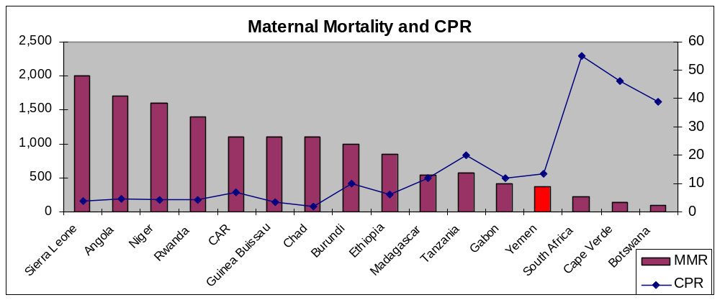
Source: UNFPA

We append in Appendix 4 a more developed example of such an advocacy tool developed from various graphs and statistics used in this report, in this case in support of supply chain improvement.

Coordination of advocacy roles
As indicated above, there appears to be much overlap in terms of advocacy roles in Yemen. The following table serves to provide an illustrative description of the types of roles each of these stakeholders could and likely should be focusing on:
Table 8: Illustrative advocacy functions
Advocate | Illustrative advocacy functions
Population Sector | - Leverage funds and support for RH program support and RHCS Framework and hold stakeholders accountable for commitments  - Establish and oversee RH programmatic policies  - Set measurable targets and monitor progress of indicators that support RH policies  - Resource and implement policies  - Link RH program indicators to national goals (i.e., CPR impact on maternal mortality)  - Understand core competencies of and lobby donor partners, civil society, and NPC to advocate for RH among respective target groups  - Coordinate RH program advocacy efforts of key stakeholders  - Develop effective and responsive evidence-based advocacy messages  - Oversee outreach and community-based advocacy messages to ensure quality content
NPC | - Conduct yearly Population Conference  - Lobby for routine inclusion of effective messages regarding population in presidential statements  - Establish, update, and fund the national population policy  - Elevate population and family planning issues to broader audiences (showing impact on economy, burden on schools and infrastructure, etc.)  - Develop macro-level messages that resonate with intra-ministerial level, parliamentarians, the GCC and other broader stakeholders  - Engage the media as a communicator of key RH messages
Civil society (YFCA, religious leaders, women’s groups, grassroots organizations) | - Develop effective messages that resonate at the community level  - Target influential community leaders and population segments  - Develop and implement innovative messaging techniques  - Organize and mobilize community messages supporting RH programs  - Engage the media as a communicator of key RH messages

Capacity
Maintaining the progress already made, and overcoming varied problems discussed in the preceding sections, requires that all concerned with RHCS have the capacity to do the work expected of them. In this final section before making recommendations we discuss some of the issues related to building capacity. We have considered the problem in two ways:

- Creating overall RHCS management capacity within the Population Sector

- Taking advantage of capacity that already exists in Yemen

The Population Sector
According to Article 23 of the Bylaws, the Population Sector and specifically the Reproductive Health unit have the responsibility for all functions related to guidance and oversight of reproductive health programs within the public sector, providing policy guidance and setting strategies to ensure the program is achieving measurable progress. Implicit in these responsibilities are monitoring and evaluation, coordination of training and capacity building, mobilizing resources, collaborating with key partners, and setting standards.

In examining the capacity needs within the Population Sector, it appeared that staff were able and dedicated to their jobs and to improving reproductive health. In our focus group discussions with the Population Sector staff, all were candid in their acknowledgement that they currently lack the capacity to fulfill the mandate summarized above. Gaps in capacity were typically categorized three ways: 1) skills, 2) staffing levels, and 3) resources (funding, systems, and equipment).

Skills
Concerning skill needs, it appears that all staff have the clinical or technical skills for their respective position. However, sector staff noted that they were lacking in management skills (planning, budgeting, reporting, oversight/supervision). A common problem seen in many countries is that staff rise in the ranks from clinicians or other “on the ground” positions to roles of managers; yet rarely are these staff provided the training for these new responsibilities.

Examples of specific skill deficits cited by the staff include the following: quantitative and qualitative analysis (for both HMIS and LMIS data); computer skills; report and proposal writing; supervising and performance monitoring; and planning and budgeting. In addition, many expressed the need to be “refreshed” in their specialty to ensure they are up to date in state of the art practices. For example, staff expressed the need for contraceptive technology updates and logistics skills for forecasting and procurement management.

The training coordinator for the Population Sector is responsible for coordinating all trainings through a national training plan. However, due to resource constraints, the coordinator tends to respond to donor project needs, developing training plans specific to the donor sponsored projects or interests. As a result, rather than having one coordinated national training plan, the coordinator manages several donor specific training plans. As mentioned earlier, many donor interests are at the governorate level or lower and therefore training resource typically bypass the central level needs. However, the coordinator does recognize this and makes efforts to identify and include management training needs for the central level whenever possible. It appears that the entire Population Sector staff are aware of this issue and not only does it limit opportunities for skill development, it also seems to affect their morale.

There was much discussion related to mechanisms for knowledge transfer and capacity building. Staff expressed concern about limited time for trainings and poor quality of trainings in the past. Training methods suggested included: exchange visits/study tours, both on and off-site courses, on the job trainings, online trainings, cascade training and working with management consultants. All of these suggestions can make sense, depending on the assumptions on which each is based.

Infrastructure and resources
Not only did staff identify skill needs, they also recognized numerous deficits in infrastructure and resources that limit their ability to perform their jobs effectively. One example came from the HMIS unit which reported that the governorate level enters the HMIS data into a computer program and sends this hard copy to the central level. This results in the central level staff having to re-enter this data, limiting time they could be spending on analysis or other core functions. There were also many examples of staff limiting their planning to 3 month increments or focused on specific donor mandates due to funding constraints. Similarly, insufficient funding restricts transport (and therefore supervision) as well as printing of training materials, forms and registries and guidelines and standards. Lastly, unclear procedures and processes limit performance. For example, procurement requires the input from numerous decision makers yet no clear process or division of authority appears to be in place. These inefficiencies severely hamper the central level staffs’ ability to perform their functions effectively.

Other stakeholders also sited as a challenge within the Population Sector that it is unclear who has responsibility for what functions and who has the authority for decision making. Centralized decision making does not appear to be unique to the Population Sector. However, it does leave individual staff members with little authority to act.

Again, staff appear to be fully aware of the limitations. When asked what resources are needed to improve productivity concerning RHCS activities, they gave the following answers: simplified procedures, funds for transport, computer hardware and software, electronic data transfer from governorates, support for data entry, automation of routine data-based reports and books and reference materials.

Staffing levels
Another limitation expressed is a lack of staff. The actual staffing needs are unclear at this point as it would be expected that staff would be alleviated much unnecessary work as a result of efficiency gains from improved skills and systems.

Another important issue raised concerned incentives, and with this we arrive at an important concern that is difficult to address and, therefore, often ignored. Staff were candid about their hopes for incentives, or forms of compensation that would provide encouragement for learning new skills and working more efficiently. To be equally candid, it is the case that MOPHP resources for financial compensation are extremely limited, and donors normally will not agree to pay salary supplements. This raises the question, what can be done to respond to this important staff concern? As consultants who do not represent the stakeholders, but rather advise them, we have to be very careful here.

Local Resources for Capacity Building
Resources for capacity building already exist in Yemen and it is important to incorporate them into RHCS planning. We have not performed an extensive inventory of relevant organizations, and this should be an early step in RHCS plans. We can, however, give three examples of how taking advantage of pre-existing capacities should speed up implementation and in some cases enhance the national environment for RHCS.

The first example concerns the Higher Institute for Health Sciences, already described in the Coordination Section. With its network of governorate level centers and its pre-service and in-service health worker training and training of trainers capacities, this important educational institution appears to be well positioned to assist with training at governorate, district and health facility levels. Although logistics training is not part of their current program, it would be useful to institutionalize capacity in Yemen and the HIHS is a good candidate.

A more modest resource but never the less a useful one is the Yemeni Midwives Association. They have already been active in advocacy for allowing CMWs to insert IUDs and their members have participated extensively in midwife training.

Another different type of local capacity to leverage is the donor assisted projects that operate at governorate and district levels. For many years it has been the practice of donors to specify target governorates and districts and provide them with extensive support through projects that seek to provide basic health services as close to home as possible. Population Sector leadership has acknowledged that this approach has produced many useful results that can be disseminated beyond the projects in which they originate.

As already noted, however, these projects tend to provide subsidized support systems for their target districts and have usually done little to empower governorates to manage districts, or the central ministry to manage national systems. As the targeted district approach is likely to endure, MOPHP should consider a sort of “systems development tax approach” in which these highly decentralized projects continue model building activities in target districts, but also provide governorate wide or district wide support for selected man agent support systems, such as logistics and health worker training and supervision.

Recommendations

Financing
The overall recommendation is for the Population Sector to develop and implement a long term approach to financial management and planning for RH programs and supplies.

Forecasting and Quantification
- The MOPHP Population Sector will need assistance in 1) conducting actual forecasts/quantifications, 2) developing the capacity within the MOPHP to take on this function and 3) ensuring that resources are in place to support this function.

- The Population Sector Logistics Unit should plan to review and update RH commodity forecast at least every six months. As both data quality and capacity to do the work improves, the updates should become more frequent (some countries update their forecasts monthly).

- As part of the quantification exercise, it is recommended that the stakeholders collect total in-country RH commodity inventory.

- Until logistics data is improved (both in quantity and quality), the forecasts will be based primarily on demographic data and confirmed with logistics data and service statistics.

- Once logistics data is more reliable, forecasts will be based primarily on logistics data. As this shift takes place, forecasters will validate their results using demographic data and service statistics.

- Basic information technology (IT) training and updated computer hardware and software applications (basic M.S. Office applications and data base applications [Pipeline] will be required by the logistics unit to conduct their core functions.

- Initially quantification will focus on contraceptives, and later expand to other reproductive health products. It is premature to make specific recommendations for forecasting the broader group of products. However, the Logistics Unit should begin to collect and evaluate logistics data for this diverse group of products.

Financial management
- The Population Sector should identify staff to be responsible for commodity forecasting and RH programmatic funding.

- These functions will require significant coordination and monitoring efforts and agreed upon and clearly defined terms. To facilitate consistency in data and routine monitoring and sharing of information, those responsible could track and report out on the following financial indicators

- Source of funding

- Amount of funding committed, allocated and disbursed by year

- Volume and value of donations committed, and procured by year

- Funding trends for all sources and products

The RHInterchange may be a useful resource in tracking contraceptive funding from donors as well as shipment schedules. It can be resourced at http://rhi.rhsupplies.org/rhi/index and a screen shot for Yemen is included in Appendix 5.

- The Population Sector should assure that all stake holders inside and outside MOPHP are informed of what may be expected of them in terms of providing information. Along this line, the Sector should plan to hold quarterly meetings with donors and other funders to ensure that funding information is accurately captured.

- It would also be important to map out who needs this funding information and for what purposes (i.e., advocacy/resource mobilization, to reconcile against forecasted need and identify funding gaps, for procurement, planning, etc) and to share the relevant information with each. The monthly RHWG meetings may be an appropriate venue for sharing such information.

- The Population Sector should assure that the staff with these new responsibilities have the basic computer skills and financial skills required for doing the work.

- The Population Sector should continue to support efforts to move to a results oriented budgeting.

- Specifically, the Population Sector can work closely with the Policy Unit of the MOPHP and provide them with important information and justifications. The above mentioned indicators from the improved financial tracking and management interventions will be useful in this regard.

- The Policy Unit should also involve the Population Sector staff in discussions about how to frame a new results oriented budget to ensure that it is aligned to basic functions but not so detailed that it places additional procedural (management or tracking) barriers.

- The Population Sector should develop a financial sustainability plan. For this activity, the following clarifications are provided. A financial sustainability plan will help all stakeholders understand the intended direction of the program as well as potential gaps in its support. Financing for RH supplies, their promotion, supply chain management, and service delivery can come from diverse sources including government, donors, households, and private companies including these sources.

- The EPI program has developed a Financial sustainability Plan. Lessons learned in the development and implementation of this should be factored into the development of a comparable plan for reproductive health.

- Within this plan, MOPHP should commit to making modest, but growing, contributions to financing the reproductive health program. As procurement capacity within the MOPHP is not yet strengthened, it is recommended that the MOPHP initially fund programmatic costs and advocate for investment in MOPHP procurement capacity strengthening. Until procurement capacity is strengthened, they should continue to leverage support for contraceptives from donors and partners.

- The financial implications of MOPHP policy changes or strategies should be considered and costed.
- For example, strategies focusing on altering the method mix (promotion of LAPM, emphasis on IUDs or implants) will have cost implications in terms of commodities as well as in terms of training inputs.

- There are financial implications for the recent policy change authorizing free contraceptives. In other countries, such decisions have increased demand in the public sector requiring additional funding for purchases and placing additional pressures on the existing supply chain. Finally, this change also brings along costs associated with disseminating the new policy and monitoring the progress of implementation.

- The Population Sector budget development and forecasting activity should be done in advance of and aligned with the broader MOPHP annual budget exercises.

Mobilize resources
- Although the MOPHP has indicated plans to increase internally generated funding support for RH, it is likely that significant donor support will be needed especially in the near future. Such support could help ensure that the MOH develops the capacity and focus to successfully sustain the RH program in the years to come. Donors are often willing to provide financial and technical support to focused program improvement efforts. A two or three year “family planning program initiative” would create valuable focus and should provide enough time to address key issues

- To help ensure sustained financing for RH services and supplies, it will be important to strengthen and further institutionalize the topic of RHCS within the partner meetings, health summits, stakeholders' conferences, and other meetings. Advocacy and policy strategies should clearly articulate the MOH and donor commitment to financing contraceptives and provide evidence for support from untapped advocates. (see policy/commitment section)

Supply Chain
Stakeholders should support extensive efforts to upgrade the operations of the public sector supply chain, nation-wide and top to bottom. The availability of an appropriate mix of contraceptives at all times is an absolute prerequisite to good quality family planning services. Despite the many problems that characterize the supply chain at this time, upgrading this system represents one of the best opportunities for bringing measurable improvement.

- As a first step in improving the supply chain, the Population Sector should hold as soon as possible a “design workshop,” during which system operators from facility, district, governorate and central level will systematically discuss and agree upon all aspects of the system design. More detail on this point is provided in recommendation 7, below.

- The Population Sector must resolve problems with lengthy delays in customs for its incoming supplies. Within the Sector, designate a small group of staff to work on this problem and propose solutions. Among their early activities should be:

  - Meet with customs staff and make a detailed list of the steps required for the entire clearance process.

  - Meet with EPI staff (or others with positive lessons to share) to learn about the approach they use, which is reported to be relatively efficient.

  - Prepare a brief written guide that documents the correct process.

- The Population Sector should make improving the quality and completeness of reported logistics data a major theme in system design and training activities at governorate level and below. This will support key activities in forecasting and distribution. Practical steps that will help to achieve this result are

  - Strengthen the capacity of central level staff to independently carry out forecasting responsibilities.

  - Carry out good quality training in support of implementing the nationwide logistics system that emerges from the design workshop.

  - Create a monitoring and supervision capacity to support implementation of the new system.

- The Population Sector should contact the PIU of the Health Reform Support Project for assistance in securing storage space for the incoming World Bank funded contraceptive procurements. World Bank staff have indicated that the Health Reform Support Project may have funds that can be used for this purpose. The acute storage problem at the moment arises from the fact that the existing warehouse is full, and supplies from the $2.5 million Bank procurement are starting to arrive.

- Develop a long term resolution to the serious storage problem at central level. There are basically three options to consider:

- Expand storage capacity. The options for doing this are to use storage space available through other programs; rent additional space; or construct new space.

- Lower inventories at the central level. This implies larger inventories at governorate level or more frequent and smaller deliveries to the central warehouse from suppliers, or both.

- Institute direct deliveries from port to governorates, at least in some cases. For Aden and southern Yemen it does not make sense to bring supplies up to Sana’a to take up limited storage space and incur the costs of being shipped back.

- The central storage problem is one for which additional study will be required. Topics that need to be covered include:

- For expanded storage options, space available, space requirements, equipment requirements, and atmospheric control requirements

- For the lowering inventory level option, space available at regional or governorate levels, space requirements, equipment requirements, and atmospheric control requirements

- For all of these options, capital and recurrent costs must be estimated.

- The Population Sector should lead a process to rationalize the distribution process at the governorate level and below. Use the design workshop as an opportunity to enlist support from governorate and district levels, as well as international partners. The details for the final system should come out of the “design workshop process” recommended in point 2, above. However, while that step is pending, we can make a number of provisional recommendations for the types of issues that the workshop will clarify:

  - Eliminate the practice of some sites reordering and reporting on a monthly basis and some sites on a quarterly basis. Put all sites below governorate level on a regular schedule for reordering/reporting.

  - Eliminate the practice of some sites picking up their own supplies while for other sites supplies are delivered. Plan for suppliers – primarily the Governorate Health Offices – to deliver stock to health facilities and District Health Offices.

  - Plan to purchase transport services locally, rather than acquire vehicles for this purpose. This is already a widespread practice.

  - Reduce the proposed pipeline length form its existing 19/33 month min/max levels to a shorter length.

  - Automate the logistics management information system. The upgraded system should have the following characteristics:

- Reporting to cover quantities of contraceptives dispensed to users, quantities in stock, and quantities lost.
- Streamline reporting levels and processes
- Data input into LMIS at governorate level.
- Electronic data transfer from governorate to central levels, where this is possible.
- Feed back reports provided by central level to lower levels

- The points listed above should be documented in a revised and upgraded logistics manual, which should have the following characteristics:

  - Separate sections for work to be carried out at central, governorate, district, and health facility levels

  - Each section should contain the following sub sections: job descriptions and step by step instructions for receiving, storing, controlling, issuing, ordering and reporting.

  - An appendix that gives examples of the different forms filled in and with instructions on what to enter in each field and where to find the required data.

- Develop a training roll out plan that will provide the following:

- Strategy and schedule for systematically covering all of the governorates.
- Specification of the staff, materials, equipment and financing required.

- The Population Sector should consider how to take advantage of the High Institute for Health Sciences as a training resource, with its experienced trainers and physical presence in 18 governorates.

- Very importantly, whatever plan is developed must correctly coordinate logistics training with family planning services training. The correct sequence of activities must be observed in order to get good results. That sequence is:

  - Fill the pipeline for facilities, districts and governorates, so that all stock outs are eliminated and quantities of supplies sufficient for the newly established maximum levels are in place at all sites.

  - Carry out logistics training for the new system in which the following skills will be taught: receiving, storing, controlling, issuing, ordering and reporting.

  - Carry out family planning services training, which should include building capacity for community outreach.

  - Recognize that it may be most efficient to integrate logistics and family planning services training for some staff, especially health facility-based care providers.

- The overall training strategy must include realistic plans for facilitating logistics supervision from the district level. This could be achieved through a district level training strategy wherein district supervisory staff and facility staff are trained together. This will require reliable funding for transport, a point covered in the next recommendation.

- Related to the need for supervision, develop a long term transport strategy for distributing contraceptives, and for supervision. Based on three recent surveys, we know that hiring local transport is viable in many cases in terms of the availability of vehicles for hire. However, it is not clear how this can be financed so that transport becomes scheduled and reliable. Some informants say that there is not enough money to cover this cost in the governorate and district budgets. Others say that the money would be sufficient, if used efficiently. The transport guidelines developed by GTZ will be a useful point of departure.

- The Population Sector should consider allocating resources to create a public health logistics training capacity at the HIHS. There are few health activities that do not require logistics support and there is a significant potential market for these services with development assistance projects. This is an opportunity to strengthen an important national resource.

Service Delivery
Plan and carry out a nation-wide program to expand and improve family planning services. Very importantly, this stream of activities must be coordinated with plans for supply chain improvement, so that it is assured that all sites have the complete method mix available before family planning services training takes place.

- The Population Sector should ensure the options identified in the RH Strategy to increase the number of trained family planning service providers, especially female, are sufficiently resourced. Priority should be given to rural areas. One method already implemented in Yemen is recruiting women from remote areas with the expectation that these women will return to their community to practice, be hired by the local health council. Another is to provide these women with incentives to stay in these communities by providing them with lodging.

- Donors and other partners should commit to aligning service delivery interventions within existing MOPHP structures and systems and coordinating their plans and efforts with the central level. While partners may focus on the lower levels, it is important for them to realize the role of the central level and to support the Population Sector functions accordingly and strengthen MOPHP systems as needed.

- Within the Population Sector, the Family Planning Unit should assure that quality of care standards, guidelines and other resources are available for family planning providers at all levels

  - Work with primary and family health units to make supervision strategies more effective

  - Work to maximize the amount of supervision that takes place from the district level

  - Pilot appropriate technologies to address gaps in service provider needs in hard to reach areas. Cell phones may be an appropriate strategy to supplement supervision visits and provide immediate feedback to providers.

  - Health registries are also an important tool for service providers to manage and understand their catchment area needs and as such should be available at all times. Donors have addressed the immediate needs but steps should be taken to ensure that registries are routinely printed and disseminated and therefore always available.

- The Population Sector should strengthen coordination and collaboration between major service providers. The Yemeni Midwives Association, Yemen Family Care Association, the social marketing program and the public sector service provision should all be well orchestrated to help ensure quality, reduce gaps in target groups and areas and share strategies. With such a high unmet need in Yemen, these groups should not be competing against each other for clients. Rather, they should ensure that their services are well segmented to reach their respective target groups.

- The Population Sector should continue to advocate for devolution of responsibility for IUD insertion and removal to the community midwife cadre. Advocacy efforts will also need to target the cadre who currently are authorized to insert and remove IUDs, particularly physicians and nurses. As the policy change could have direct implications for personal compensation, these cadres could be a barrier to the devolution. One strategy to generate support is to convene family planning conferences for public and private doctors and nurses. Such conferences could focus on the public health benefits of family planning and provide contraceptive technology updates.

Once policies are authorized and opposition subsides, resources must be available to carry out the required training. Also important is the guarantee that those identified for training are either at sites with the required equipment for IUD insertion and removal or that equipment is procured and provided to sites with newly trained providers.

- The Population Sector should focus IEC strategies initially on reducing barriers to those with existing family planning demand. Until the existing unmet need is reduced, it is NOT recommended to create additional demand.

  - Leverage the Social Marketing program’s behavior change capacities to support improving services. For example, knowledge, attitudes and practices (KAP) studies to learn more about consumer behaviors or informational messages for the public, coordinated with health work training activities.

  - Strengthen the quality of family planning services through contraceptive technology updates, outreach and other trainings will help reduce the community’s negative perception of public family planning service providers. These trainings should be integrated into pre-service training (with support from the High Institute for Health Sciences) and factored into in-service interventions such as training and supervision.

  - Tap into grass roots or community resources (such as women’s groups, teachers, local council leaders, religious leaders) to support provider outreach activities. Not only will this stretch the limited resources of the health providers, these highly respected leaders also add credibility to the messages.

- Efforts should be made to inventory the availability of reproductive health equipment – which is essential to ensuring quality service provision and RH commodity security. One suggestion is to include these indicators in the health facility assessment to understand generally gaps in equipment and supply needs.

- Although successes have not been sufficiently documented, the CBD strategy should be further supported. While important to coordinate the implementation of these programs through the MOPHP, the specific strategies can vary from governorate to governorate. For example, some CBD programs may provide incentives while others do not; some may be “educators” while others are “distributors” and still others may target certain catchment groups. These projects should be well documented and lessons learned shared.

Coordination and Partnerships
Tap into the core competencies of existing and potential partners at all levels, form specific expectations of how each could contribute to RHCS, and systematically work to realize the potential benefits of these relationships.

- In support of Article 23 of the MOPHP’s By Laws, the Population Sector should work to formalize collaborative opportunities (meetings, briefings, etc) with the other sectors: primary health, curative (especially related to the Medical Private Entities, emergency services, and pharmaceutical and medical supplies), and health planning and development and other units (i.e., the finance, policy and personnel units).

- The Population Sector should host a meeting to present the RHCS Framework (when it is finished) to garner ownership and commitment for activities and ensure activities are consistent with other program areas and priorities..

- The Population Sector should work to activate high level Reproductive Health Steering Committee (RHSC). Groups like the RHSC have played key roles in resource mobilization and policy formation in many countries within the context of the GFATM and other global funds. The Population Sector should attempt to give the committee reasons to meet. Presenting the RHCS Framework is one example of a reason; presenting forecasts and their financial implications and presenting funding trends are others.

- At the program implementation level, the Reproductive Health Working Group does appear to meet routinely. Some participants have observed that participation varies depending on interest in the agenda. This may be the one reason for another apparent weakness of the group – a lack of continuity and follow up. For purposes of maintaining interest in the RHCS Framework, the Population sector should develop a list of indicators for tracking Framework implementation. Examples of indicators include:

- Funding allocations, disbursements and needs.

- Routine reporting of contraceptive procurement related information, such as shipment amounts, dates of arrival, issues related to customs, that would help stakeholders better understand procedural barriers and better plan for storage, transport.

- Updates on supply chain improvement activities, including numbers of staff trained, expansion of geographical coverage of the improved system and problems encountered in implementation

- Service statistics updates and efforts to upgrade and expand family planning services.

- Donors and partners commit to effectively sharing and coordinating with the Population Sector. One possible strategy would be the development of an MOU that would outline points of contact who have decision making authority within the Population Sector.

- Conduct a market segmentation analysis and develop an active strategy for total market coordination that clearly outlines roles of both public sector and private sector actors. In doing this, it is important to recognize the comparative advantages of the public and private sectors. This approach has been used in several countries (Philippines, etc) to guide public sector priorities, achieve national family planning goals and advocate for increased private sector participation in the development of national contraceptive security strategies. As part of a well orchestrated total market approach, the public sector has certain roles and responsibilities. For example, the public sector:

- Engages and coordinates key stakeholders
- Ensure quality controls and regulation:
- Promote enabling environment for private and NGO’s.
- Serves as a safety net and extends coverage.

- A study confirming the existence and determining the impact of leakage of public sector contraceptives on the private sector should be conducted. The SMP and other stakeholders may want to help fund and support such a study as it has direct impact on their market shares.

- Through a total market approach, stakeholders should assess and understand the prices of contraceptives available through the various sources. This may be a useful exercise for partners to update and share occasionally. For example such information helps partners identify leakage, as well is if sectors are overlapping unintentionally in their prices. It will also help identify and avoid costly competition between sectors (due to undercutting of prices). The successful stabilization of prices between public and private sectors is a cornerstone of financial viability of the program.

Policies and Advocacy
The Population Sector should use the RHCS framework activity to strengthen its capacity for advocacy. As foreseen in the preceding discussion of Coordination and Partnerships, the concept of advocacy must include the ability to communicate and persuade at all levels of the system.

- The Population Sector has taken responsibility for steering the RHCS Framework and using it as a road map for strengthening commodity security in the country. This leadership must be continued to ensure the completion and eventual implementation of the strategy, including coordination of activities.

- The National Drug Authority, Population Sector and other key stakeholders should review the National Essential Drug List revision process and ensure it includes implants and injectables.

- To support the RHCS Framework, it is important for the Population Sector to better understand the support available from donors and partners who have global strategies supporting commodity security.

- The Population Sector will need to continue to monitor the health sector review process, proactively determining the impact on the population sector and making necessary adjustments for issues such as integration (especially those related to the logistics and health information systems).

- Similarly, the decentralization of funding and management that may result from the health sector review process will affect the security of family planning commodities and will likely require some advocacy at the governorate and district levels to ensure family planning and RHCS are fully supported.

- There are numerous stakeholders involved in advocacy of population, family planning and reproductive health issues. It is important to rationalize these roles to reduce overlap and ensure appropriate messaging. The following table serves to provide an illustrative description of the types of roles each of these stakeholders could and likely should be focusing on:
Table 9: Illustrative advocacy functions
Advocate | Illustrative advocacy functions
Population Sector | - Leverage funds and support for RH program support and RHCS Framework and hold stakeholders accountable for commitments  - Establish and oversee RH programmatic policies  - Set measurable targets and monitor progress of indicators that support RH policies  - Resource and implement policies  - Link RH program indicators to national goals (i.e., CPR impact on maternal mortality)  - Understand core competencies of and lobby donor partners, civil society, and NPC to advocate for RH among respective target groups  - Coordinate RH program advocacy efforts of key stakeholders  - Develop effective and responsive evidence-based advocacy messages  - Oversee outreach and community-based advocacy messages to ensure quality content
NPC | - Conduct yearly Population Conference  - Lobby for routine inclusion of effective messages regarding population in presidential statements  - Establish, update, and fund the national population policy  - Elevate population and family planning issues to broader audiences (showing impact on economy, burden on schools and infrastructure, etc.)  - Develop macro-level messages that resonate with intra-ministerial level, parliamentarians, the GCC and other broader stakeholders  - Engage the media as a communicator of key RH messages
Civil society (YFCA, religious leaders, women’s groups, grassroots organizations) | - Develop effective messages that resonate at the community level  - Target influential community leaders and population segments  - Develop and implement innovative messaging techniques  - Organize and mobilize community messages supporting RH programs  - Engage the media as a communicator of key RH messages

- The Supreme Drug Authority, the Population Sector and the Policy Unit should collaborate to develop a policy for donated products. The WHO model policy for donated drugs can be resourced at http:///whqlibdoc.who.int//hq/1999/WHO_EDM_PAR_99.4.pdf, and may serve as a point of departure for developing a national policy.

- As the National Population Council is a natural advocate for macro-level awareness raising and advocacy, it is recommended that they identify and develop effective messages and correlations between the impact of population growth on issues such as education, poverty reduction, environment/water issues. A useful tool for this is RAPID. It describes the impact of population growth on the economy, agriculture, school, and health infrastructure needs and can be a convincing tool in lobbying a broader audience. The tool is accessible electronically at http://www.constellagroup.com/toronto/software/RAPID/RapmanE.pdf.

- In ensuring that policies are translated into action, it is essential that the Population Sector and other stakeholders develop specific, measurable, accurate, realistic and timely (SMART) indicators to show progress. Similarly, it is essential that strategies to achieve these targets and goals are adequately funded and resources.

- The National Population Council is holding its Population Conference in October 2007. This is an important opportunity for the MOPHP and other key stakeholders to join forces, harmonize messages and collectively advocate for these important issues. If time permits, it would also be a very timely opportunity to showcase findings from the above mentioned RAPID analysis.

Capacity Building
The key recommendation for Capacity Building is to ensure that all concerned with RHCS have the capacity to do the work expected of them.

- As referenced earlier, it is recommended that donors and partners establish MOU’s with the MOPHP. Within this MOU, donors and the Population Sector should identify central level management responsibilities required and to account for the training and resource needs within the agreed support. The Population Sector could establish a “systems development tax approach” in which decentralized projects continue activities in target districts, but also provide support for management support systems, such as logistics and health worker training and supervision.

- In addition to skills and resources, central level staff also must have the authority to act and make relevant decisions. It is recommended that roles and responsibilities within the sector are reviewed and levels of authority and decision making are clarified.

- Resources for capacity building already exist in Yemen and it is important to incorporate them into RHCS planning. Taking advantage of pre-existing capacities, such as the HIHS, should speed up implementation and in some cases enhance the national environment for RHCS.

- Donors and partners should commit to supporting and buying into parts of a comprehensive national training. Such a plan will take the place of training plans that are currently segmented by district, intervention or donor need.

- The Training Coordinator within the MOPHP should develop quality standards for major training activities, and assure that implementers abide by them. For example:

  - Curricula will be based on adult learning theory

  - Instructional methods will be participatory

  - Training will be skills based, with problem solving exercises

  - Training methods and curricula will be tested, evaluated and revised before implementation

  - Print materials will be professionally prepared, though not overly fancy

  - Budgets are realistic, covering all required costs

  - Implementation schedules are realistic and coordination with other implementation activities is correct

Next Steps
By this point readers have reviewed detailed discussions of the six determinants of RHCS, plus summaries of recommendations for each of them. It will be useful to conclude this report by reflecting again on how this material will be used for developing the RHCS Framework and by considering criteria for making the framework an effective one.

As noted in both the executive summary and the body of the report, this assessment has been the first phase in a three phase process for producing and launching the framework. The next step in this process is to receive feedback (including corrections, suggestions and reactions) on this report from key RHCS stakeholders as basis for framework development.

In order for the assessment to be of any practical value it is necessary to follow through with the remaining two phases and produce a viable RHCS Framework. To the diverse group of MOPHP staff, local partners, and international development partners who will work together to produce the Framework, we propose the following definition of “viable:” In order to accomplish its goals, the Framework must include:

- Comprehensive approaches to solving the RHCS problems that are defined in ways that clearly articulate roles, identify specific resource requirements, and facilitate incremental, manageable implementation.
- Significant investment in developing capacity and systems at the central level to meet expectations of good outcomes at lower levels
- Commitment by all partners to support the MOPHP in implementing its chosen systems
- Proposals for specific improvements based on high sensitivity to management skills within the MOPHP
- High priority for activities that strengthen national institutions

References
Afif, Mohammad Bin., Abdulwarith, Anhar., Tezcari, Eva. April 2006. What Do Youth Really Want to Know? Frequently Asked Questions on Reproductive Health by Yemeni Youth.
The Cabinet National Population Council Technical Secretariat, Republic of Yemen. National Population Information, Education and Communication Strategy, 2005-2010.
Compernolle, Phil. March 2005. Estimating the Costs of Addressing the Health MDGs in Yemen.
DELIVER. 2006. Yemen Situation Analysis: Assessment of the Contraceptive Logistics System in 5 Governorates. Arlington, VA.: DELIVER, for the U.S. Agency for International Development.
Eberle, James. July 24- August 24 2004. DELIVER Technical Assistance Record. Yemen.
Eberle, James. August 6-17 2005. DELIVER Technical Assistance Record. Yemen.
Eberle, Jim., Jim Bates. January 2004. The DELIVER Project, Assessment of the Reproductive Health Logistics System of the Republic of Yemen Ministry of Public Health and Population, Draft.
Fairbank, Dr. Alan. April 2006. Public Expenditure Review, Health Sector Republic of Yemen, 1999-2003. PHRplus.
Hare, L., Hart, C., Scribner, S., Shepherd, C., Pandit, T. (ed.), and Bornbusch, A. (ed.). 2004. SPARHCS: Strategic Pathway to Reproductive Health Commodity Security. A Tool for Assessment, Planning, and Implementation. Baltimore, MD: Information and Knowledge for Optimal Health (INFO) Project/Center for Communication Programs, Johns Hopkins Bloomberg of Public Health.
Hassan, Abdul-Qawi., Dr. Jamal Ba’athar. April 2007. Community Based Reproductive Health Promotion. Yemeni-German Reproductive Health Programme.
Lehmann, Luise., Andreas Lenel. March 2004. Family Health and Family Planning Project, Expert Mission for Analysis of Actual Situation Social Marketing.
Ministry of Public Health and Population PAPFAM. March 20, 2005. Summary Report of the Yemen Family Health Survey 2003, Draft 20.
Ministry of Public Health Sana’a Republic of Yemen. October 2000. Health Reform in the Republic of Yemen, Strategy for Reform.
MOPHP Republic of Yemen. Annual Health Statistical Report for 2003-2004.
MOPHP, Yemen, Sept. 2005, Essential Service Package for the District Health System, Part One: Service Standards and Input Standards.
MOPHP, Yemen, Sept. 2005, Essential Service Package for the District Health System, Part Two: Management Guidelines.
National Health Accounts Team, Republic of Yemen. June 2006. Yemen National Health Accounts Estimate for 2003.
The National Population Policy of the Republic of Yemen. Problems and Challenges.
The National Population Policy of the Republic of Yemen. Population Action Programme 2001-2005.
The National Population Policy of the Republic of Yemen. 2001-2025. Principles and Objectives.
Republic of Yemen. Joint MOPHP- Development Partners’ Statement on Alignment and Harmonization in the Health and Population Sector.
Republic of Yemen, Ministry of Public Health and Population, Health Policy and Technical Support Unit. April 2002. The National Model of District Health System.
Republic of Yemen MOPHP Health Policy and Technical Support Unit. April 2002. The National Model of District Health System.
Sloveig, Dr. Buhl., Shoqi Maktari., Alwine Attieg. March 2006. Supporting Private Work of Community Midwives in Rural Areas.
Taher, Sameera., Ahmed Almashra’e., Ahmed Aqla’an., Nabeel Mohammed Alqubati. Manual of System of GHO Contraceptives Supply. Republic of Yemen, MOPHP, Population Sector.
Tezcan, Dr. Eva. March 31, 2007. Yemeni-German Reproductive Health Programme, PPR Report.
Yemini-German Reproductive Health Programme. January 2006. Opportunities and Challenges in Ensuring Availability of Contraceptives in Public Health Facilities.

Terms of reference for the RHCS Framework (RHWG)
Summary Report of the Yemen Family Health Survey, 2003 (Draft 20 March 2005)
Health Sector Reform in the Republic of Yemen: Strategy for Reform, MOPHP, 2000.
Health Sector Reform in the Republic of Yemen: Strategy for Reform, MOPHP, 2000
Ibid
Ibid
Ibid
Ibid
Based on an exchange rate of 1USD to 189YR
Based on an exchange rate of 1USD to 189YR
The Yemen Family Care Association (YFCA) receives approximately 20% of product through the MOPHP supply system. However, given that the projections presented in the table are based on an assumption of a relatively lengthy 26 month supply pipeline, this 20% allocation for YFCA is not included in the forecast.
Joint Project Memorandum “Programme to Help Yemen Reduce Maternal and Newborn Mortality”. DFID/RNE. 2005.
“Survey of Yemeni Midwives in targeted governorates,” BHS Project, USAID.
http://www.who.int/whosis/database/core/core_select_process.cfm?countries=all&indicators=healthpersonnel
Organizational Bylaws of the Ministry of Public Health and Population” for 2004, p. 16
Terms of Reference, National Reproductive Health Steering Committee (RHSC)

