[Publish Date]

Proposal Template – Cost Model #2017-045
Global Family Planning Visibility and Analytics Network (GFPVAN)

Table of Contents
1 Submission Instructions 2
2 Cost Model – Assumptions 3
3 Cost Model – Description 1st Year Pilot Proposal 4
4 Cost Model – Three Year Projection 6
5 Appendix 8

Submission Instructions
Proposals are to be submitted no later than February 21st, 2018. The cost model proposal is limited to 15 pages (not including cover page, table of contents, submission instructions and attachments) and responses should be provided in this template. Proposals must be submitted to GlobalFPVAN@rhsupplies.org.
For each written section, please use 1-inch margins and 11-point font.
Section 3 – Cost Model – Description 1st Year Pilot and Section 4 – Cost Model – Three Year Projection include a template table to provide cost detail/breakdown. You may customize the template to best describe your proposal.
Please see the RFP Addendum for the list of abbreviations.

Cost Model – Assumptions
For your cost model, please use the following information for the basis of the assumptions:

- Pilot is for two countries; moving to full scale is 69 countries
- Pilot is for four manufacturers; moving to full scale is 36 manufacturers
- Pilot is for two product families; moving to full scale is 8 product families

Assume the following ratios for user counts per role type:

 | Role | Pilot | Full Scale-Up
"Active" Functional Users | CDP | 6 | 207 | Assumes 3 people per country
 | CTDA | 8 | 8
 | CTP | 5 | 5
 | CTA | 2 | 2
 | CTPM | 1 | 1
 | Role | Pilot | Full Scale-Up
Report Consumers | Procurers | 8 | 88 | Assumes 4 people per organization
 | LMU | 6 | 207 | Assumes 3 people per country
 | Manufacturers | 4 | 36 | Assumes 1 person per Manufacturer
 | Role | Pilot | Full Scale-Up
Secured Access | External Organizations | 0 | 200

Cost Model – Description 1st Year Pilot Proposal
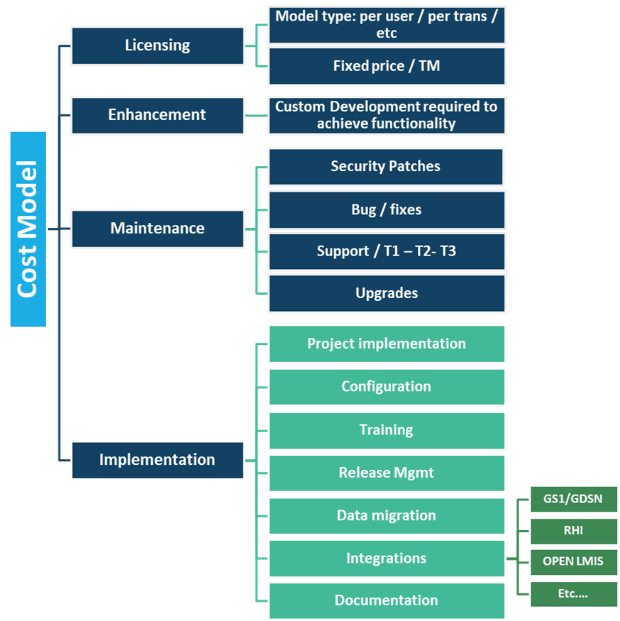
Describe your proposed cost model for a non-profit client, both via a narrative description and using the provided template that highlights both implementation costs and maintenance costs.

Provide detail on your:
- Licensing Model
- Enhancement Costs
- Maintenance Costs
- Implementation Costs

Feel free to add/adjust the template table to best describe your proposal.

Provide below a narrative description of your proposed cost model.
Using the template below, provide cost detail/breakdown. You may customize the template to best describe your proposal.

 | Category | Description | Year 1 – Pilot ($ USD) | Following Years – assume no growth (maintenance only)
Licensing | Cost Type  (per user/per transaction/fixed price)
Enhancements | Custom Development
Maintenance | Bug / fixes
 | Security patches
 | Support (tier 1/2/3)
 | Upgrades
Implementation | Project Implementation |  |  | -
 | Configuration |  |  | -
 | Training |  |  | -
 | Release Management |  |  | -
 | Data migration |  |  | -
 | Integrations |  |  | -
 | Documentation |  |  | -
Total

Cost Model – Three Year Projection
Assuming success in the pilot, the project will move to full scale. In order to project three years of cost using the provided template below, make the following assumptions:

- Move from two countries to 69 countries
- Move from four Manufacturers to 36
- Move from two product families to eight

Also, for the purposes here, do not include training / implementation costs to move to full scale, as that is unknown currently.

Describe below expected changes in your licensing model as the solution moves to scale.

Using the template below, provide cost detail/breakdown. You may customize the template to best describe your proposal.

 | Category | Description | Year 1 – Pilot ($ USD) | Year 2 ($ USD) | Year 3 ($ USD)
Licensing | Cost Type  (per user/per transaction/fixed price)
Maintenance | Bug / fixes
 | Security patches
 | Support (tier 1/2/3)
 | Upgrades
Total

Appendix
List and attach any supporting documentation.

